Facility Availability Query

Table of Contents

8. Facility Availability Query (FAQ) 2
8.1 Business Description 2
8.1.1 Query Type - Response Summary 2
8.2 Business Model 4
8.3 Facility Availability Schema 5

- Facility Availability Query (FAQ)
  - Business Description
    - Query Type - Response Summary

FAQ | Facility Availability Query
 | Select all services for which this query will be used.
1 | FAQ for POTS Service, by Address (SCATEG=P & TNADDRCKTIND=A) | Good (RESPONSE =G)
2 | FAQ for POTS Service, by Address (SCATEG=P & TNADDRCKTIND=A) | Bad (RESPONSE = B)
3 | FAQ for POTS Service, by TN (SCATEG=P & TNADDRCKTIND=T) | Good (RESPONSE =G)
4 | FAQ for POTS Service, by TN (SCATEG=P & TNADDRCKTIND=T) | Bad (RESPONSE = B)
1 | FAQ for Design Service (DS0), by Address (SCATEG=D & TNADDRCKTIND=A) | Good (RESPONSE =G)
2 | FAQ for Design Service (DS0), by Address (SCATEG=D & TNADDRCKTIND=A) | Bad (RESPONSE = B)
1 | FAQ for Hi Capacity Service (DS1, DS3), by Address (SCATEG=H & TNADDRCKTIND=A) | Good (RESPONSE =G)
2 | FAQ for Hi Capacity Service (DS1, DS3), by Address (SCATEG=H & TNADDRCKTIND=A) | Bad (RESPONSE = B)
1 | FAQ for ISDN Service, by Address (SCATEG=I & TNADDRCKTIND=A) | Good (RESPONSE =G)
2 | FAQ for ISDN Service, by Address (SCATEG=I & TNADDRCKTIND=A) | Bad (RESPONSE = B)
1 | FAQ for Loop Service, by Address (SCATEG=U & TNADDRCKTIND=A) | Good (RESPONSE =G)
2 | FAQ for Loop Service, by Address (SCATEG=U & TNADDRCKTIND=A) | Bad (RESPONSE = B)
3 | FAQ for Loop Service, by TN (SCATEG=U & TNADDRCKTIND=T) | Good (RESPONSE =G)
4 | FAQ for Loop Service, by TN (SCATEG=U & TNADDRCKTIND=T) | Bad (RESPONSE = B)
1 | FAQ for Loop Service, by Circuit ID (SCATEG=U & TNADDRCKTIND=C) | Good (RESPONSE =G)
2 | FAQ for Loop Service, by Circuit ID (SCATEG=U & TNADDRCKTIND=C) | Bad (RESPONSE = B)
1 | FAQ for DSL DSL Loop Service, by Address (SCATEG=V & TNADDRCKTIND=A) | Good (RESPONSE =G)
2 | FAQ for DSL Loop Service, by Address (SCATEG=V & TNADDRCKTIND=A) | Bad (RESPONSE = B)
3 | FAQ for DSL Loop Service, by TN (SCATEG=V & TNADDRCKTIND=T) | Good (RESPONSE =G)
4 | FAQ for DSL Loop Service, by TN (SCATEG=V & TNADDRCKTIND=T) | Bad (RESPONSE = B)
1 | FAQ for Megabit Service, by Address and TN (SCATEG=M & TNADDRCKTIND=B) | Good (RESPONSE =G)
2 | FAQ for Megabit Service, by Address and TN (SCATEG=M & TNADDRCKTIND=B) | Bad (RESPONSE = B)

  - Business Model
Facility Availability
Facility Availability provides CLEC the ability to query for and receive information regarding the facilities associated with the customer service location.
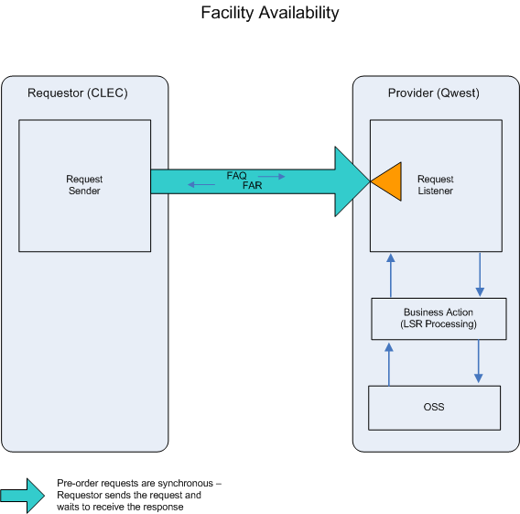

- CLEC submits a FAQ.

- If the FAQ fails the IMA edits, a FAR (BAD) will be returned.

If the FAQ passes the IMA edits, the query will be sent to the Operations Support System (OSS). This system will respond with one of two conditions: BAD or GOOD.
- FAR (BAD) will be returned when the FAQ encounters an error(s) with the OSS.

- A FAR (GOOD) will be returned when information queried (POTS (Good or Pending), Private Line, ISDN or Unbundled Loop) regarding the facilities queried is retrieved.

  - Facility Availability Schema
Please see Appendix F – WSDL - Pre-Order.

