Service Availability Transaction Cycle

Table of Contents

13. Service Availability Query (SAQ) 2
13.1 Business Description 2
13.1.1 Query Type - Response Summary 2
13.2 Business Model 3
13.3 Service Availability Schema 4

- Service Availability Query (SAQ)
  - Business Description

Query Type - Response Summary

SAQ | Service Availability Query
1 | SAQ for Multiple switches, by TOS & primary NPA/NXX | Good (RESPONSE =G)
2 | SAQ for Multiple switches, by TOS & primary NPA/NXX | Bad (RESPONSE = B)
3 | SAQ for a Single Switch, by TOS & NPA/NXX (any on switch) & Service Address | Good (RESPONSE =G)
4 | SAQ for a Single Switch, by TOS & NPA/NXX (any on switch) & Service Address | Bad (RESPONSE = B)

  - Business Model
Service Availability

Service Availability allows the CLEC to query for and receive information regarding the availability of services associated with the customer service location.

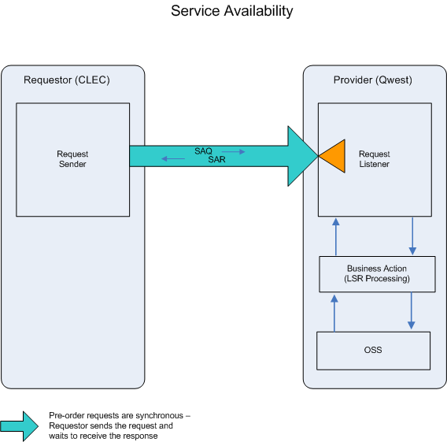

- CLEC submits an SAQ.

- If the SAQ fails the IMA edits, SAR (BAD) will be returned.
- If the SAQ passes the IMA edits, the query will be sent to the Operations Support Systems (OSS). This system will respond with one of two conditions: BAD or GOOD.

- SAR (BAD) will be returned when the SAQ encounters an error(s) with the OSS.

- An SAR (GOOD) will be returned when existing features and carriers or switch types for the NPA/NXX queried are retrieved.
  - Service Availability Schema
Please see Appendix F – WSDL - Pre-Order.

