Service Order Status Inquiry Transaction

Table of Contents

24. Service Order Status Inquiry 2
24.1 Description 2
24.1.1 Inquiry Type - Response Summary 2
24.2 Business Model 3
24.3 Service Order Status Inquiry Schema 4

Service Order Status Inquiry
  - Description
    - Inquiry Type - Response Summary
SOSI | Service Order Status Inquiry
1 | Service Order Status for LSR (TXACT=S) | Good (RESPONSE =G)
2 | Service Order Status for LSR (TXACT=S) | Bad (RESPONSE = B)
3 | Service Order Status for LSR (TXACT=S) | Mixed (RESPONSE = M)

  - Business Model
Service Order Status Inquiry
The Service Order Status Inquiry allows the Co-Provider to query for, and receive information regarding the status of an order.

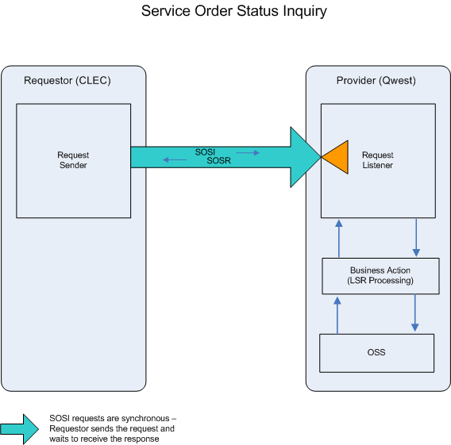

- The Co-Provider submits a SOSI, providing Purchase Order Number (PON)/Version Number (VER) or LSR ID.

- If the SOSI fails the IMA edits, SOSR (BAD) will be returned.

If the SOSI passes the IMA edits, the query will be sent to the Operations Support System (OSS). This system will respond with one of three responses: GOOD, MIXED, or BAD.

- A SOSR (GOOD) will be returned with the current order status.
- A SOSR (MIXED) will be returned with the current order status and SOSI receives an error from the OSS.
- A SOSR (BAD) will be returned when the SOSI encounters an error(s) with the OSS.

  - Service Order Status Inquiry Schema
Please see Appendix H – WSDL – Post Order.

