Appointment Reservation Transaction Cycle

Table of Contents

3. Appointment Reservation Transaction Cycle 2
3.1 Business Description 2
3.1.1 Query Type - Response Summary 2
3.2 Business Model 3
3.3 Appointment Reservation Schema 5

- Appointment Reservation Transaction Cycle
  - Business Description

    - Query Type - Response Summary

AAQ | Appointment Availability Query
1 | AAQ | Good (RESPONSE =G)
2 | AAQ | Bad (RESPONSE = B)

ASQ | Appointment Selection Query
1 | ASQ | Good (RESPONSE =G)
2 | ASQ | Bad (RESPONSE = B)

  - Business Model
Appointment Scheduling
An Appointment Schedule Assignment is needed whenever dispatch is required to install equipment or facilities as a result of a customer request. This transaction provides the CLEC the ability to check availability of time slots for the Centurylink installation workforce, as well as to reserve a time slot.
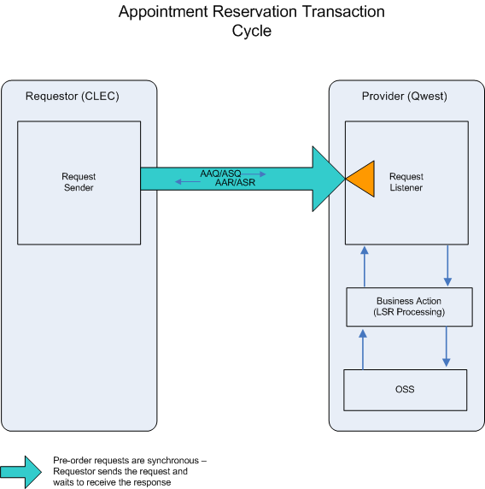

- The CLEC submits an AAQ, Appointment Availability Query, to Centurylink. A PON is needed for this query.

- If the AAQ fails the IMA edits, AAR (BAD) will be returned.

If the AAQ passes the IMA edits, the query will be sent to the Appointment Scheduling System. The System will respond with one of two conditions: BAD or GOOD. A third condition, ‘MIXED’, is not valid for a new appointment query.

- AAR (BAD) will be returned when the Appointment Availability Query encounters an error(s) in the Appointment Scheduling System.

- An AAR (GOOD) will be returned with a list of appointment time slots. One pre-reserved appointment time slot is included on the AAR. If this appointment is satisfactory, no further action is required.

- Within a configurable amount of time, currently set to 30 minutes of the receipt of an AAR (GOOD), the CLEC must submit an ASQ, if an appointment other than the pre-reserved appointment is desired.

- If the ASQ fails the IMA edits, ASR (BAD) will be returned. If the ASQ passes the IMA edits, the query will be sent to the Appointment Scheduling System. The System will respond with one of the two conditions: BAD or GOOD.

- ASR (BAD) will be returned when the Appointment Selection Query encounters an error(s) in the Appointment Scheduling System. For example, if the time slot selected is no longer available, an error will be returned with ASR (BAD).

- An ASR (GOOD) will be returned when the appointment requested is scheduled in the Appointment Scheduling System. A confirmation number, INQRES NBR, will be returned with the ASR (GOOD). This number needs to be referenced on the corresponding Local Service Request in the APT CON field. The Local Service Request must be issued within the pre-determined time frame (currently set at 24 business hours) either after the ASR (GOOD) is received by the CLEC or before the start time of the appointment, whichever is earlier.

  - Appointment Reservation Schema
Please see Appendix F – WSDL – Pre-Order.

