CFA Validation Transaction Cycle

Table of Contents

5. CFA Validation Transaction Cycle 2
5.1 Business Description 2
5.1.1 Query Type - Response Summary 2
5.2 Business Model 3
5.3 Connecting Facility Assignment Schema 4

- CFA Validation Transaction Cycle
  - Business Description

    - Query Type - Response Summary

CFAQ | Connecting Facility Availability Query
1 | CFAQ by Cable Group (SEARCHTYP=G) | Good (RESPONSE =G)
2 | CFAQ by Cable Group (SEARCHTYP=G) | Bad (RESPONSE = B)
3 | CFAQ by Cable Unit (SEARCHTYP=U) | Good (RESPONSE =G)
4 | CFAQ by Cable Unit (SEARCHTYP=U) | Bad (RESPONSE = B)

  - Business Model
Connecting Facility Assignment Validation
Connecting Facility Assignment allows a CLEC to query for and obtain a list of valid and available CFAs and channel assignment records.
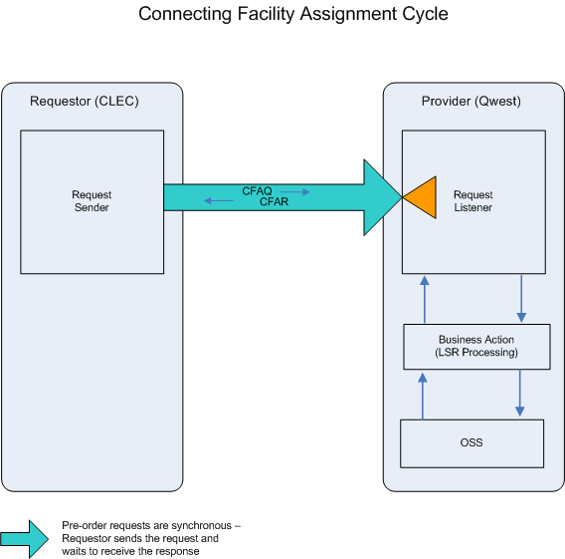

- CLEC submits a CFAQ providing the LOC A and LOCZ, or the LOC A, LOC Z, Cable Name, First Unit, and Last Unit.

- If the CFAQ fails the IMA edits, a CFAR (BAD) will be returned.

If the CFAQ passes the IMA edits, the query will be sent to the Operations Support System (OSS). This system will respond with one of two conditions: BAD or GOOD.
- CFAR (BAD) will be returned when the CFAQ encounters an error(s) with the OSS.

- A CFAR (GOOD) will be returned when the queried Cable Pair Group or Cable Pair Unit of the connecting facility assignments are retrieved.
  - Connecting Facility Assignment Schema
Please see Appendix F – WSDL – Pre-Order.

