Design Layout Record

Table of Contents

7. Design Layout Record 2
7.1 Business Description 2
7.1.1 Query Type - Response Summary 2
7.2 Business Model 3
7.3 Design Layout Record Schema 4

- Design Layout Record
  - Business Description

    - Query Type - Response Summary
DLRQ | Design Layout Request Query
 | Select all services for which this query will be used.
1 | DLRQ for Serial Service (CKTFORMAT=S) | Good (RESPONSE =G)
2 | DLRQ for Serial Service (CKTFORMAT=S) | Bad (RESPONSE = B)
1 | DLRQ for Telephone Service (CKTFORMAT=T) | Good (RESPONSE =G)
2 | DLRQ for Telephone Service (CKTFORMAT=T) | Bad (RESPONSE = B)
1 | DLRQ for Carrier Service (CKTFORMAT=C) | Good (RESPONSE =G)
2 | DLRQ for Carrier Service (CKTFORMAT=C) | Bad (RESPONSE = B)
1 | DLRQ for Message Trunk Service (CKTFORMAT=M) | Good (RESPONSE =G)
2 | DLRQ for Message Trunk Service (CKTFORMAT=M) | Bad (RESPONSE = B)

  - Business Model
Design Layout Record Return
The Design Layout Record Return gives the CLEC the ability to query for and receive information regarding a circuit’s technical information describing the facilities and terminations provided by the local telephone company (Centurylink). The technical information can be used by the CLEC to design the overall service.

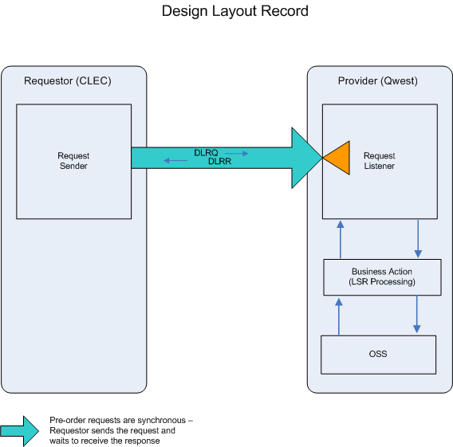

- The CLEC submits a DLRQ.

- If the DLRQ fails the IMA edits, DLRR (BAD) will be returned.

If the DLRQ passes the IMA edits, the query will be sent to the Operations Support System (OSS). This system will respond with one of two responses: BAD or GOOD.

- DLRR (BAD) will be returned when the DLRQ encounters an error(s) with the OSS.

- A DLRR (GOOD) will be returned with the Design Layout Record.
  - Design Layout Record Schema
Please see Appendix F – WSDL - Pre-Order.

