Listings Reconciliation

Table of Contents

9. Listings Reconciliation 2
9.1 Business Description 2
9.1.1 Query Type - Response Summary 2
9.2 Business Model 3
9.3 Listing Reconciliation Schema 5

- Listings Reconciliation
  - Business Description

RLDQ | Listings Reconciliation Query
1 | LSTRQ by TN (TXACT=A) | Good (RESPONSE =G)
2 | LSTRQ by TN (TXACT=A) | Bad (RESPONSE = B)
3 | LSTRQ by TN (TXACT=A) | Multiple (RESPONSE = M)
4 | LSTRQ by TN (TXACT=B) | Good (RESPONSE =G)
5 | LSTRQ by TN (TXACT=B) | Bad (RESPONSE = B)
6 | LSTRQ by TN (TXACT=B) | Multiple (RESPONSE = M)
    - Query Type - Response Summary

  - Business Model

Listing Reconciliation
The Pre-Order process for Facility Based Directory Listing (FBDL) utilizes the fields identified in the Ordering and Billing Forum (OBF) Listing Reconciliation practice. Listing Reconciliation provides a CLEC the ability to query for and receive information regarding the FBDL related information associated with a Listing telephone number.

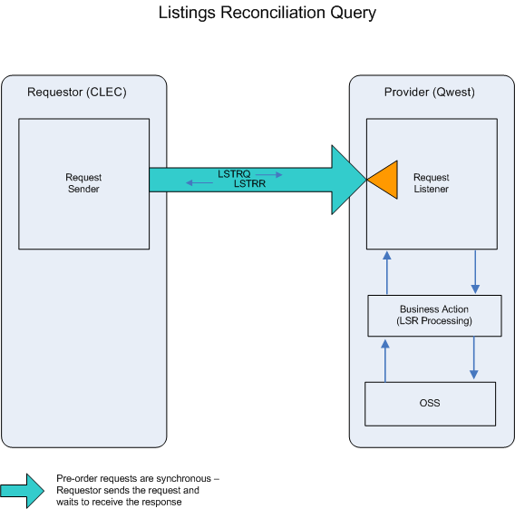

- CLEC submits a LSTRQ by providing a FBDL Listing telephone number.

- If the LSTRQ fails the IMA edits, a LSTRR (No Match or Error) response will be returned.

If the LSTRQ passes the IMA edits, the query will be sent to the Operations Support System (OSS). This system will respond with one of three conditions: NO MATCH or ERROR, MULTIPLE MATCH or EXACT MATCH.

- LSTRR (No Match or Error) will be returned when the LSTRQ encounters any error(s) with the OSS.

- A LSTRR (MULTIPLE MATCH) will be returned when more than one listing exists for the requested FBDL Listing telephone number. A new LSTRQ can be submitted to resolve the multiple match situation, using one of the Listing telephone numbers provided in the initial response.

- A LSTRR (EXACT MATCH), including the available listing information, will be returned when the Listing telephone number is matched in the legacy systems.

  - Listing Reconciliation Schema
Please see Appendix F – WSDL - Pre-Order.

