Loop Qualification

Table of Contents

10. LOOP QUALIFICATION 2
10.1 Business Description 2
10.1.1 Query Type - Response Summary 2
10.2 Business Model Business Model 3
10.3 Loop Qualification Schema 4

- LOOP QUALIFICATION

  - Business Description
    - Query Type - Response Summary

LQQ
1 | LQQ by TN (TNADDRCKTIND =T) | Good (RESPONSE =G)
2 | LQQ by TN (TNADDRCKTIND =T) | Bad (RESPONSE = B)
1 | LQQ by Address (TNADDRCKTIND =A) | Good (RESPONSE =G)
2 | LQQ by Address (TNADDRCKTIND =A) | Bad (RESPONSE = B)

  - Business Model Business Model
Loop Qualification
Loop Qualification provides CLEC the ability to query for loop qualification and receive loop qualification data compliant with LSOG5.
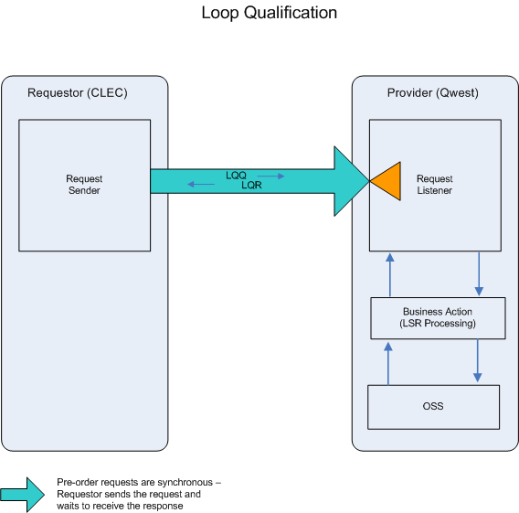

- CLEC submits an 850LQQ.

- If the 850LQQ fails the IMA edits, an 855LQR (BAD) will be returned.

If the 850LQQ passes the IMA edits, the query will be sent to the Operations Support System (OSS). This system will respond with one of two conditions: BAD or GOOD.
- 855LQR (BAD) will be returned when the 850LQQ encounters an error(s) with the OSS.

- An 855LQR (GOOD) will be returned when information regarding the loop qualification queried is retrieved.
  - Loop Qualification Schema

Please see Appendix F – WSDL - Pre-Order.

