Raw Loop Data

Table of Contents

12. RAW LOOP DATA 2
12.1 Business Description 2
12.1.1 Query Type - Response Summary 2
12.2 Business Model 3
12.3 Raw Loop Data Schema 4

12. Please see Appendix F – WSDL - Pre-Order.

RAW LOOP DATA

12.1 12.2
Raw Loop Data

Raw Loop Data enables CLECs the ability to query for and receive information regarding the makeup of a loop in order to determine whether or not a loop is capable of supporting DSL services.

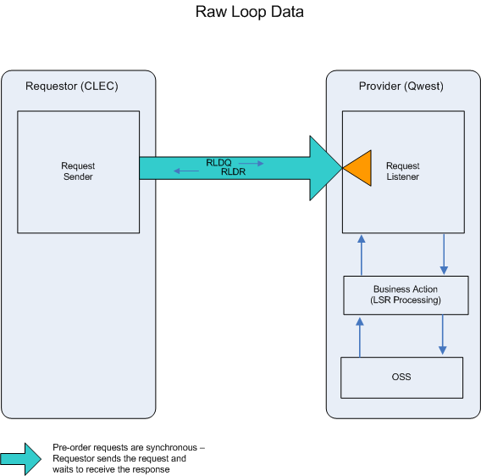

- The CLEC submits a RLDQ by providing either a valid telephone number, ECCKT, or an address that has at least one working telephone number.

- If the RLDQ fails the IMA edits, RLDR (BAD) will be returned.

- If the RLDQ passes the IMA edits, the query will be sent to the Operations Support System (OSS). This system will respond with one of two responses: BAD or GOOD.

- RLDR (BAD) will be returned when the RLDQ encounters an error(s) with the OSS.

- RLDR (GOOD) will be returned with information regarding the makeup of the loop.

12.3 Raw Loop Data Schema

Business Model

Business Description

Query Type - Response Summary
RLDQ | Raw Loop Data Query
1 | RLDQ by TN (TNADDRCKTIND=T) | Good (RESPONSE =G)
2 | RLDQ by TN (TNADDRCKTIND=T) | Bad (RESPONSE = B)
3 | RLDQ by Address (TNADDRCKTIND=A) | Good (RESPONSE =G)
4 | RLDQ by Address (TNADDRCKTIND=A) | Bad (RESPONSE = B)

