Address Validation Transaction Cycle

Table of Contents

2. Address Validation Transaction Cycle 2
2.1 Business Description 2
2.1.1 Query Type - Response Summary 2
2.2 Business Model 3
2.3 Address Validation Schema 5

- Address Validation Transaction Cycle
  - Business Description

    - Query Type - Response Summary

AVQ | Address Validation Query
1 | AVQ by TN (SEARCHTYP=T) & ZIP/CALA | Exact Match (ADRES=A)
2 | AVQ by TN (SEARCHTYP=T) & ZIP/CALA | Multiple Match (ADRES=D)
3 | AVQ by TN (SEARCHTYP=T) & ZIP/CALA | No Match or Error (ADRES=B)
4 | AVQ by Address (SEARCHTYP=A) & ZIP/CALA | Exact Match (ADRES=A)
5 | AVQ by Address (SEARCHTYP=A) & ZIP/CALA | Exact with Supplemental (ADRES=A)
6 | AVQ by Address (SEARCHTYP=A) & ZIP/CALA | Exact Match, SAG-Only (ADRES=A)
7 | AVQ by Address (SEARCHTYP=A) & ZIP/CALA | Near Match (ADRES=C)
8 | AVQ by Address (SEARCHTYP=A) & ZIP/CALA | No Match or Error (ADRES=B)

  - Business Model
Address Validation
Address Validation provides a CLEC with the capability to utilize a known address or telephone number and validate an address at which service can be provisioned for the end user. The Address Validation transaction consists of two activities: Address Validation Query (AVQ) and Address Validation Response (AVR).

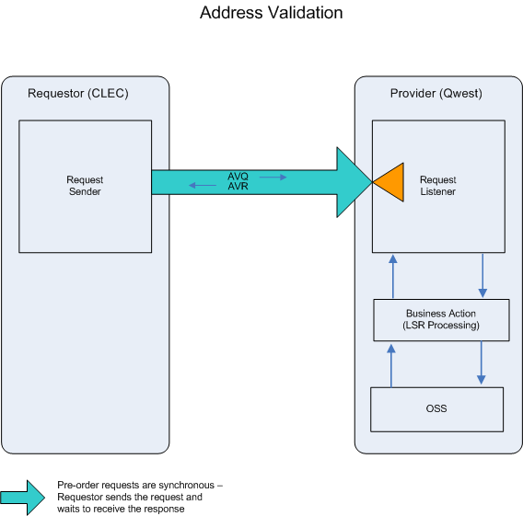

- The CLEC submits an AVQ transaction to validate an address. The CLEC will provide either a telephone number or an address for the attempted match.

- An AVR (BAD) will be returned if:

- the AVQ fails the IMA edits
- no addresses can be returned from the OSS
- the Address Validation query passes the IMA edits but encounters an error in the OSS
The AVR (BAD) will return one or more error messages. If the AVQ passes the IMA edits, the query will be sent to the Operation Support Systems (OSS). The System will respond with one of the following responses: EXACT, MULTIPLE, NEAR, MULT CALA or BAD
- An AVR (EXACT) will be returned when an exact address match to the address or TN used in the AVQ is found.

- An AVR (MULTIPLE) will be returned when multiple addresses are found for a given telephone number used in the AVQ.

- An AVR (NEAR) will be returned when a near match to the address used in the AVQ is found.

- An AVR (MULT CALA) will be returned when multiple CALAs exist for a zip code used in the AVQ address.

  - Address Validation Schema

Please see Appendix F – WSDL - Pre-Order.

