TN/Appointment Cancellation Transaction Cycle

Table of Contents

4. TN/Appointment Cancellation Transaction Cycle 2
4.1 Business Description 2
4.1.1 Query Type - Response Summary 2
4.2 Business Model 3
4.3 Cancellation (TN & Appointment) Schema 5

- TN/Appointment Business Model
Cancellation Transaction
The Cancellation Transaction provides a means for the CLEC to cancel a confirmed appointment or a TN reservation that is no longer needed and to be released for re-use in a timely manner.

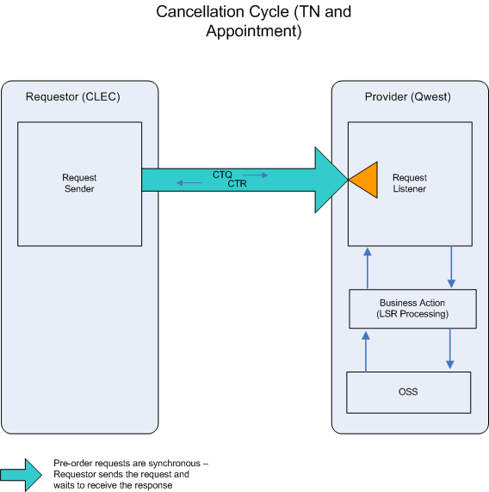

- The CLEC submits a CTQ to cancel a confirmed appointment or TN assignment. To cancel an appointment, the INQRES NBR is required. To cancel a TN reservation, the TN is required.

- If the CTQ fails the IMA edits, CTR (BAD) will be returned.

If the CTQ passes the IMA edits, the query will be sent to the Operations Support System (OSS). This system will respond with one of three conditions: GOOD, BAD, or MIXED.

- CTR (BAD) will be returned when the CTQ encounters an error(s) with the OSS.

- A CTR (GOOD) will be returned when the appointment or the TN reservation has been successfully released.

- A CTR (MIXED) will be returned when at least one TN can be returned, but an error is encountered in the OSS while attempting to return one or more of the other TNs.

  - Cancellation (TN & Appointment) Schema
Please see Appendix F – WSDL – Pre Order.

- Cancellation Transaction Cycle
  - Business Description
    - Query Type - Response Summary

CANCEL | Cancellation Request
 | Select queries depending upon the use of AAQ and/or TNAQ transactions
1 | Cancel a Confirmed Appt (INQTYP=D) | Good (RESPONSE =G)
2 | Cancel a Confirmed Appt (INQTYP=D) | Bad (RESPONSE = B)
1 | Cancel a Confirmed TN (INQTYP=B) | Good (RESPONSE =G)
2 | Cancel a Confirmed TN (INQTYP=B) | Bad (RESPONSE = B)
3 | Cancel a Confirmed TN (INQTYP=B) | Mixed (RESPONSE = M)

