Customer Service Record Transaction Cycle

Table of Contents

6. Customer Service Record Transaction Cycle 2
6.1 Business Description 2
6.1.1 Query Type - Response Summary 2
6.2 Business Model 4
6.3 Customer Service Record Schema 5

6. Customer Service Record Transaction Cycle

6.1 Business Description

Refer to the Centurylink Wholesale Product Catalog - Pre-Ordering Overview
URL: http://www.centurylink.com/wholesale/clecs/preordering.html

6.1.1 Query Type - Response Summary
CSRQ | Customer Service Record Query
 | For Large Accounts, use Partial CSRQ, otherwise use Full/Base Size CSRQ
 | CSRQ by TN for Full CSRs
1 | CSRQ by TN & Address (SERVIND = T), for Full CSR/Base Size (INQACT=A) | Good (RESPONSE =G)
2 | CSRQ by TN & Address (SERVIND = T), for Full CSR/Base Size (INQACT=A) | Bad (RESPONSE = B)
3 | CSRQ by TN & Address (SERVIND = T), for Full CSR/Base Size (INQACT=A) | Mixed Multiple Match (RESPONSE = M, MIXTYP=M)
 | CSRQ by TN for Partial CSRs
1 | CSRQ by TN & Address (SERVIND=T), for [Partial CSR/Base Size OR Larger than Base Size (INQACT=C or D)] | Good (RESPONSE =G)
2 | CSRQ by TN & Address (SERVIND=T), for [Partial CSR/Base Size OR Larger than Base Size (INQACT=C or D)] | Bad (RESPONSE = B)
3 | CSRQ by TN & Address (SERVIND=T), for [Partial CSR/Base Size OR Larger than Base Size (INQACT=C or D)] | Mixed Multiple Match (RESPONSE = M, MIXTYP=M)
4 | CSRQ by TN & Address (SERVIND=T), for [Partial CSR/Base Size OR Larger than Base Size (INQACT=C or D)] | Mixed Incomplete (RESPONSE = M, MIXTYP=I)
 | CSRQ by Non-TN for Full CSRs
1 | CSRQ by Non-TN (ECCKT- ISDN, etc) (SERVIND=N), for FULL/Base Size (INQACT=A) | Good (RESPONSE =G)
2 | CSRQ by Non-TN (ECCKT- ISDN, etc) (SERVIND=N), for FULL/Base Size (INQACT=A) | Bad (RESPONSE = B)
3 | CSRQ by Non-TN (ECCKT- ISDN, etc) (SERVIND=N), for FULL/Base Size (INQACT=A) | Mixed Multiple Match (RESPONSE = M, MIXTYP=M)
 | CSRQ by Non-TN for Partial CSRs
1 | CSRQ by Non-TN (ECCKT- ISDN, etc) (SERVIND=N), for [Partial/Base Size OR Larger than Base Size (INQACT=C OR D) | Good (RESPONSE =G)
2 | CSRQ by Non-TN (ECCKT- ISDN, etc) (SERVIND=N), for [Partial/Base Size OR Larger than Base Size (INQACT=C OR D) | Bad (RESPONSE = B)
3 | CSRQ by Non-TN (ECCKT- ISDN, etc) (SERVIND=N), for [Partial/Base Size OR Larger than Base Size (INQACT=C OR D) | Mixed Multiple Match (RESPONSE = M, MIXTYP=M)
4 | CSRQ by Non-TN (ECCKT- ISDN, etc) (SERVIND=N), for [Partial/Base Size OR Larger than Base Size (INQACT=C OR D) | Mixed Incomplete (RESPONSE = M, MIXTYP=I)

  - Business Model
Customer Service Record

Customer Service Record provides CLEC the ability to query for and receive information regarding the listing, billing and services related information associated with an account number.

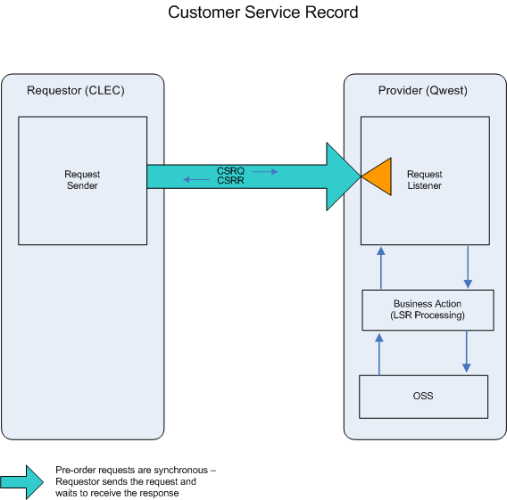

- CLEC submits a CSRQ by providing an account number, a telephone number, or an ECCKT.

- If the CSRQ fails the IMA edits, CSRR (BAD) will be returned.

If the CSRQ passes the IMA edits, the query will be sent to the Operations Support System (OSS). This system will respond with one of three conditions: BAD, MULTIPLE or EXACT.

- CSRR (BAD) will be returned when the CSRQ encounters any error(s) with the OSS.

- A CSRR (MULTIPLE) will be returned when more than one CSR exists for the requested telephone number or ECCKT. A new CSRQ can be submitted to resolve the multiple match situations.

- A CSRR (EXACT), including listing, billing, and Service/Equipment sections (S&E), will be returned when the CSR is found in the legacy systems.
  - Customer Service Record Schema
Please see Appendix F – WSDL – Pre-Order.

