Telephone Number (TN) Reservation Transaction Cycle

Table of Contents

14. Telephone Number (TN) Reservation Transaction Cycle 2
14.1 Business Description 2
14.1.1 Query Type - Response Summary 2
14.2 Business Model 3
14.3 TN Reservation Cycle Schema 5

- Telephone Number (TN) Reservation Transaction Cycle
  - Business Description

Query Type - Response Summary
  - Business Model
TN Availability

TN Reservation provides CLECs with the capability to identify one or more telephone numbers as available and to reserve them. In the TN Availability Query (TNAQ) activity, the CLEC may request up to 9 numbers based on a validated address and other information obtained from the Address Validation transaction. After the CLEC submits the TNAQ, they will receive a TN Availability Response (TNAR) with pre-reserved TN(s). The CLEC is not required to submit a TN Select Query (TNSQ) to use the pre-reserved TN(s).

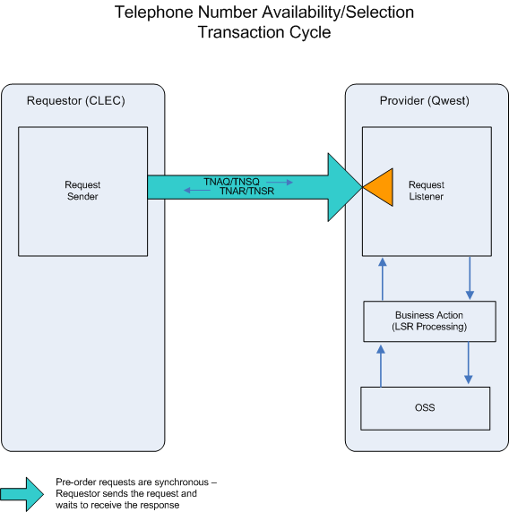

TN Availability

- The CLEC submits a TNAQ to request up to 9 numbers.
- If the TNAQ fails the IMA edits, a TNAR (BAD) will be returned.

- If the TNAQ passes the IMA edits, the query will be sent to the TN Administration System. The System will respond with one of three conditions: MIXED, GOOD, or BAD.

- A TNAR (MIXED) will be returned when the total number of TN’s requested cannot be returned. The TNAR (MIXED) will return as many TN’s as possible, accompanied with error messages. The TN’s returned will be reserved for 30 calendar days. The CLEC must submit an LSR with the reserved TN’s within a pre-determined time frame (e.g., 30 calendar days) from the TN Availability Transaction or the reservation will be canceled by CENTURYLINK. The CLEC may also initiate a CTQ, Cancellation Query Transaction, to cancel the TN reservations.

- A TNAR (GOOD) will be returned when the total number of TN’s requested are available. These TN’s will be reserved in the TN Administration System for a configurable amount of time, currently set to 30 calendar days. To avoid tying up TN resources, the CLEC must submit an LSR with the reserved TN’s within a pre-determined time frame (e.g., 30 calendar days) from the TN Availability Transaction or the reservation will be canceled by CENTURYLINK. The CLEC may also initiate an CTQ, Cancellation Query Transaction, to cancel the TN reservations.

- An TNAR (BAD) will be returned if no TN’s can be returned or the TN availability query encounters an error in the TN Administration System. The TNAR (BAD) will return one or more error messages.
TN Selection

- After receiving a TNAR (GOOD) or a TNAR (MIXED), TNSQ is required if the CLEC wants different TN(s) than the one(s) pre-reserved in TNAR. If the CLEC submits a TNSQ for a PON, all pre-reserved TNs from initial reservation are returned to the reservation system. The CLEC must request all new TNs within the TNSQ, and can not include any TNs provided in the original TNAR. To avoid tying up TN resources, the CLEC must submit an LSR with the reserved TN’s within 30 calendar days or the TNs reserved will be returned to Centurylink. This Selection query is not required since the TNs returned in the TNAR (GOOD) or an TNAR (MIXED), are in selected status in the TN Administration System

- If the TNSQ fails the IMA edits, a TNSR (BAD) will be returned. If the TNSQ passes the IMA edits, the query will be sent to the TN Administration System. This system will respond with one of the two conditions: BAD or GOOD.

- A TNSR (BAD) will be returned when the TN Selection Query encounters an error in the TN Administration System. For example, after a TNAR (GOOD) has been returned to the CLEC and 30 days has elapsed, CENTURYLINK will cancel the TN reservation in the TN Administration System. After that, if a TNSQ is received for those previously reserved TN’s, a TNSR (BAD) will be returned.
- When a TNSR (GOOD) is returned: To avoid tying up TN resources, the CLEC must submit an LSR with the reserved TN’s within a pre-determined time frame (e.g., 30 calendar days) from the TN Selection Transaction or the reservation will be canceled by CENTURYLINK. The CLEC may also initiate a CTQ, Cancellation Query Transaction, to cancel the TN reservations.
- A TNSR (MIXED) will be returned when the TN Selection Query is successful with reserving at least one TN, but encounters an error in the TN Administration System while attempting to reserve one or more of the other TN’s
  - TN Reservation Cycle Schema
Please see Appendix F – WSDL - Pre-Order.

TNAQ | Telephone Number Availability Query
1 | TNAQ for POTS Service by SITEID, TTA & Address, ZIP/CALA | Good (RESPONSE =G)
2 | TNAQ for POTS Service by SITEID, TTA & Address, ZIP/CALA | Bad (RESPONSE = B)
3 | TNAQ for POTS Service by SITEID, TTA & Address, ZIP/CALA | Mixed (RESPONSE = M)

TNSQ | Telephone Number Selection Query
1 | TNSQ for POTS Service by SITEID, TTA & Address, ZIP/CALA | Good (RESPONSE =G)
2 | TNSQ for POTS Service by SITEID, TTA & Address, ZIP/CALA | Bad (RESPONSE = B)
3 | TNSQ for POTS Service by SITEID, TTA & Address, ZIP/CALA | Mixed (RESPONSE = M)

