CLEC QPP Results Report
AND PAYMENT CALCULATIONS

Requirements to access the report
- Internet Explorer 4.0 – 5.x OR Netscape 4.5.1 - 4.7 browser (Netscape 6 is not supported)
- Access Authorization
- Adobe Acrobat 4.0 (or better)

Certification to Access the Report
Users will need to gain Access Authorization with access to Qwest Protected Internet Delivery (QPID) by contacting their Service Manager.
If you currently have QPID access, you will need to verify that access includes the report posting site. The Access Authorization form is located at: http://www.qwest.com/wholesale/clecs/electronicaccess.html
Click on the MS Excel Downloads: “ECR Access Requests” and complete the form.
If you do not have Qwest access, please visit the following URL for Access Authorization Requirements and ordering instructions: http://www.qwest.com/wholesale/systems/generalinfo.html. Click on “View information about Access to Qwest’s Systems” and follow the instructions listed.

Additional Help with ECR application
All questions regarding content on the ECR site should be directed to the CLEC’s service manager. Users who have questions regarding the “availability” of the site or who wish to report trouble with the site can contact the Wholesale Systems Help Desk at 888-796-9102.

QPP Reports
QPP Reports are found at the same location as the Performance Results and Payment Calculations.

Accessing the Report
Users can access individual CLEC reports by going to the following url and logging into the QPID system:
- https://qpid01.qwest.com/cgi-bin/index.exe

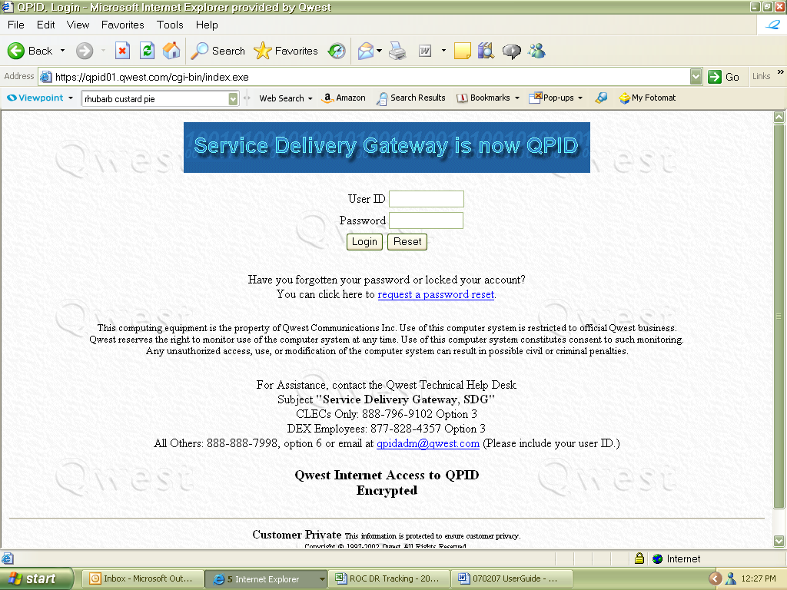

CLEC Name
Each individual login in is associated to the reports to which access is authorized for that login. Reports will be aligned by current and previous reporting months in alphabetical order.
You must be authorized to view these pages. If you see a page that says "not found", or have other problems accessing the reports, please contact your service manager.
The file will be named 271_Exhibit_QPP_RSID_MMYY(14_State_PID) and is in a CSV format.

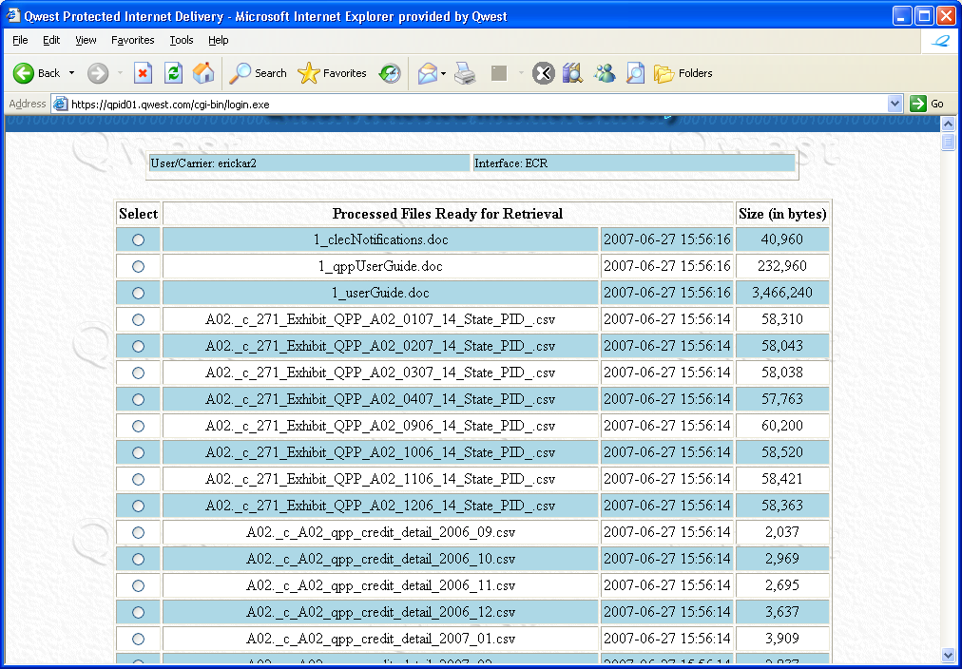

Understanding the Report
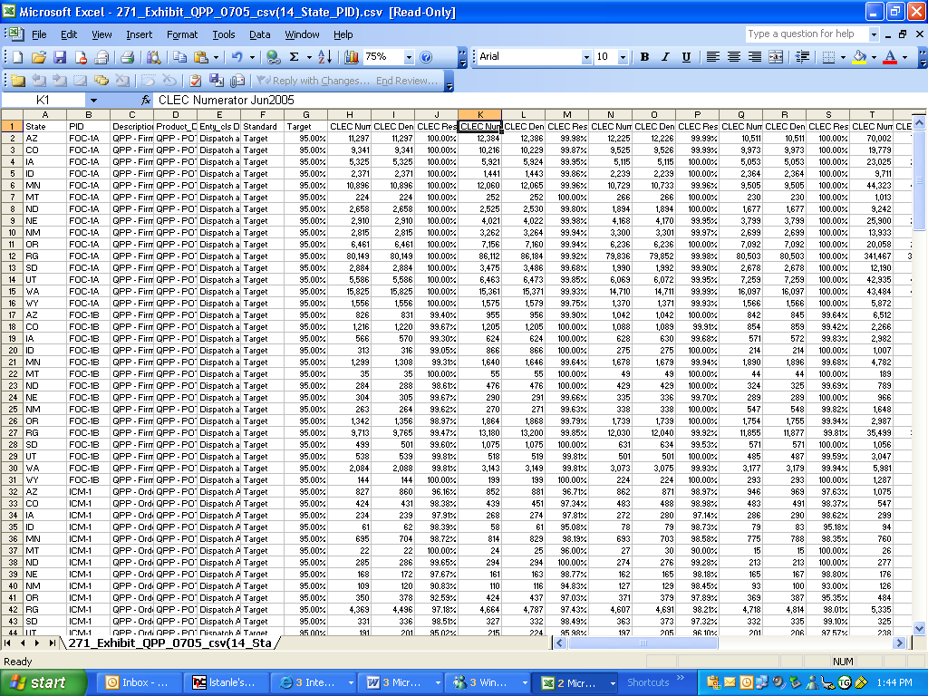

Column Headings for QPP files
Column Name | Column Description
State | State
PID | QPP Measure
Description | Description of the QPP Measure
Product_Description | Product Description
Enty_cls Dispatch | Dispatch and Location Information
Standard | Type of Measurement (Target or Diagnostic for QPP)
Target | Target Level of Performance the CLEC Result should meet
CLEC Numerator MONYY | The quantity meeting the criteria described in the measurement indicator definition for the numerator of the formula for the measurement, dealing with services Qwest provides to CLECs for that MONYY.
CLEC Denominator MONYY | The quantity meeting the criteria described in the measurement indicator definition for the denominator of the formula for the measurement, dealing with services Qwest provides to CLECs for that MONYY.
CLEC Result MONYY | The outcome of executing the formula calculation defined in the measurement indicator definition to represent the specified dimension of service performance provided to CLEC(s) for that MONYY.

Printing/Saving the Report
Print as a normal Excel file by clicking on the printer icon or selecting 'Print' from the 'File' drop down menu.
You may also choose to save the report to a different drive. Select 'Save As' from the 'File' drop down menu. Select the drive you wish to save the report to, name it, and select 'OK'.
Each report will be available until the next cycle replaces it; for example, Feb 05 replaces Jan 05.

QPP Payment Reports and Calculations

QPP Payment Reports are available in the same location as the QPP performance reports (in the CLEC Name directory, in the same section where the state folders are listed). There are 2 QPP Payment reports available to CLECs who’ve opted into QPP:

RSID_qpp_credit_summary_YYYY_MM.csv and

RSID_qpp_credit_detail_YYYY_MM.csv.

Both files are in CSV format and will open in Excel.

Calculation of Payment
If a QPP order has missed the commitment date, the order is examined to see if it contains any of the following USOCs: NHCRA, NHCRC, NHCUU, URCCU, and/or URCCY. If any of these USOCs exist on the order, the amount for the USOC is attached to the order in the column labeled with the USOC. Each USOC has a specified nonrecurring charge associated with it based on the state the order is in. That amount is the amount entered into the column with the USOC label and used for reporting and making payments to the CLECs.

Column Headings for QPP Credit Summary Files
Column Name | Column Description
State | State
CLEC | CLEC RSID/ZCID
CLEC Name | CLEC Name
Booking Month | Month the payment is made
Current Payment | The sum of the nonrecurring charges for all orders missing the ICM1 measure.
Data Month | Month the orders are reported for
Prior Payment | If QPP data were rerun and any payment had been given previously, the previously paid amount.
Total Payment | Sum of Current Payment and Prior Payment

Column Headings for QPP Credit Detail Files
Column Name | Column Description
State | State
CLEC | CLEC RSID/ZCID
CLEC Name | CLEC Name
Booking Month | Month the payment is made
Order Number | Order Number - This is the order which missed the commitment per ICM1
Main Phone Number | Main Telephone Number on the Order
COS | Class of Service USOC on the order
Completion Date | Completion date of the order
NHCRA | Amount of Nonrecurring charge associated with this USOC for this order (This usoc is used for nonrecurring charge associated with unbundled network elements - Primary Line)
NHCRC | Amount of Nonrecurring charge associated with this USOC for this order (This usoc is used for nonrecurring charge associated with unbundled network elements - Additional Line)
NHCUU | Amount of Nonrecurring charge associated with this USOC for this order (This usoc is used for nonrecurring charge associated with unbundled network elements - Subsequent Order Processing Charge)
NHCVQ | Amount of Nonrecurring charge associated with this USOC for this order (This usoc is used for nonrecurring charge associated with unbundled network elements - Feature Change Charge)
URCCU | Amount of Nonrecurring charge associated with this USOC for this order (This usoc is used for nonrecurring charge associated with unbundled network elements - Primary Line Conversion Charge)
URCCY | Amount of Nonrecurring charge associated with this USOC for this order (This usoc is used for nonrecurring charge associated with unbundled network elements - Additional Line Conversion Charge)
Current Payment | Sum of the NHCRA, NHCRC, NHCUU, URCCU, URCCY Amounts
Data Month | Month the orders are reported for
Prior Payment | If QPP data were rerun and any payment had been given previously, the previously paid amount.
Total Payment | Sum of Current Payment and Prior Payment

Printing/Saving the Report
Print as a normal Excel file by clicking on the printer icon or selecting 'Print' from the 'File' drop down menu.
You may also choose to save the report to a different drive. Select 'Save As' from the 'File' drop down menu. Select the drive you wish to save the report to, name it, and select 'OK'.
.

