Listing Discrepancy Form

The Listing Discrepancy Form is provided as a means for Directory Assistance (DA) Providers purchasing CenturyLink’s Directory Assistance List (DAL) product to report any discrepancies in the listing information contained in the DAL file.

The following information provides a description of the information contained in the Listing Discrepancy Form, and which fields must be completed for CenturyLink to have sufficient information to perform an investigation. Any fields identified as Optional, need only be populated if the discrepancy is related to that portion of the subscriber’s DA record:

Field Name |  | Description |  | Data Requirement
Inquiry Date |  | The date the Listing Discrepancy Form is submitted to CenturyLink in MM/DD/YYYY format |  | Required information
Bus/Res/Govt |  | Indicates the class of service [as it appeared on the DA List file]  B = Business  R = Residence  G = Government |  | Optional information
Telephone Number |  | 10-Digit telephone number for the listing in question. Area code is required (as it appeared on the DA List file) |  | Required information
Listed Name |  | Subscriber Name (as it appeared on the DA List file) |  | Required information
Listed Address |  | House Number, Street Name and Zip Code (as it appeared on the DA List file) |  | Optional information
City |  | City associated with the Listed Address (as it appeared on the DA List file) |  | Optional information
State |  | Two-character abbreviation for the state (i.e., AZ, CO, IA, ID, MN, MT, ND, NE, NM, OR, SD, UT, WA, WY) |  | Required information
Discrepancy |  | Description of the discrepancy with as much detail as necessary |  | Required information
CenturyLink Response |  | To be completed by CenturyLink  Response will include as much detail as necessary to respond to the inquiry, including effective dates of any corrective orders required. |  | To be completed by CenturyLink
Response Date |  | To be completed by CenturyLink  CenturyLink will note the date that the response is returned to the DA Provider in MM/DD/YYYY format |  | To be completed by CenturyLink

A sample of a completed form can be found on page 2.

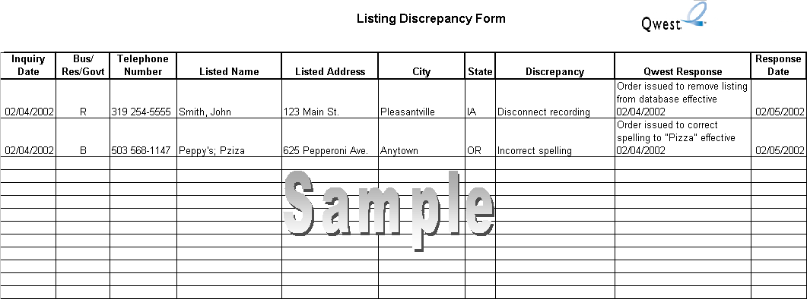
Inquiry  Date | Bus/  Res/Govt | Telephone  Number | Listed Name | Listed Address | City | State | Discrepancy | CenturyLink Response | Response  Date

