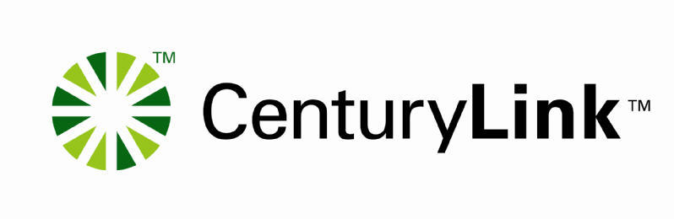
Tuesday, February 8, 2005
Customer Company Name
Dear Customer,
This letter summarizes activity on the following dispute:
Main Billing Account Number: 000 000-0000 000
Bill Date: 2/1/2005
Customer Claim Number:
CenturyLink ID #: 20283
Amount in Dispute: $100.00
Below are the details related to the resolution of this dispute.
ID | Type | Status | Amt | Items | Resolved  QWEST | Resolved  Cust | Credit Dates | Amt Adj | Resolved | ST/Cost Docket,  Tariff, SGAT/Contract/  Service Order
1 | Rates-NRC-Service Issue | Resolved | $50.00 | 5 | $50.00 | $0.00 | - | $0.00 | 2/8/05 | Per Tariff Section 10.2.1 rate is correct
2 | Rates-MRC-USOC | Resolved | $50.00 | 5 | $0.00 | $50.00 | 1/4/2005 - 1/7/2005 | $50.00 | 2/8/05
Item Totals |  |  | $100.00 | 10 | $50.00 | $50.00 |  | $50.00
ID #1 - Resolved in CenturyLink Favor. The rates billed are correct per the tariff.
ID #2 - Resolved in Customer Favor.
Credits should appear within two billing cycles.
Resolved items will remain closed unless further disputes related to this item are submitted to CenturyLink in writing.
Thank you,
Wholesale Billing Service Billing Department
CenturyLink Wholesale Billing Department
303 000-0000

