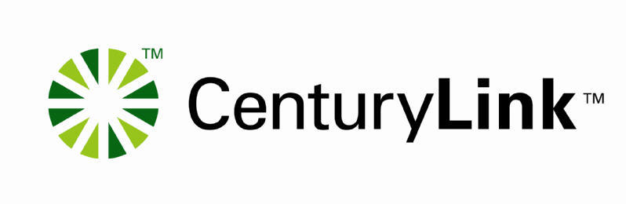

INTEREXCHANGE CARRIER

OPERATOR SERVICES / DIRECTORY ASSISTANCE

DISCONNECT REQUEST

CONFIDENTIAL

The information contained herein is confidential and should not be disclosed to unauthorized persons.

Intended for use by authorized representatives of CenturyLink.

OPERATOR SERVICES (OS) /DIRECTORY ASSISTANCE (DA)

Instructions for Disconnect Request Completion

Enter the requested information, and then send the completed disconnect request, via email, to your CenturyLink Service Manager with “OS/DA Disconnect Request” in the subject line.

TODAYS DATE: ___________ DISCONNECT REQUEST DATE: ____________

Please indicate which service/s you are requesting disconnection of:

DIRECTORY ASSISTANCE- Regional/Local _____ National _____ International _____

OPERATOR SERVICES _______ BUSY LINE VERIFY/INTERRUPT ______

GENERAL

1. Customer Name

Registered Account Office (RAO) _________

Carrier Identification Code (CIC): ________ State: _________

CenturyLink Account Manager: ___________________________________________________________

Telephone Number: ________________________ Fax Number: _________________________________

- Customer Contact

Name: ________________________________________________________________________________________

Telephone Number: ________________________ Fax Number: _________________________________

Address: _________________________________ City: __________________ State_______ Zip: _____

PLEASE LIST THE SERVING AREA IN WHICH YOU CURRENTLY HAVE THIS SERVICE THAT YOU WOULD LIKE TO HAVE DISCONNECTED:

OPERATOR SERVICES

DOMESTIC

LATA# ____________________ TO and FROM trunk group CILLI __________________

Provide all trunk groups you will be disconnecting:
Trunk group | To CLLI | From CLLI

INTERNATIONAL

Country ___________________ Country Code _______________________

DIRECTORY ASSISTANCE

Provide all trunk groups you will be disconnecting:
Trunk group | To CLLI | From CLLI

INTERNATIONAL

Provide the 700 or 800 number that your end-user must dial to access this service __________________

