Wholesale Walled Garden Support Documentation
General Information

This documentation is an addendum to the existing process documentation for: Wholesale Support Boundaries
It is specific to “Walled Garden” support and customer explanation.
Reminder regarding Standard Wholesale Scope of Support
For walled garden issues, CenturyLink Tier 1 agents should work with the Wholesale Agent directly without talking to the end user. If the end user calls in to CenturyLink directly, CenturyLink agents will refer the end user to their wholesaler who should provide the end user with the specifics about the “walled garden” and any remediation requirements.
WHOLESALE SUPPORT: in this process, where the process states “Customer” insert “Wholesale Agent”. Tier 1 and Tier 1.5 should refer any end users to their “Wholesale” provider for support. Do not remove the “end user” from the locked “Walled Garden"

Overview CenturyLink Managed Security Services – CIPP Customer Internet Protection Program: The CenturyLink Customer Internet Protection Program (CIPP, aka Walled Garden) is part of CenturyLink's ongoing commitment to Internet security. It is a notification tool to help customers remove viruses and malware from their computers and it educates customers and small businesses on good Internet security practices. It is also a resource to provide customers with downloadable or online anti-virus software. Once customers' computers are disinfected, they're back online in minutes. In addition, CenturyLink allows customers to immediately exit the CIPP system (a process which takes one to three minutes) if they are not a persistent, repeat offender. CenturyLink does not "lock" normal customers into the CIPP system and we do not block all network traffic, only Web and outbound mail traffic.
Current “Walled Gardens” used by CenturyLink Managed Security Services – Abuse include:
Malware Walled Garden (also used for AUP violations)
DMCA Enforcement
Excessive Use Policy (EUP) Walled Garden

CenturyLink Tier 1 agents must follow specific support requirements when addressing customers in each of these “Walled Garden” instances. CenturyLink Tier 1 agents will work with the Wholesale Agent in properly identifying the end user’s “walled garden” reason and provide the Wholesale Agent with necessary remediation resources, suggestions, and supporting documentation as required.

Internet Security - CenturyLink Managed Security Services
There are a variety of situations where a customer could be affected by internet security problems such as phishing scams, DoS attacks and wireless hijacking. This document is intended to help support agent identify the problem, take steps to help the customer and/or refer them to the most appropriate avenue for resolving the issue.
If the customer is reporting one of the following reasons, have the customer send an email to the appropriate email address. Refer to abuse@centurylinkservices.net.
  - Spam/bulk email/unauthorized mail relay sent from a qwest.net/ceturylink.net address - Include in the email the IP address the spam is coming from by forwarding the email and its header. Attachments will be dropped so please advise customer to send all information in the body of the message. Remind the customer to delete the email after they have forwarded appropriately.
  - Reports that a qwest.net /centurylink.net, CenturyLink HSI customer is spreading a virus, trojan, violated AUP (Acceptable Use Policy), etc. - Include in the email as much detail as possible, including the IP address, email header or other supporting information. Attachments will be dropped so please advise customer to send all information in the body of the message.
Malware "Walled Garden" Support:
CenturyLink Managed Services and Internet Security will notify customers via email (if possible) when the CenturyLink servers detect a virus, trojan, etc. is being spread via that customer's qwest.net/centurylink.net account (PPP User name account).
When the customer tries to surf the internet, they are redirected to the “Malware Walled Garden”. A specific Malware message will inform the customer about the issue and that they need to resolve the problem/issue before they can surf the web. The customer must take action to assure they resolve the issue. If the customer does not take action, the malware will continue to originate from their network, and their account will eventually be locked. Support agents should assist the customer with recommendations for removing Malware/Virus and updating PC Desktop Security when applicable.
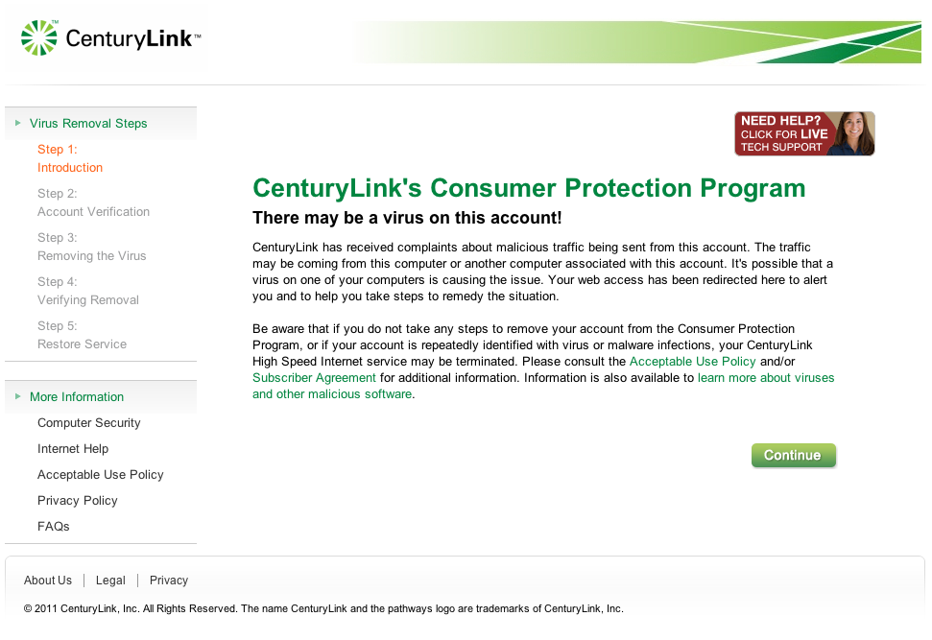

Security - DMCA Violations
DMCA - DEFINITION: Under the Digital Millennium Copyright Act, service providers like CenturyLink are required to establish and enforce a policy that provides for the termination in appropriate circumstances of subscribers who are repeat copyright infringers and to enforce a notification/take down process (as described more specifically in the Act) for content hosted on a Service Provider’s network.
When a copyright owner believes in good faith that its copyright has been infringed by one of CenturyLink's customers, the owner may (and often does) send CenturyLink a DMCA copyright violation notice that gives information about the alleged violation. The majority of DMCA copyright complaints we receive are in connection with our high speed internet customers and relate to P2P file sharing. These kinds of notices are taken into account in determining whether a customer is a “repeat offender”. NOTE: At any point in the DMCA violation process, if a customer has concerns or complaints about the claim(s) CenturyLink has received, they may be directed to contact the Copyright Agent (or Owner) listed in the email and contact information.

The DMCA violation notices received by the majority of these customers are because of "repeat infringements". That is, we have received several notices of copyright infringements from the Copyright Agent.
“Wholesale” end users are subject to the same notification process as other CenturyLink HSI subscribers, to include potential temporary or permanent deactivation, or other account limitations. When an account has been temporarily deactivated,

Wholesale Support: In the event the DMCA violation is identified as a “Wholesale” end user, CenturyLink support agents will email the violation information to the “Wholesale” provider, prior to releasing the user from the walled garden. The Wholesale agent will be required to provide the CenturyLink agent a valid email address.
It will be the Wholesale provider’s responsibility to notify the end user of the notification and enforcement, ensuring the end user understands their obligations for compliance..The DMCA notification emails that are sent to the customer contain the following information about the DMCA Violation:
- Copy of the letter from the Complainant
- Title/s in question
- Protocol used to download the title/s
- File Name and location of the material
- Time/Date stamp of content referenced
Please note that, if copyright violations are continually reported to CenturyLink for any one user, that subscriber’s HSI service may be subject to permanent deactivation. Notifications for prior offenses will have been received and addressed between CenturyLink and the Wholesale Account support teams prior to this time. For this reason, it is important for Wholesale Account teams to develop processes and procedures to immediately address copyright reports with their end users, and work with the end user to eliminate opportunities which may result in future violations.

General Information: EUP - Excessive Usage Policy

The majority of CenturyLink High-Speed Internet HSI customers make great use of their high-speed service and comply with the CenturyLink High-Speed Internet Service Agreement. An extremely small percentage use CenturyLink High-Speed Internet excessively, or at such extreme high volumes, that they violate the terms of their CenturyLink High-Speed Internet Subscriber Agreement. While this high volume use is very rare, CenturyLink makes it a point to talk to these customers and help them find a high-speed internet solution to better meet their needs.

This Excessive Use Policy (EUP) enforcement process will continue to use the "EUP Walled Garden" primarily on the Legacy Qwest region. For the Legacy CenturyLink region, EUP will be enforced with existing processes until a EUP Walled Garden is available.
Highlighted updates include the following "bulleted" changes:
- Policy will now provide download usage "Limits" based on customer purchased HSI speed (See Usage Limits below)
- Policy applies to Residential HSI customers and is only enforced in the "downstream" (from internet to customer) direction
- Business Class lines are exempt from the download "limits" but will still be subject to EUP policy compliance and future updates
- Not all CenturyLink regions have metering capabilities but the EUP policy will be enforced as required manually for all CenturyLink regions
- All customers should have 30 calendar days between their notifications. The enforcement will be applied via a 3 stage process for compliance notifications/walled garden message to disconnection notice within 12 month period
- CenturyLink PRISM video traffic is not included in the limit
- There are no overage charges or metering fees for usage as part of the Policy
EUP - Excessive Usage Policy Call Handling

General Information: EUP - Excessive Usage Policy

General EUP Support:
HSI Tier 1 support agents will provide support for calls regarding the EUP Notification and Walled Garden messaging. Support will include handling inquiries for general customer education including support references at ctlhelp.com FAQ, customer usage amounts from support tools, applicable customer options for HSI speed upgrades or business class changes if available or appropriate, escalations to CenturyLink Managed Services as necessary. Agents will also use the "Talking Points" documentation to satisfy customer inquiries and support issues.

Customer Support References:
EUP – www.ctlhelp.com (Link to http://qwest.centurylink.com/internethelp/eup.html)
EUP HSI "Talking Points" (Link to http://qwest.centurylink.com/internethelp/eup.html

Customer Usage Information:
If a customer contacts support to inquire about their current usage, Tier 1 will be able to use the Usage Validation tool or "chat" to Tier 1.5 to obtain the customer specifics. That detail information can then be shared back to the customer. Tier 1 will have visibility for the walled garden insertion data. If the customer needs historical download information, Tier 1 will need to chat to Tier 1.5.

We will receive the last 3 months of usage information available from our tools.
Note: We do not have a customer facing tool available at this time but one is planned for a future release.
Usage Limits per calendar month:
- Customers purchasing service at speeds of 1.5Mbps and below, have a usage limit of 150 Gigabytes (GB) of download volume per month.
- Customers purchasing service at speeds greater than 1.5Mbps, have a limit of 250 Gigabytes (GB) of download volume per month.
CenturyLink may evaluate variables such as network health, congestion availability of customer usage data, and the line speed purchased by the customer as factors when enforcing this policy. Our Excessive Use Policy is application neutral. It only looks at the total usage (bytes transferred) over a defined period of time independent of protocols, applications, or the content that is generating the excessive usage. Note: Not all customers will be enforced for EUP at the same time and the Managed Services Group is responsible for determining who is being EUP "enforced".

Customer Scenarios for "Support":
There will be 2 types of customer calls received for EUP support. HSI Tier 1 agents could receive EUP calls through normal Phone, Chat or the Email option available from ctlhelp.com.
- Scenario 1 : Customer with General Q/A about the EUP, and are not being impacted by EUP enforcement….curious about what does it mean for them. What usage they may be using, etc.
- Scenario 2 : Customer who received a letter and/or “walled garden” experience now or in the past for EUP notice and needs support, instruction or escalation.
Support for Customer Scenario 1:
- Providing general information, customer education and Q/A regarding the policy update.
- Explaining EUP Limit Enforcement policy update
- Providing customer recommendations to upgrade speed where available/applicable or offering upgrade to Business class HSI to be excluded from EUP Limit policy.
- Providing “upon customer request” actual usage via Chat to Tier 1.5 to help guide customer through support questions and possible impacts around EUP enforcement.
- Understanding the CenturyLink policy on EUP “limit” and what the levels set are based on for downloads. Provide general customer education on the FAQs and resource information found on ctlhelp.com.
It is the Wholesale provider’s responsibility to understand and educate their end user regarding the proper usage of the service, and/or provide solutions better fit to meet the customer needs, including a speed upgrade or account change to Business class
Support for Customer Scenario 2:
- Same level of detail as provided to customer Scenario 1
- Assistance with “Walled Garden” failures if the customer is unable to remove themselves from the walled garden
- Support regarding the “letter” notification as provided by CenturyLink EUP enforcement occurs
- Providing assistance with the policy for future prevention of EUP Limit enforcement. i.e. offer options when available to upgrade speed or business class offering.**See Note Below**
- Escalation will only be available per guidelines.
Customers could be offered Stand alone HSI, Res to Bus POTs w/HSI, or multiple HSI lines when applicable or available.

EUP Notification Process

Those customers that are found to have exceeded these limits may receive up to 3 notifications from CenturyLink, via web message (Walled Garden), email or phone call and should be informed of alternatives to consider in order to maintain their Residential HSI service.
For the majority of notifications, the customer is taken to the CenturyLink Walled Garden when they try to access the internet. They will be required to acknowledge that they understand the EUP prior to having their internet service restored. If after the third warning letter, the customer still does not comply with the EUP; their account with CenturyLink will be terminated.
Remember in "Walled Garden" experience, it is not a locked instance and anyone using the customer's HSI service can remove the account from the Walled Garden Notice. The Stage 3 Walled Garden is a "locked" instance.

The Stages for enforcement are as follows:
Stage 1 = First "Walled Garden" message after the 1st month of data where usage limit was exceeded
Stage 2 = Second "Walled Garden" message after the 2nd time usage limit was exceeded
Stage 3 = Third notification via mail delivery to the wholesale provider advising "Disconnection" notice for usage limit being exceeded, in addition to Locked Walled Garden messaging.
Customers who are in the Stage 3 will only have recourse to escalate or be escalated to security.
Customers in the Stage 3 Disconnection would need to upgrade HSI speeds (if eligible) or re-grade to Business class HSI. Under escalation circumstances Tier 1.5 may be able to reset the Stage one time and then all other requests will need to be submitted to Managed Security Services.

Q) How will agents know the number of times the customer has been notified on EUP violation? Which “step” the customer is currently on?
A) The actual "stage" of notification will be available in 2012 when more data will be available and the tools updated. Tier 1.5 will be able to request this information from Security upon request.

Process Sample Letter of Disconnect Notice ( Link to Sample Letter of Disconnect)
Managed Security Services - Abuse (MSS Abuse) will change customer's host to DISCONNECT PERM/EUP, effectively disabling the customer's account. (Like a temp deny status).
MSS - Abuse will notify the RMSC, requesting the HSI service be disconnected in 5 Business days. Prior to disconnect, the RMSC support will follow normal business rules:
- Check to confirm that the customer's account has not been re-graded to a business class of service
- Confirm usage data over 150Gig/250Gig - Disconnect
- Check to confirm the customer's account has not had its speed upgraded with the following conditions: 1.5 MB or less and upgraded to 3 MB or greater
If any of these conditions have been met, RMSC will contact MSS-Abuse to notify them that the customer has not been disconnected. MSS-Abuse will reset the customer's stage if they upgraded speed, will be removed from the process if re-grade to business.

- Call Handling FAQ's

- What will the customer see when they try to connect to the internet:
  - They will be taken to the CenturyLink Walled Garden where they MUST acknowledge that they understand the CenturyLink EUP.
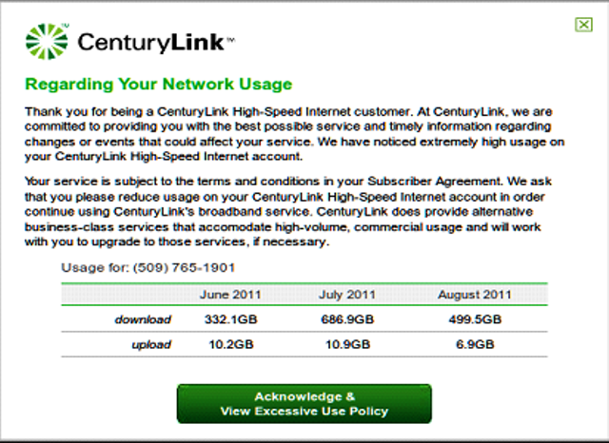

- How does the customer restore their service?
  - The customer should complete the steps laid out "after" they click the Acknowledge & View button on the web page. In most cases, completing all three steps will automatically restore full Internet access. Examples of step 1 and 2 are shown below:
- What if the customer cannot access the internet after stepping through the acknowledgement?
  - If the customer has trouble accessing web pages on the Internet after completing Step 3, they should turn off their DSL modem and exit their browser.
  - After waiting five minutes, they should turn on their modem to restore unrestricted Internet access.
  - If the customer is still unable to get out of the Walled Garden, please contact Tier 1.5 for further assistance.
  - Other issues or questions should be referred to Managed Services via Tier 1.5.
- What if the customer has general questions about the CenturyLink EUP? FAQ's about the EUP can be found at:
  - EUP FAQ's on ctlhelp.com ( link to http://qwest.centurylink.com/internethelp/)
- What are the hours or operation for the CenturyLink Managed Services?
  - Mon-Fri 7AM to 5PM Mountain Time, excluding company holidays.
  - CenturyLink Managed Services is not available to work escalations except during these business hours.
- What information do I need to provide when I need to escalate the customer to CenturyLink Managed Services?
  - Customer's Name, BTN and WTN
- Is there an escalation process if we get a call after the CenturyLink Managed Services hours or on weekends?
  - No. Tier 1/1.5 may need to take a call back request for the customer on escalation requests. To help alleviate the possibility of a call on the weekends, no customers will be taken down on Fridays.
Additional FAQ's:

- How frequently will CenturyLink Managed Services review customer usage to determine if there are customers that are exceeding the CenturyLink Services EUP?
  - Each month, CenturyLink Managed Services Security will review the usage of its customers and determine the number of times the customer will be notified. 4 times in a 12 month rolling calendar, will put the account at risk of disconnection.
- How many customers will be put into the Walled Garden in each round of EUP review?
  - The number of customers placed into the walled garden and EUP notification process will vary depending on the variables listed in the EUP usage policy. There is no pre-determined amount of customers being placed into enforced policy enforcement.
- What do the letters look like that the customers will receive?
  - EUP Walled Garden First Notice
  - EUP Walled Garden Second Notice
  - EUP Third/Final Notice - Postal Mail – See Sample Disconnect Letter provided above.

Other Walled Garden Scenarios:
Temporary Disconnection for Non-Payment is available with CenturyLink Broadband Service . When you request deny/restoral of any voice services with CenturyLink Broadband Service, both the voice and the broadband service will be denied/restored. For additional information, refer to the CenturyLink Temporary Disconnection For Non-Payment/Restore PCAT.( Link to http://www.centurylink.com/wholesale/pcat/tdnpr.html)
The Wholesale provider will control the Temporary Disconnection through submission of an LSR. This is a service order process and may require up to 24 hours to restore service that has been temporarily disconnected.

