

Windows 7 Certificate Download Instructions
for
CenturyLink OneStep Client Certificates

Contents
Revision History 3
Purpose 4
Introduction 4
Assumptions 4
Detailed Instructions – IE Security Settings 4
Installing CenturyLink’s Root Certificate 10
Installing the CenturyLink Client Certificate 16
Verifying the Installation of the Certificate 18

Revision History
The latest version of this document can always be found at
Changes | Version | Modified By | Date
Initial Draft – CTL Internal | 1.0.0.0 | Steve Kennedy | May 4, 2012

The most current version of this document can be found at: http://www.centurylink.com/wholesale/systems/generalinfo.html

Purpose
This document provides detailed instructions for installing CenturyLink issued client certificates on a Windows 7 workstation using Microsoft Internet Explorer (IE 9).

Introduction
Windows 7 has increased operating system security affecting the Internet Explorer (IE) web browser. The CenturyLink OneStep certificate download page at https://certs.centurylink.com requires downloading a Microsoft Active Directory Services Control to install a CenturyLink client certificate. There is also a CenturyLink Visual Basic script that must be downloaded to populate the dropdown box for Cryptographic Service Provider and Key Size. The following settings need to be adjusted from the Internet Explorer Tools Menu / Internet Options. All of the following are on the Security Tab.
- Trusted Sites -> Sites -> ADD https://certs.centuryLink.com
- Protected Mode is turned off
- Custom Level for Trusted Sites is set to medium
- Custom Level -> Initialize and script ActiveX controls not marked as safe for scripting -> set to Enable

The URL, https://certs.centurylink.com , should redirect the Windows 7 and Vista browsers to https://certs. centurylink.com/enroll_msie_qwest_v6.html.

Assumptions
This document is written for Windows 7 users. The user has access to the Internet.

Detailed Instructions – IE Security Settings

Start your IE browser and go to https://certs.certurylink.com.  Click Allow for the prompt for the Microsoft Active Directory Certificate Services. | 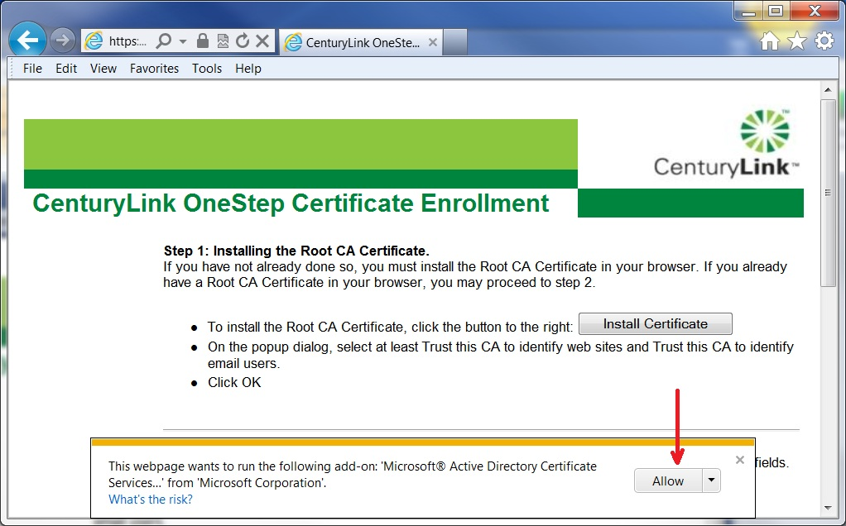
Click on the gear icon in the upper left corner of the browser. A pop up menu will appear. Select “Internet Options” which is the second entry from the bottom. | 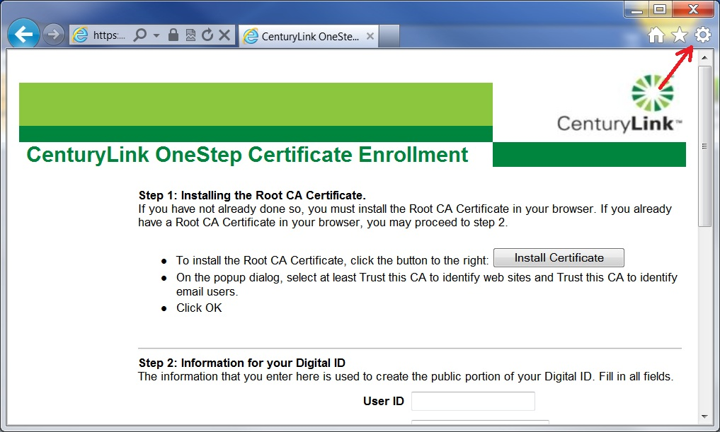
Select the Security tab. | 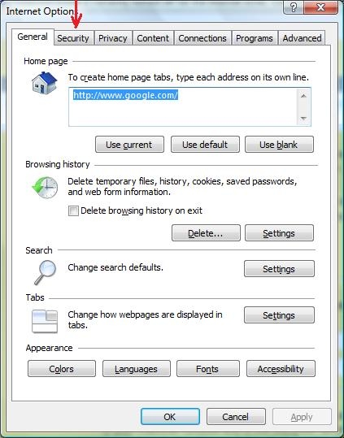
Click on the green check mark, Trusted Sites. Then click on the Sites button. | 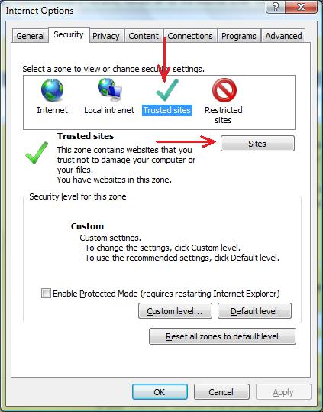
Type in  https://certs.centuryLink.com  Then click Add.  After clicking on Add,  “https://certs. centurylink.com” will appear in the Websites box.  Click Close. | 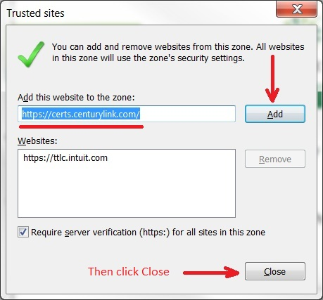
While the “Trusted sites” green check mark is still highlighted, verify that:  - The slider bar is in the middle for Medium.  - Enable Protected Mode is not checked.  - Click on the “Custome level …” button. | 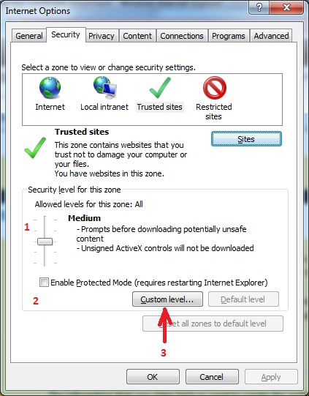

- Scroll down about 1/3 of the way to find:  - “Initialize and script ActiveX controls not marked as safe for scripting.”  Note: This option is located under the ActiveX Controls and plugins heading.  - Select Enable.  - Click OK. | 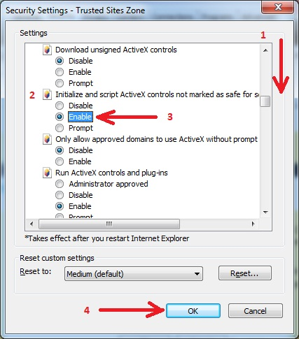
There will be a Warning pop-up window. Click on the Yes button. | 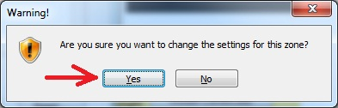
Click on Apply.  Then, click on the OK button. | 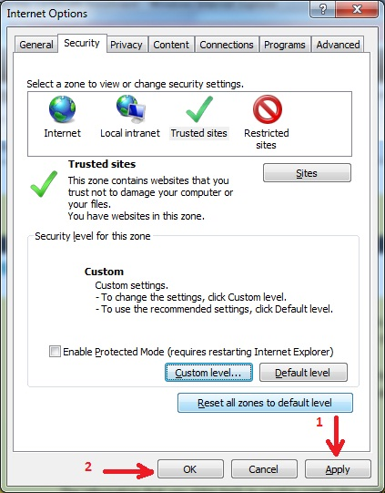

Installing CenturyLink’s Root Certificate
Before a CenturyLink client certificate can be downloaded, the CenturyLink Root certificate must first be installed.
Click on the refresh button to load the Cryptographic Service Provider and Key Size options.  Click on the Install Certificate button on the web page.  Note 1. If the security settings have been set correctly, then the Cryptographic Service Provider box will be populated. Accept the default. | 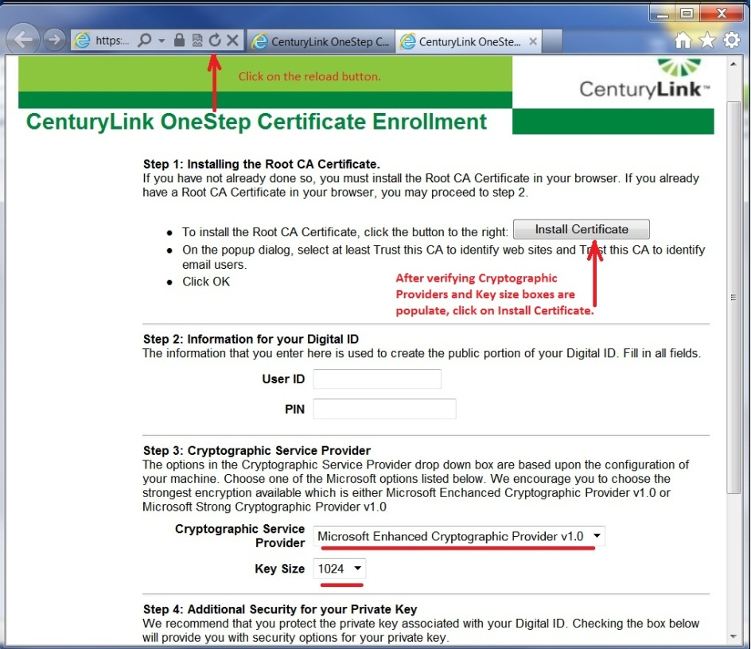
Click on Open. | 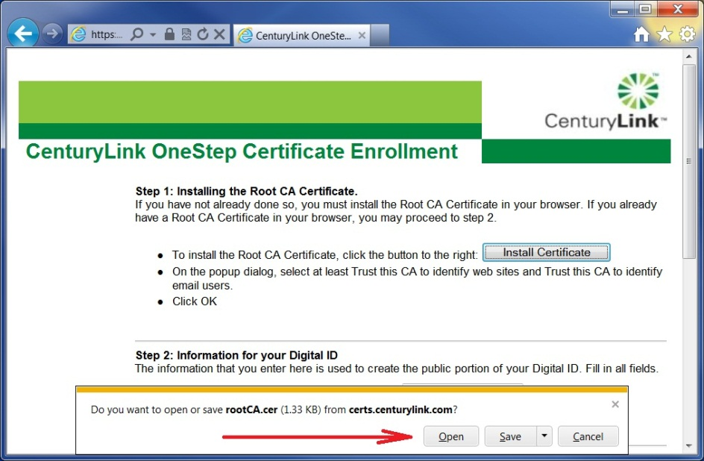
Click on the “Install Certificate … “ button. | 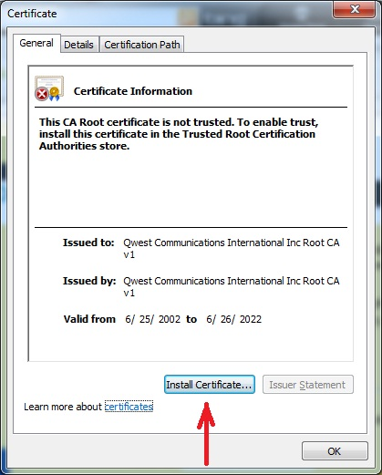
Click on the Next button. | 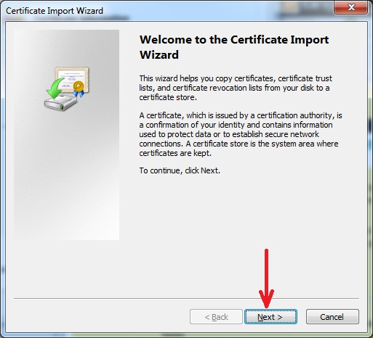
1.  Click on the second radio button for “Place all certificates in the following store.  2..  Click on the Browse Button. | 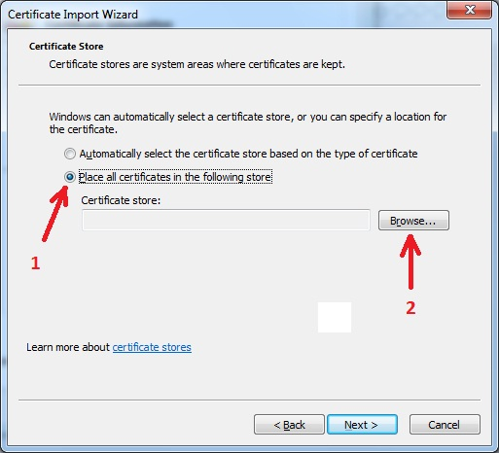
Select “Trusted Root Certification Authorities”, then  Click on the OK button. | 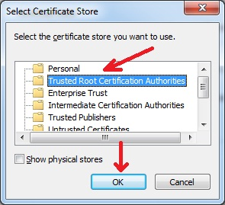
.  The text, “Trusted Root Certification Authorities” will be displayed in the text box.  Press the Next button. | 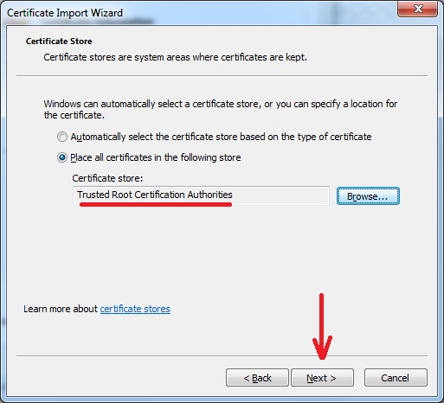
Click on the Finish button. | 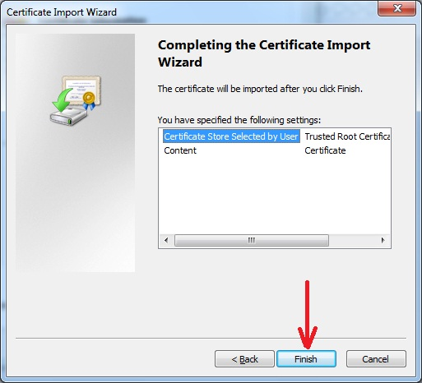
The next security warning pop-up window will appear.  Click on the Yes button.  . | 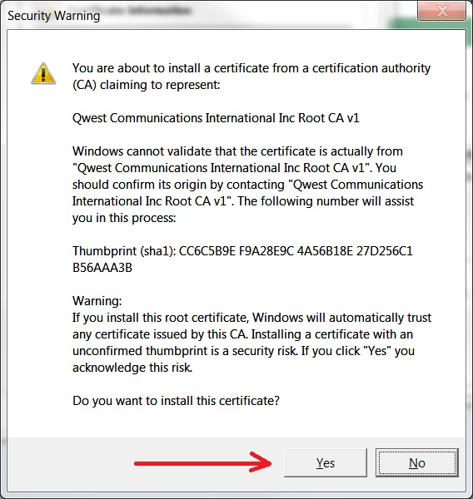
Click OK. | 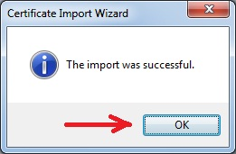
Click the OK button to complete the installation of the CenturyLink root certificate. | 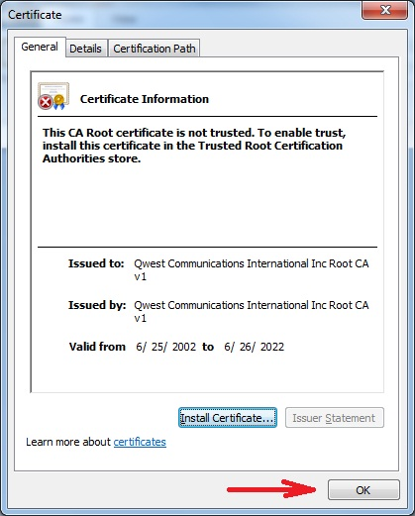

Installing the CenturyLink Client Certificate

Enter the 9 digit number for the User ID.  Enter the 4 digit PIN that was provided to you.  Accept the default Cryptographic Service Provider.  Do not check Protect Private Key.  Click Accept. | 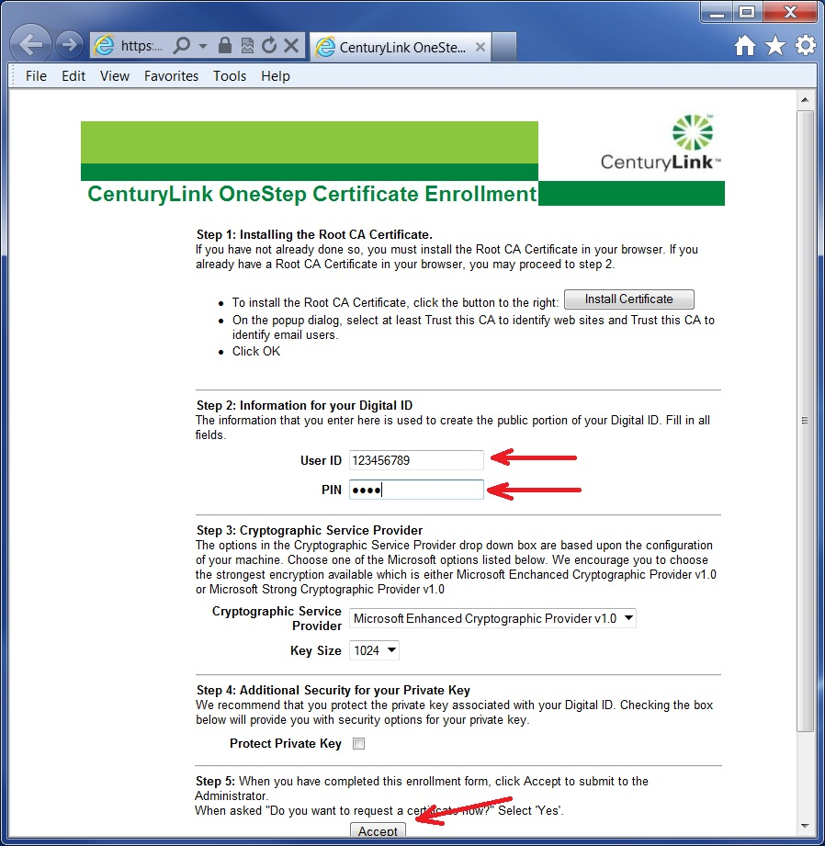
If you see this screen, your certificate has been successfully installed. | 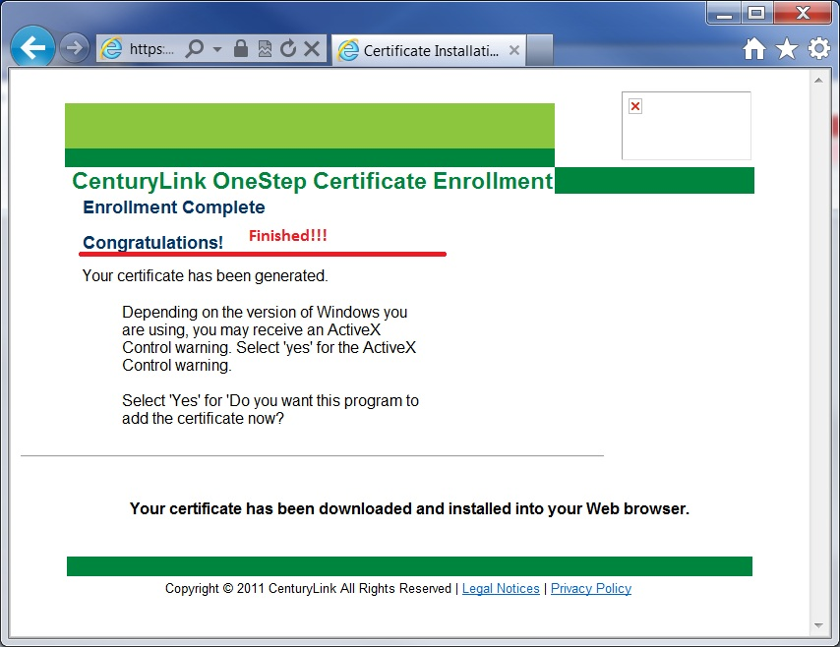

Verifying the Installation of the Certificate

Activate the tools menu by clicking on the gear icon, select Internet Options.  Then, click on the Content folder. | 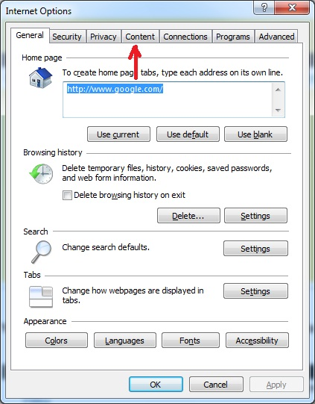
Click on the Certificates Button. | 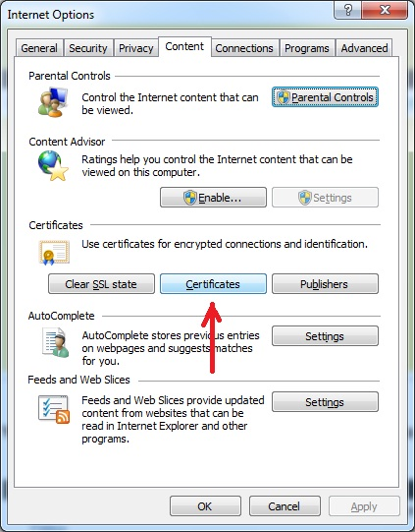
Your newly installed certificate will appear in the Personal folder.  Click Close. | 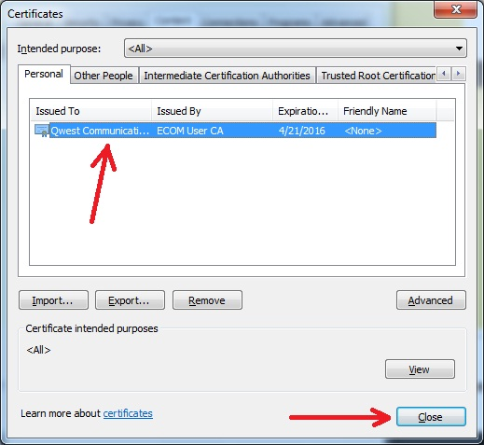
 | Then click OK or Cancel to close the Internet Options box.

