
End User Customer Requirements for terminating SONET Services

The End User must:

1. Provide adequate conduit from the right-of way into the building, confirm
access facilities to the building are available for fiber provisioning.
Conduit from the right-of-way to the building is the customer’s responsibility. If no conduit exists or space in existing conduit is not sufficient, the installation will not proceed.

It is the customer’s responsibility to locate private Utilities on your premises should construction be required. Construction will not proceed until this is complete.

CONDUIT SPECIFICATIONS: One 2 inch schedule 40 PVC conduit from 2 ft below grade at the building exterior to a pull box on the building exterior. Pull Box to have a minimum dimension of 12inch x 12inch x 6 inches deep. Place one 2 inch conduit sleeve through wall from pull box to the inside of the equipment room.

Conduit must be equipped with 400 lb rated pull tension. Equip conduit with no more than 2 rigid galvanized sweeps between cable pulling points. It is the responsibility of the customer to seal the conduit after installation to protect from damage such as water.

2. Provide adequate backboard space in equipment demarcation room.
The customer will provide minimum of one 4 x 4 feet plywood backboard, 4 x 8 feet preferred, in Minimum Point of Entry (MPOE), also known as equipment demarcation room. If an Extended Demarcation is needed, conduit must be supplied to Customer IDF (Intermediate Distribution Frame). Ensure adequate clearance of 36-inch in front of backboard. If the fiber demark is within 25 feet of the equipment rack, a wall board will not be required; all hardware and terminations will be installed in the customer provided rack. Access to MGN (Multi-grounded Neutral) or ground bus, with a run length of no more than 20 ft. is needed. The bonding/ground is to be provided by the customer at the telephone cable service entry location. For grounding conductors beyond 20 feet in length, drive a 5 foot 1/2 inch diameter rod a minimum of 4 inches below grade in undisturbed soil at the location of the NID. (NEC 800.100(B)(2)). MGN Buss bar should support irreversible crimped connections for CenturyLink’s MGN Termination.

Non Stand Alone Building (i.e. multi-tenant/strip malls): If shared building terminal supporting this location does not have adequate space for local telephone company fiber termination, customer or building owner will need to provide a 24” x 24” x 9” ventilated cabinet with ¾” plywood. This cabinet needs to be associated next to the original building terminal, to support association of shared (MPOE) DEMARC facilities. Access to MGN or ground bus, with a run length of no more than 20 feet is needed. The bonding/ground is to be provided by the customer at the telephone cable service entry location. For grounding conductors beyond 20 feet in length, drive a 5 foot 1/2 inch diameter rod a minimum of 4 inches below grade in undisturbed soil at the location of the NID. (NEC 800.100(B)(2)). MGN Buss bar should support irreversible crimped connections for CenturyLink’s MGN Termination.

3. Ensure the demarcation point is in an accessible and environmentally controlled location (i.e. Multi-tenant buildings):
The CENTURYLINK Equipment requires a clean, dust free environment that is environmentally controlled to temperatures of 55-80 degrees Fahrenheit and humidity of 70% or less.

If you are in a Multi-tenant building ensure that the CENTURYLINK MPOE demarcation point, (the location where the local telephone company wires enter your building), is accessible to the CENTURYLINK technician. You may need to coordinate access with the building manager to ensure that access is available on the day of installation. Ensure that this location remains dry and free of dampness, and the room temperature needs to remain within the tolerance of sensitive electronic hardware.

4. Ensure four (4) consecutive Rack Units of space in a 19” or 23” data rack are required for Enhanced Service:
It is the customer’s responsibility to provide space in a 19” or 23” wide equipment rack for the SONET hardware. CENTURYLINK will not install the hardware on a shelf or the floor. The rack may be either wall or floor mounted.

5. Provide dedicated power outlet and Common Ground:
The CENTURYLINK termination electronics are powered by customer provided 120 VAC (20 Amp) circuit. CENTURYLINK requires the outlet to be a three-prong, non-GFCI duplex, dedicated and grounded electrical outlet within six (6) feet of the equipment location. If the outlet is in a public area, a single plug must be provided so other equipment cannot be plugged into the outlet. Common ground must be 25 ohm or less. If the customer does not have a UPS on the AC, service will be lost in the event of an AC power failure. If UPS is required, customer will provide such arrangement.

6. Complete inside wiring work.
Inside wiring must be completed by the customer prior to the arrival of the CENTURYLINK installation technician. Customer must extend the wiring from the demarcation point to their suite or office location where the SONET service will be used. If copper Ethernet service, a minimum of Cat 5e or Cat 6e cable is recommended with a maximum of 328 feet/100 meters run to the Customer equipment. Copper SONET service may have distance limitations and will need to be verified at placement of service. If fiber, then the cable must match the handoff ordered on the ASR. Fiber slack storage needs to be located at the customer equipment and not at the MDF/IDF.

7. Confirm SONET Hand-Off requirements:
CENTURYLINK will provide RJ-45 Ethernet, RJ-48 Copper DS-1 services or Coax DS-3/STS-1 services as ordered by the Carrier on the ASR requesting the service. The type needs to be coordinated with your Carrier. Options include standard Multimode or Single mode Fiber connections.

8. If applicable, confirm that any planned Customer Equipment connections have an appropriate SONET port available:
The customer needs to ensure a suitable port is available to provide the network functionality they desire and within distance of SONET specifications. Customer will program SONET port for appropriate speed and full duplex setting (No auto-sense). It is the customer’s responsibility to provide a cable(s) to connect you equipment to the CENTURYLINK SONET equipment. Customer will provide an appropriate SONET patch cable for connecting CENTURYLINK demarcation and Customer Provided Equipment. Fiber slack storage needs to be located at the customer equipment and not at the MDF/IDF.

9. CENTURYLINK SONET products are transport Layer 2 network service only. Any customer premises equipment configuration or Local Area Network (LAN) Layer 3 (e.g. IP) addressing is the responsibility of the customer. If the customer only requires layer 2 bridging (a flat network) across the SONET service then a standard SONET switch port is all that is required.

10. The CENTURYLINK installer will not connect the SONET service to the Customer Equipment.
Our installers will install the hardware and identify a port for your connection.
- CENTURYLINK highly recommends the use of a qualified networking vendor to assist you with your equipment configuration.

11. Access
- CenturyLink requires an emergency customer contact for access 24 hours a day, 7 days a week.

- Compatible SONET equipment is required.
Customers are responsible for using SONET equipment that is compatible with equipment used by CenturyLink. If you need assistance or have questions, please contact your CenturyLink Sales Representative.

SONET Service
Fiber
Termination
Panel
Wallboard
-
20" x 44" x 3/4"
2" Conduit from
Exterior of building
Demarc
Room.
Pull box
Fiber
Transceiver
SONET Service
Customer Provided UPS Optional
Customer
Provided
Equipment
Fiber
Termination
Panel
Fiber
Termination
Panel
-
2" Conduit from
Exterior of building
Demarc
Room.
2" Conduit from
Demarc
Room.
Pull box
Fiber
Transceiver
Fiber
Transceiver
Customer Provided UPS Optional
Customer
Provided
Equipment
Fiber
Termination
Panel
Fiber
Termination
Panel
-
2" Conduit from
to
2" Conduit from
to
Fiber
Transceiver
Fiber
Transceiver
Customer Provided UPS Optional
OC3/12/48/192 to
Customer
Provided
Equipment
Provided
Equipment

CENTURYLINK provides fiber termination and the SONET equipment.

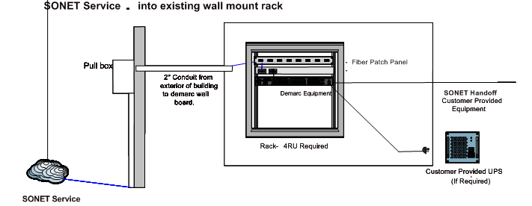

CenturyLink provides fiber termination, fiber patch panel, and if needed SONET equipment, SONET DEMARC device and power surge protector.
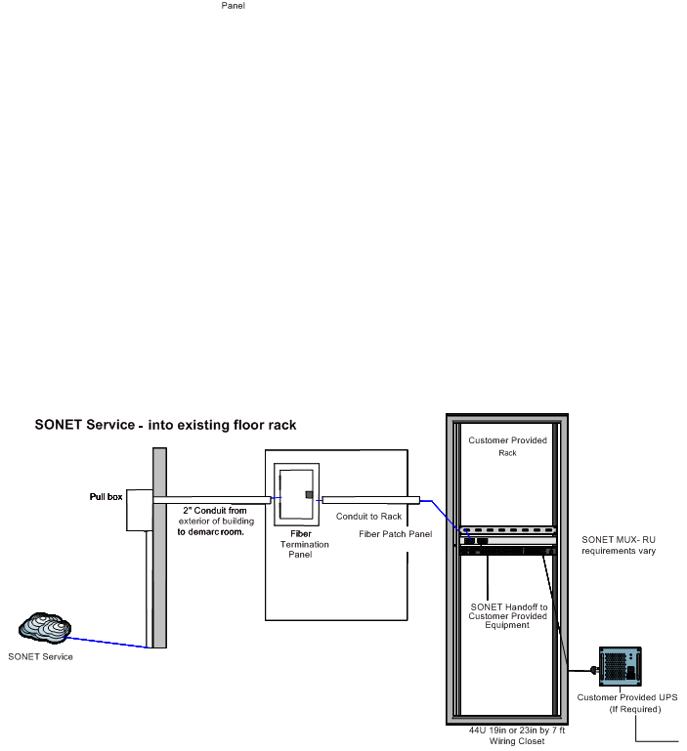

CenturyLink provides fiber termination, fiber patch panel, and if needed SONET equipment, SONET DEMARC device and power surge strip.

