EXHIBIT F

CENTURYLINK WIRELESS CONSTRUCTION SPECIFICATIONS

- Only one Antenna per Pole allowed.
- Antenna owner must install a RF warning sign on the Pole at the level where the safe approach distance ends for general population/uncontrolled environments. WARNING-ANTENNA RADIATION MINIMUM APPROACH DISTANCE IS ___ FT. It must also include the Licensee name and 24 hour contact phone number. The approach distance shall be based upon the Uncontrolled Exposure limits in the FCC OET-65 bulletin Appendix A. The sign shall be 60 mil. lexan with U.V. inhibitors and comply with IEEE C95.2 standards.
- Antenna Attachment to the Pole must meet all NESC clearance specifications.
- ONLY the antenna and cables/risers necessary for antenna operations are allowed on CenturyLink Poles. ALL power equipment, on/off switches and cabinets are not permitted on CenturyLink Poles. Cabinets/stub poles must meet NESC clearance, space/measurements requirements from CenturyLink Poles.
- All risers must be placed in conduit with fasteners/straps not less than 24”. Maximum 2-2” conduits per Pole.
- All antenna Attachments must be approved by CenturyLink prior to construction. Antenna may be attached above the top Attachment in the designated Communications Space or below the lowest Attachment in the Communication Space, if an electric utility is attached to the Pole. If no electric utility is attached to the Pole (or has an approved Application to attach) the Attachment may alternatively be located on the Pole top with no bolts or screws in the top 12 inches of the Pole. All Attachments must meet NESC, FCC, State and Local requirements.
- All electrical power equipment must be bonded to MGNV where available or grounded to the commercial power source, meeting all codes applicable.
- All Antenna attachments will have a power on/off switch accessible by CenturyLink installed on the cabinet/stub pole that will terminate the transmission of radio frequency when turned to the off position. The on/off switch must be shown on the application and any deviation from the approved permitted location must be approved by CenturyLink prior to installation.
- CAUTION: Disconnect power to antenna before working on any Pole in the area above the RF warning sign or closer than the stated safe distance indicated on the warning sign.

See example drawing on Exhibit “F” which depicts a CenturyLink Pole WITH an electric utility attached.
Note: Exhibit “F” may be revised and/or updated as necessary to maintain a safe working environment and as regulations require.

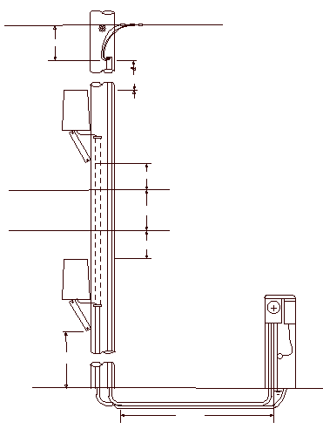

12” Min
Antenna Equipment
See Note 8
5’ – 0” Min
40”
12” Min
12” Min
12” Min
EXHIBIT “F”
EXHIBIT F - diagram
Triplex or Neutral
Proposed Antenna
Com. Cable
Com. Cable
Proposed Antenna
Power Meter

