

CenturyLink Access Service Ordering and Billing System Consolidation Plan

Appendix A: CDG CABS Invoice & CSR Examples (Redacted)
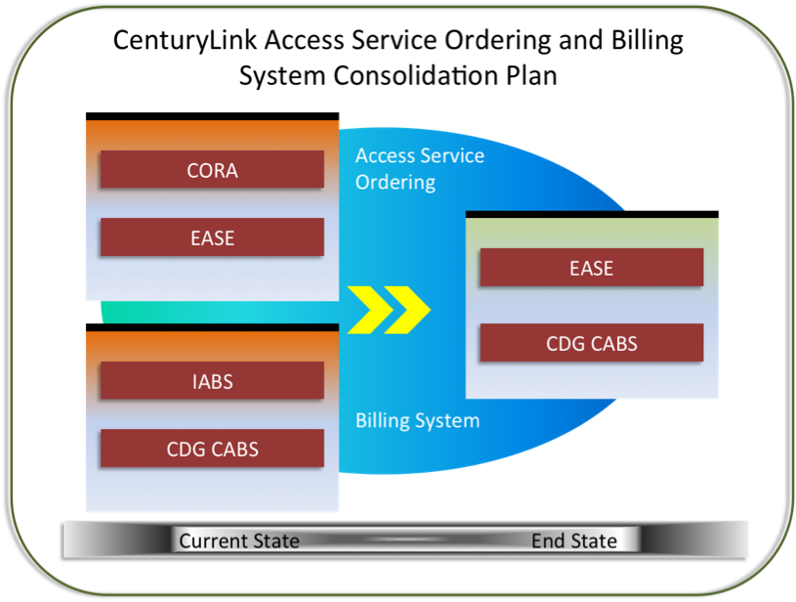

Version 1.0 4/29/15

© 2015 CenturyLink, Inc., All Rights Reserved. The CenturyLink mark, pathways logo, and certain CenturyLink product names mentioned herein are the property of CenturyLink, Inc. All other marks are the property of their respective owners.

Contents
CenturyLink Access Service Ordering and Billing System Consolidation Plan Appendix A: CDG CABS Invoice & CSR Examples (Redacted) 1
Appendix A: CDG CABS Invoice & CSR Examples (Redacted) 4
CDG CABS Facility Invoice & CSR Example A:…………………………………….4
CDG CABS Switched Invoice & CSR Example B:………………………………….5
Local Interconnect Services (LIS) billed in IABS (a switched BAN). IABS LIS Usage Invoice, Example C:……………………………………………………………6
Local Interconnect Services (LIS) billed in IABS (a specials BAN). IABS Facility Invoice, Example D:…………………………………………………………………….7

- CDG CABS Invoice & CSR Examples (Redacted)

CDG CABS Facility Invoice & CSR Example A:
Double-click on the image to view the complete eight-page document (via the Adobe Acrobat viewer).

CDG CABS Switched Invoice & CSR Example B:
Double-click on the image to view the complete sixty one-page document (via the Adobe Acrobat viewer).

Local Interconnect Services (LIS) billed in IABS (a switched BAN). IABS LIS Usage Invoice, Example C:
Double-click on the image to view the complete ten-page document (via the Adobe Acrobat viewer).

Local Interconnect Services (LIS) billed in IABS (a specials BAN). IABS Facility Invoice, Example D:
Double-click on the image to view the complete twelve-page document (via the Adobe Acrobat viewer).

