

EASE ASR VFO
User’s Guide

Table of Contents
Document Information 4
Version Notice 4
Change Log 4
Document Location 4
Records Retention Policy 4
Introduction 5
Browser Guidelines 5
Navigating EASE 5
EASE VFO Standards 6
EASE VFO System Requirements 6
Whom to Call and When 6
Overview 7
EASE VFO Overview 7
Password Rules 7
EASE Access 8
Login 10
EASE Home Page ICONs 11
EASE Home Page Tabs 12
Order Status List 13
Order Status ICONs 13
Order Tab 14
ASR Order Entry 14
Transport Form Entry 17
D / N Related Orders 20
Order Validation 21
Error Code List 21
Order Submission 23
Address Details 24
Complex Addresses 24
Data Search 24
Order Replicate 26
Order Supplements 29
Ordering Options 30
Resend 31
View 32
Save Order 32
Revert 32
Void 33
Order History 33
View Status from the Order List 34
PreOrder Tab 35
Template Tab 39
Initiating a Template 39
Creating a Template 40
Modifying or Deleting a Template 41
EASE Help 42
Appendix 1 - Order List Status 43
Appendix 2 - Order Types 54
Appendix 3 – PreOrder IRM Responses 58
Appendix 4 – Address Fields and Definitions 59
Appendix 5 – Sample ASR 61
Appendix 5 – Sample ASR Continued 62

Document Information

Version Notice
Document Date | Software Release | Document Version
February 2016 | xx | .01
March 7, 2016 |  | 1.0

Change Log
Revision Date | Document Version & Software Release | Description
February 2016 | .01 | New Document
March 7, 2016 | 1.0 | Final
May 27, 2016 | 1.1 | Changed screenshot on page 13 to include RPON present ICON

Document Location
You can obtain the latest version of this document at http://www.centurylink.com/wholesale/systems/ossconsolid.html

Records Retention Policy
ASRs that have been submitted to CenturyLink and processed will be retained in the database for a period of 2 years. CenturyLink will perform a purge of these records twice annually in January and July. The purge date will be based on the date of the last activity transmitted on the ASR. For example, if the date the C/NR form for completion or cancellation of the ASR is November 2015, the deletion of this record would occur in January 2018 and once purged will no longer be accessible to you.

Requests that have been created but not submitted to CenturyLink will not be purged from the database regardless of the date created. However, unsubmitted ASRs that have not been modified for more than 2 years whose "Last Edited User" is no longer a valid user in the system may be purged at CenturyLink's discretion.

Introduction

This User guide provides the user with instruction to create, modify, cancel, and submit Access Service Requests (ASRs). This guide is meant for a generic order representation only. The ASOG and custom business rules should be referenced for specific guidelines in the population of fields for specific order submission.

Browser Guidelines
Your browser may ask whether you want passwords and information you type to be saved for future use. If you see a message asking you to save your password or other information, do not do so. Saving your password may create security problems. Saving other information may not work as intended within the system.

Navigating EASE
To navigate in EASE, use the top row of buttons and the system tabs:

To do this... | Click this button / tab...
Return to the Order List page | Home
Open a pop-up window that lists login name of current user, current user’s full name, date and time the current version of the application was installed, VFO copyright information | About
Logout of VFO and return to the login page | Logout
Access functionality to create or search for an order | Order
Initiate, search, and / or submit pre-order transactions | PreOrder
Access functionality to create or search for a template | Template
Access User Profiles and other security related information. This tab will only be visible if you have sufficient permissions | Administration
Access VFO Online Help | Help

EASE VFO Standards

Following are standard guidelines to follow when working in EASE VFO

- UPPERCASE must be used when creating orders. Failure to use UPPERCASE may cause issues with an order not routing properly, or not routing at all.

- A user can edit all fields unless they are dimmed. Fields that are automatically filled in cannot be edited.

- Avoid copying/pasting text from other applications (Word, Excel, PDF, and so on) into fields. Doing so may introduce "garbage characters" (carriage returns, tabs, line feeds, unsupported non-ASCII characters, and so on) that cannot be interpreted or translated properly when the data is transferred. Once a situation like this occurs, the only workaround is to perform a copy-to-new function and fix the offending field prior to requesting a validation, which forces the user to submit the ASR under a different PON. The workaround is cumbersome, and data could be unrecoverable if the situation occurs on a SUP.

EASE VFO System Requirements

Browser: VFO will support Internet Explorer version 10 and Google Chrome and will be backward compatible with IE8 and IE9. Earlier versions of Internet Explorer will cease to be supported.

Whom to Call and When

If you need an account created or changes to your CCNA permissions or personal information (name, email address, etc.), contact your EASE system administrator at Helpdesk.EASE@CenturyLink.com.
For ASR Ordering Systems Information, go to http://ease.centurylink.com/.

Requirement updates and additional questions and answers can be found at the CenturyLink ASR Ordering Systems web site at http://ease.centurylink.com/.

For all other problems, call the Wholesale Systems Help Desk:
1-888-796-9102, option 2

Monday-Friday 6:00 a.m. to 7:00 p.m. (Mountain Time) Saturday 7:00 a.m. to 2:00 p.m. (Mountain Time)

Overview

EASE VFO Overview

Virtual Front Office (VFO) is the Web-based EASE application that provides a gateway for external CenturyLink Wholesale customers to submit Access Service Requests (ASRs) to CenturyLink. Internal CenturyLink employees also have access to VFO for order submission and tracking. VFO provides easy access to all of the industry standard ASR forms and allows the user to initiate, submit, and track Access Service Requests (ASRs).
Orders submitted to CenturyLink can be tracked in VFO.
ASRs can be submitted to CenturyLink:
- Directly via online access to VFO
- Batch—submitted via customer scheduled feeds throughout the day and tracked in VFO
- By UOM (Universal Ordering Module)
- By paper—all paper orders received by CenturyLink are entered into VFO

Password Rules

Customer users can change their own passwords using the following rules:

Passwords chosen must:
- Be at least 8 characters in length but not more than 16 characters
- Contain at least one character from any three of the following four categories
  - Uppercase alphabets (A-Z)
  - Lowercase alphabets (a-z)
  - Numbers (0-9)
  - Special characters (~ ` ! @ # $ % ^ & * ( ) - _ = + { } [ ] \ | ; : ‘ “ , . < > / ?)

Passwords chosen must not:
- Contain a space
- Be “password” itself
- Be the same as the login user name
- Be the same as the old password that is being changed

EASE Access

EASE is accessed via the following URL: http://ease.centurylink.com

The home page of EASE will present with several tabs: VFO, Guide, Schedules, Contacts, as well as access to the Address Validation Utility Tool.

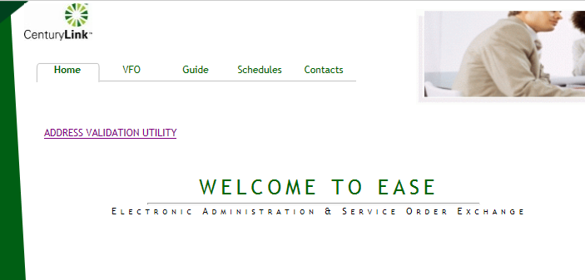

The VFO > ASR Tab provides access to the Virtual Front Office (Access Service Request) and the Reference Table Maintenance (Access Service Request).

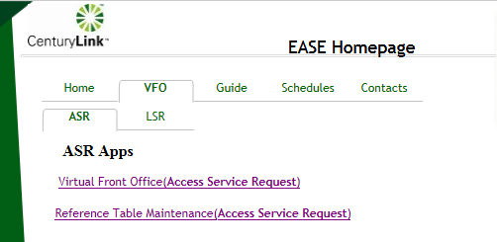

The Guide > ASR Tab provides access to several helpful links as shown below.

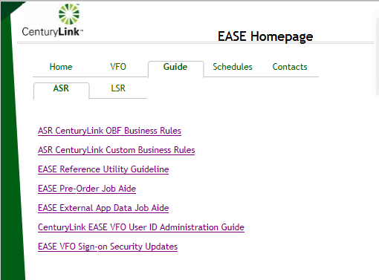

The Schedules Tab provides a list of Release Schedules.

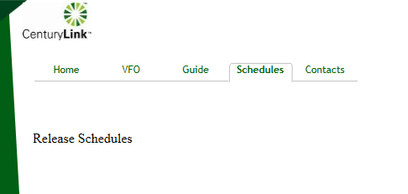

Contact Tab provides the phone number to the EASE Help Desk as well as the email address(es).

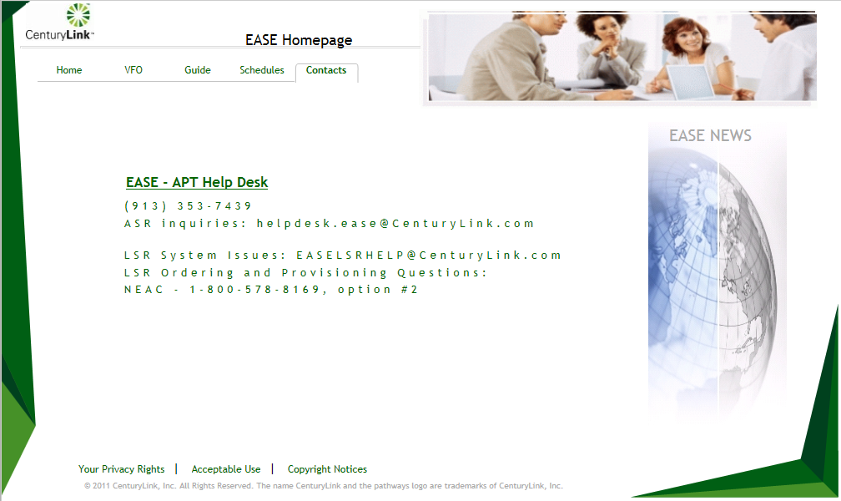

Login

EASE VFO users must log in with established credentials

Enter: Username and Password
Module: Access
Click the Login button

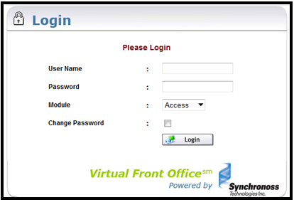

Upon successful login the user will be presented with the EASE Homepage.

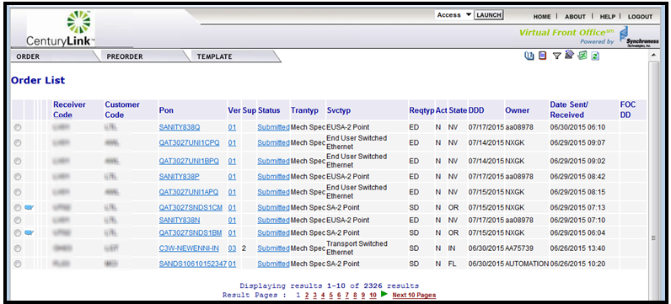

EASE Home Page ICONs

The upper right hand corner of the VFO Home Page has 6 action icons to select.


ICON | DEFINITION
 | History – provides a detailed history of an order, including Errored, Confirmed, Clarification, Jeopardy, DLR/Design, Completed, etc.
 | Create Response – allows user to create a manual response such as a Jeopardy or Clarification for a selected order
 | Filter – provides a way to filter orders from the order list. Clicking this ICON prompts another screen to open and requires the user to filter the criteria. Once filtered, user must clear the filter to return the order list to default view.
 | Return to Default Sort – allows user to return the order list to the default sort order
 | Export to Excel – exports an order selected from the Order List into an excel document
 | Refresh – Refreshes the Order List to show the latest order activities including new orders and updates to existing orders. This is NOT used to clear a filter or a sort, but only to update the Order List

EASE Home Page Tabs

The top menu bar offers three options: Order, PreOrder, and Template. Each of these tabs contain drop down menus. The user can return to this screen at any time by clicking the Home link in the top right of the screen.

Tab | Function
Order | New – Initiate a new order
 | Search – Search existing orders
 | Save as Order – Replicate an existing order
 | Save as Template – Create a template from an existing order
 | View History – View the history of an existing order
 | Create Response - Create a manual response for a selected order
 | Resend – Resend a selected order
 | Disconnect – Select an existing, completed order to create a disconnect order for installed services
 | Reassign Order – Reassign an order to someone else
External App Data > NcNciInquiry – Search for valid NCNCI combinations
External App Data > BAN Inquiry
PreOrder | New – Perform the following:  - Preorder on CenturyLink addresses  - Preorder on CFAs
 | Search – Search for a preorder that was previously saved
Template | New – Create an order template
 | Search – Search for an existing order template

Order Status List

There is a Status column in EASE VFO that shows the user current status of orders in the Order List. These statuses also show when viewing the history of an order. Appendix 1 – Order Status List provides a definition, action, and user action for each status.

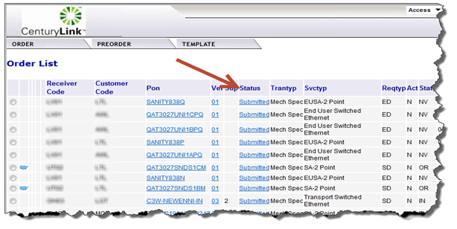

Order Status ICONs

Status ICONs may display to the left of the Receiver Code column on the Order List. These status ICONs are designed to assist with identifying the current status of orders in the Order List. Below is a list of all available status ICONs that may display on the Order List in EASE VFO.
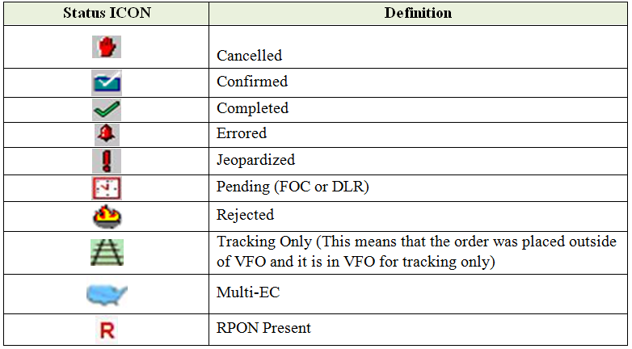

Order Tab

ASR Order Entry

EASE VFO contains all of the industry standard forms and fields that are required to enter an Access Service Request (ASR). This document only includes the fields that are necessary for new installations of most order types; however, keep in mind that more or less fields may be required depending on what type of order being entered.

There is help text available for each field in an order in EASE VFO. The help text may assist the user with correcting errors or choosing valid field values. The help text for each field displays at the bottom of the screen after clicking into the field.

Note: All orders entered in EASE VFO must be in all capital letters. Set Caps Lock button on the keyboard before entering an order.

The user will select New from the Order Tab.

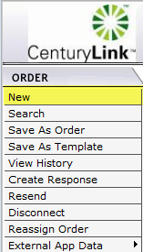

Once New has been selected, the Order Initiation window displays and the user will enter basic ordering criteria.

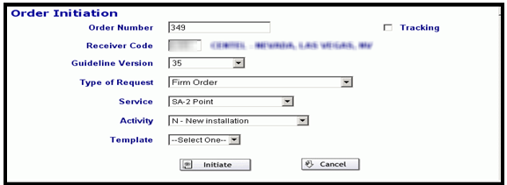

- Order Number – Purchase Order Number (PON). The PON can be up to sixteen alpha, numeric, or alpha-numeric characters. A user can only use a PON once. EASE VFO automatically populates the Order Number field with the next available number, but a user can override the number that EASE VFO assigns.

- Tracking – the Tracking button is used to indicate that the order is for tracking purposes only.

- Receiver Code – the ICSC of the region of the order—for example, MG04 or LV01. If the order is meet-point with two or more Local Exchange Carriers (LEC), the Receiver Code field must be the ICSC code of the LEC that is in control of the order. Once the user begins typing in this field, a list of codes appears in a drop-down list and the user must click the ICSC wanted.

- Guideline Version – the version of the industry standard guideline that applies to the order. This field prepopulates once the Receiver Code is added.

- Type of Request – Firm Order is the default value and is the only valid value for this field.

- Service – the types of services are available in the Service field drop-down menu—for example, EUSA-2 Point or SA-2 Point.

- Activity – the order activities are available in the Activity field drop-down menu—for example, New, Change, or Disconnect.

- Template – previously created templates are in the Template field drop-down menu. User can choose to apply a template to an order if one is available.

- Initiate – initiates the order.

- Cancel – discontinues the order entry process.

Upon initiating the order, the user will be navigated to the order. All information populated on the Order Initiation Page will populate onto the order. The default form is the ASR form as shown below. The red outline will indicate what form the user is creating.

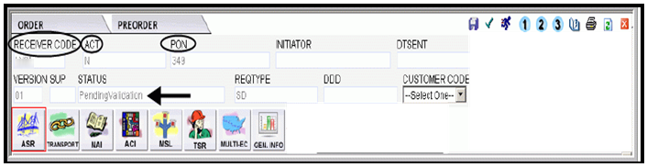

- Select the valid CCNA for the order from the CUSTOMER CODE field drop-down menu.

- In the Administrative section of the ASR form, choose a due date from the calendar next to the DDD field that fits within the standard interval.

- Populate the QSA field with the quantity of service addresses included in the order. This field requires that the valid entry be two numeric characters—for example, type 01 of there is only one address.

- Choose the response type requested from the RTR field drop-down menu; for example, F = Send FOC only. After choosing the response type requested value from the RTR field, it is important that the user does not scroll to move to the next field. If the user scrolls before clicking somewhere else on the ASR form, the RTR field value changes.

- Populate the PIU field with the percentage of Interstate usage—for example, 100.

- Use the following matrix to determine the next step:

If | Then
Bill the order on an existing billing account number (BAN) | Type E or the actual twelve alpha-numeric BAN number in the BAN field
Bill the order on a new BAN | Type N in the BAN field

- Using the scroll bar to move down in the order, type in the eleven alpha-numeric Access Customer Terminal Location in the ACTL field. This field is not mandatory for all order types.

- If requesting a new BAN, populate the Billing section of the ASR form.

- Type the ACNA of the customer who is to be billed for the order in the ACNA field.
- In the Contact section of the ASR form, type the name of the customer employee who originated the request in the INIT field.

- Populate the INITIATOR_TEL field with the phone number of the person who initiated the order. This field can be up to fourteen numeric characters and there should be no hyphens.

- Type either the initiator’s FAX number in the in INIT_FAX_NO field or the initiator’s e-mail address in the INIT_EMAIL field. Per the ASOG, use of these fields is optional.

- Type the name of the person to contact for design, engineering, or translations questions in the DSGCON field.

- Populate the DSGCON_TEL field with the phone number of the person to contact for design, engineering, or translations questions.

- Type the name of the person responsible for control of installation and completion in the IMPCON field.

- Populate the IMPCON_TEL field with the phone number of the person to contact for installation and completion issues.

Transport Form Entry

Once the ASR Form has been populated, select the Transport Form from the ordering options. Note: If the user is creating an EUSA 2-Point order that contains two addresses, the Transport form is not visible and would choose the EUSA form instead. Note: the ICONs will vary depending on the service selected.



- Type a valid Network Channel (NC) in the NC field; for example, HCE-.

- Type a valid Network Channel Interface (NCI) in the NCI field; for example, 04DS6.44.

- Type a valid Secondary Network Channel Interface (SECNCI) in the SECNCI field; for example, 04DU9.1SN.

- When requesting local transport, populate the Surcharge Status (S25) field. For example: A = Exempt, B = Blanket Exemption, C = Non-Exempt.

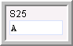

- Use the following matrix to determine the next step:

If | Then
The circuit is riding a higher facility | Type a valid Connecting Facility Assignment with a vacant channel in the CFA field and proceed
The circuit is not riding a higher facility | Proceed

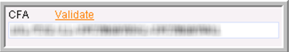
The CFA must contains slashes (/) and not spaces or periods.

- Click the Validate button to the right of the CFA field to check the CFA for validity and channel vacancy.

- Use the following matrix to determine the next step:

If | Then
The CFA is not valid or the channel is busy | Make the necessary corrections, validate again, and proceed
The CFA is valid and the channel is not busy | Proceed

- Type a valid value in the SECLOC field—for example, E or an eleven-character CLLI code.

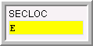

- Use the following matrix to determine the next step:

If | Then
The CFA field is populated | Type the MUX CLLI code from the CFA in the MUXLOC field and proceed
The CFA field is not populated | Proceed

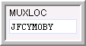

- Scroll down to the Service Address Information section, type the end user name in the EUNAME field.
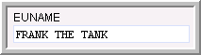

- In the Address Detail section, populate the address using the appropriate fields.

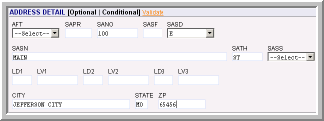

- Click the Validate button to the right of the Address Detail section header to check CenturyLink addresses for validity.

- Use the following matrix to determine the next step:
If | Then
The CenturyLink address is not valid | Make the necessary corrections, validate again, and proceed
The CenturyLink address is valid | Proceed

- Scroll down and choose a jack status from the JS field—for example, D, E, F, or N. After choosing the jack status value from the JS field, it is important not to scroll to move to the next field. If you scroll before clicking somewhere else on the Transport form, the JS field value changes.

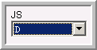

- Type the name of the local contact name for access in the LCON field.

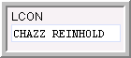

- Populate the ACTEL field with the phone number of the local contact.

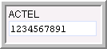

D / N Related Orders

D/N (Disconnect / New) related orders require that the RPON fields of both orders are populated with the related PON.

Order Validation

Once the required forms and fields have been completed, the order must be validated prior to being submitted. There are three ways to perform order validation.

- Click the Validation ICON  in the upper right hand corner of the screen while in an order.

- Select Validate from the Action sub-menu of the Order tab menu while in an order.

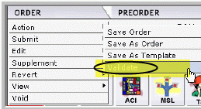

- Selecting Validate and Submit from the Order tab menu while in an order.

Selecting Validate and Submit instigates order validation and submits the order to CenturyLink if there are no validation errors.

Error Code List

After an order is validated, if there are errors, an Error Code List box will display. The status of the order changes to “Errored” if the order is validated and there are errors. The user needs to correct the items shown in the Error Code List before the order can be successfully submitted.

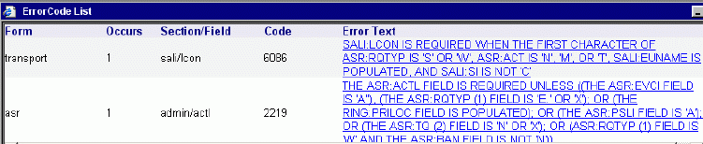

These are the Error Code List columns:
- Form – On which ASR form the error occur
- Occurs – How many occurrences of the error
- Section/Field – In which section and field the error occurs
- Code – Internal code connected to the error
- Error Text – Description of the error – Errored fields are highlighted in red.
Click the blue underlined Error Text to be taken to the location of the error within the order. The field will be highlighted in red and the user can make the correction and move on to the next error for correction. The user can validate at any time during this process to check progress. It is recommended a user validate after each error correction as correcting one error may eliminate other errors, or may generate new errors.

Occasionally, clicking the blue underlined error text does not take the user to the error. If this happens, the user will be presented with a Manual Error Search Box. Click OK to close the box. The user must manually look for the error.

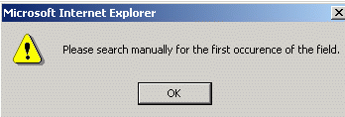

A user may view the Error Code List by selecting View Error List from the View sub-menu on the Order Tab.

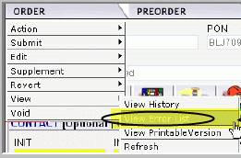

Help text is available for each field once in an order in EASE VFO. The help text may assist with correcting errors or choosing valid field values. The help text for each field displays at the bottom of the screen after clicking in the field.

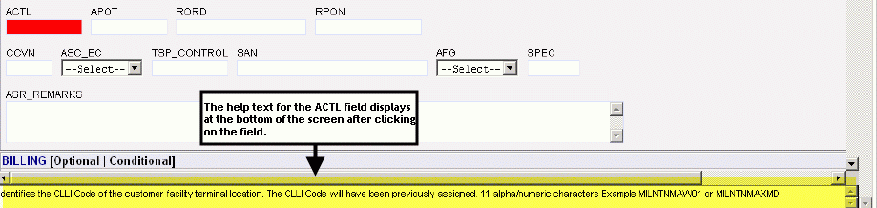

Order Submission

Once order validation is performed and the order is error free, the Status field will change to Validated and the order is ready to be submitted. There are two ways to submit an order.

- Click the Submit ICON  in the top right hand corner of the order.

- Select Validate and Submit from the Order Tab drop-down menu.
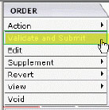

Upon successful submission, the Status field in the order will change to Sent, then will change to Submitted, then Accepted. If a customer does not receive an “accept” or “error” status within their normal processing time, the customer may contact CenturyLink to determine if the order is stuck before resending.

Use the following matrix to determine the next step:

If | Then
The Status field at the top of the order shows Accepted  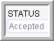  Exception: Meet-point orders where CenturyLink is not in control do not change to Accepted status and show Sent status. This is OK | The order has been submitted to CenturyLink and the user is completed with order entry unless wanting to supplement the order.
The Status field at the top of the order says Sent or Resent  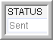  Exception: Meet-point orders where CenturyLink is not in control stop at Sent status. This is OK and the user does not have to resend when this happens. | Roll the cursor over the Order tab and choose Resend from the Edit sub-tab menu.

Address Details

Certain fields are required in the Address Details section for any order that contains an address. The minimum entries in the Address Details section are:
- SANO = House Number
- SASN = Street Name
- CITY
- STATE
- ZIP CODE
For a complete list of the available fields in the Address Details section of an ASR, see Appendix 4 – Address Field and Definitions.

Complex Addresses

Complex address inquiries can be entered using the Location Designator fields. User must populate the minimum required address inquiry fields plus the location designators if applicable as follows.

- LD1 – Enter description types—for example, UNIT, APT, ROOM, RM, FL, FLR, BLDG, or STE
- LV1 – Enter the value associated with the description type—for example, 100, 1, or 36
The LD description type can be placed in any Location Designator field, LD1, LD2, or LD3 and the associated value is placed in the corresponding LV1, LV2, or LV3 fields.

Data Search

A user can access the Order tab Search menu option to find different search criteria, view the history of an order including Clarifications, Jeopardies, Completions, etc., and search for and modify existing templates. Note: A partial search can be performed by entering part of the search criteria followed by a %. This is considered a wildcard or partial search.

With the Order List in view, select the Order Tab > Search option.

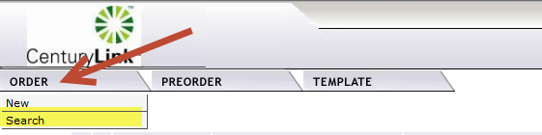

The Order Search Page appears with Purchase Order Number (PON) as the default search option.

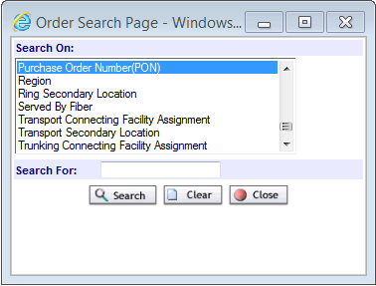

Select a search option; for example Purchase Order Number (PON), Region, ATCL, etc. Type the exact information in the Search For field, then click the Search button. The query will be initiated.

Use the following matrix to determine the next step:

If | Then
The search is successful and orders matching the search criteria are displayed in the Order List | Click the Close button in the Order Search Page box.
The search is not successful and “No Records Found” displays below the Order List | From the Order Search Page box, click the Clear button to search again or click the Close button to discontinue the search function.

Order Replicate

A user can replicate an existing order to use for new order creation in EASE VFO. The order that a user replicates (copies) is for a one time use. If a user wants to create a shell order for use on a go forward basis, a user would create a template and not replicate an existing order. Replication requires the user to change the existing PON. There are two methods to replicate an order.

- From the Order tab when the Order List is in view, select an order from the Order List, then select the Save As Order menu option from the Order Tab to initiate the order replication function.
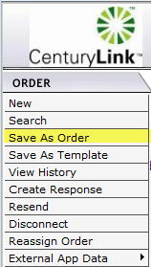

- From the Order tab when in an existing order—when viewing an existing order, the Save As Order menu option can be selected from the Action sub-menu of the Order tab to initiate the order replication function.

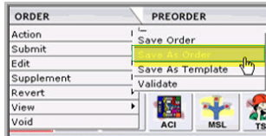

Use the following matrix to determine the next step:

If | Then
A user want to replicate the order from the Order List screen | - Click the radio button next to the order to replicate.  - Select Save As Order from the Order tab menu.  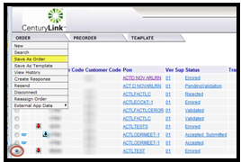  - Proceed
A user want to view the order and then replicate | - Click the PON of the order to replicate  - Select Save As Order from the Action sub-menu of the Order tab.  - Proceed

Once the user proceeds, the screen will populate with the Save As New Order page.

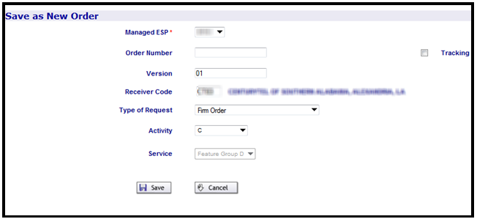

Use the following matrix to determine the next step:
If | Then
New order to be for tracking purposes only | Click the Tracking button and proceed
New order is NOT to be for tracking purposes | Proceed

- The user will enter the ICSC applicable for the new order in the Receiver Code field. Note: The Receiver Code field is already populated with the ICSC of the order replicating; however, it can be changed.

- Leave the Type of Request field populated with Firm Order. Note: If the Type of Request field is populated with anything other than Firm Order, change it to Firm Order.

- Select the activity applicable to the order from the Activity field drop-down menu. Note: The Activity field is already populated with the activity of the order replicating; however, it can be changed

Use the following matrix to determine the next step:

If | Then
User is ready to create the order | Click the Save button and proceed  Result: The order is replicated and the new order displays.
User is not ready to create the order | Click the Cancel button and do not proceed.  Result: The order is not replicated and the screen returns to the previous screen of either the Order List or the order.

Enter all pertinent fields and submit the order to CenturyLink.

Order Supplements

Once an order is submitted and the status changes to Accepted (or Sent for meet-point orders where CenturyLink is not in control), the user must issue a supplement order to make changes or cancel. The user can make changes or cancel all the way up to the point at which the order changes to Completed status. There are two ways to supplement an order:

- Select the 1, 2 or 3/4 ICON in the top right of the order to initiate the supplement.

1 = Supplement Cancel
2 = Supplement DDD Change (Due Date Change)
3 / 4 = Supplement Others

- Select Cancel, DDD Change, or Others from the Order Tab Supplement sub-menu.

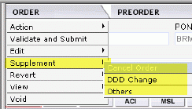

Use the following matrix to determine the next step:

If | Then
The user issues a supplement to cancel the order (SUP 1)  Result: A pop-up box appears asking if user wants to proceed with cancelling the order  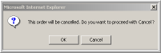  Note: Clicking the Cancel button discontinues the cancel request. | Click the OK button to cancel the order. Result: A pop-up box appears which allows the user to enter remarks.  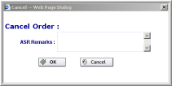  Type remarks and click OK to cancel the order.  Note: Clicking the Cancel button discontinues the cancel request.

If | Then
The user issues a supplement to ONLY change the due date (SUP 2)  Result: A Desired Due Date Change pop-up box appears | Select a new due date, add remarks if necessary, and click the Change button.  Note: Clicking the Cancel button discontinues the due date change.
User issues a supplement to change something other than the due date or in addition to the due date (SUP 3)  Result: The Status field changes to Pending Validation. | Make the necessary changes to the order and click the Submit ICON .  Note: If an Error Code List box appears, correct the error and resubmit.

Ordering Options

There are two Order Tabs as follows:

- The Order Tab that displays when the default Order List screen is in view

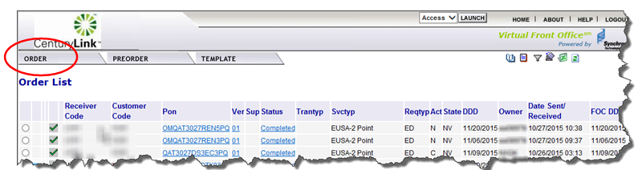

- The Order Tab that displays when initiating a new order or viewing an existing order.

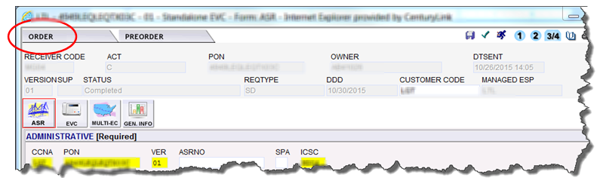

Resend

If the order gets stuck in Sent or Resent status and it is not a meet-point order where CenturyLink is not in control, the user can resend the order to try to get it to go to Accepted status. If a customer does not receive an “accept” or “error” status within their normal processing time, the customer may contact CenturyLink to determine if the order is stuck before resending.

The order stays in Sent status initially on meet-point orders where CenturyLink is not in control, so do not resend the order in that scenario.

There are two ways to resend an order (other than meet-point orders where CenturyLink is not in control) as follows:

- Resend from within an Order
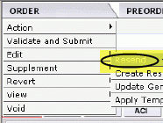

- Resend from the Order Tab when an order is selected from the Order List

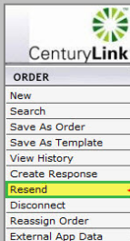

View

A user can view a printable version of an order by selecting the View Printable Version from the View sub-menu of the Order tab menu while in an order.

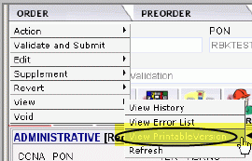

Save Order

The Action menu option from the Order tab drop-down menu within an order contains a Save Order sub-menu option. When working with an order, a user can save work any time by selecting Save Order from the Action menu option of the Order tab. An order will be saved every time it is validated.

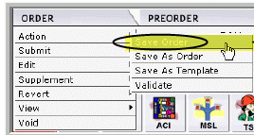

Revert

The Revert menu option from the Order tab has two sub-menu items as follows:

- Revert to Last Save - Reverts the order back to the last time it was saved or validated.
- Revert to Last Submitted - Reverts the order back to the last time it was submitted.

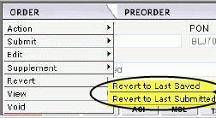

Void

The Void menu option from the Order tab within an order allows the user to void an order that has not been submitted and accepted. Once an order has been submitted and accepted, the user will have to supplement the order to cancel if it is not needed. If an order is voided, the PON associated with that order cannot be used again until the voided PONs are purged from the database. There is not a timeframe established for purging voided orders at this time.

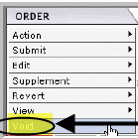

Order History

There are several ways to view the history of an order in EASE VFO as follows:
- Click the History ICON  when an order is selected from the Order List
- Clicking the History ICON while viewing an order
- Selecting View History from History sub-menu of the Order tab while viewing an order

Use the following matrix to determine the next step:

If | Then
User wants to see the history of an order from the Order List | - Click the radio button next to the left of the order.  - Click the History ICON in the upper right hand corner of the screen.
User wants to see the history of an order that user is viewing | - Click the History ICON in the upper right hand corner of the screen.  - Select View History from the History sub-menu of the Order tab.

Use the following matrix to determine the next step:

If | Then
User wants to see errors associated with the order | - Click the PON that has a Status column that says Errored.  Result: The order displays with Error Code List box that shows you what errored at that point in the order lifecycle.  - Click the Close button at the top right of the screen to exit that piece of the order history.
User wants to view a Clarification, Jeopardy, DLR, Confirmation, or Completion | - Click the PON that has a Status column that says Clarification, Jeopardy, DLR, Completion, or Confirmation.  Result: The appropriate form is displayed.  - Click the X in the top right hand corner of the window to exit the form.  Note: User can select the Print button at the top right to print the form data.

Use the following matrix to determine the next step:

If | Then
User wants to return to the order of which you were viewing the history | Click the Back to Order ICON  in the top right hand corner of the screen.
User wants to close the order | Click the X in the top right hand corner of the window.

View Status from the Order List

Looking at the Order History screen is not the only way to view Clarifications, Confirmations, Jeopardies, DLRs, and Completions. When the PON is in view on the Order List, a user can click the Status column of that PON and view these items.

PreOrder Tab

Using preorder functionality ensures good data is present on the order before it is submitted to CenturyLink. This eliminates multiple rejections and delays in customer orders. There are two submenus under the PreOrder Tab in EASE VFO.

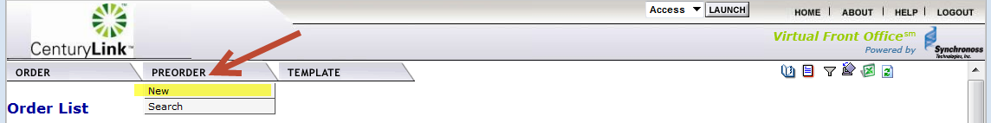

- Selecting New from the PreOrder menu allows the user to initiate a new preorder.
- Selecting Search from the PreOrder menu allows user to search for an existing preorder.

If a CenturyLink address preorder is not done by using the PreOrder tab menu, the user can perform an address preorder during order initiation. Instructions on how to perform the CenturyLink address preorders while entering an order are in the EASE VFO Order Module.

With the Order List in view, place the cursor over the PreOrder Tab and select New. The PreOrder Initiation screen appears.

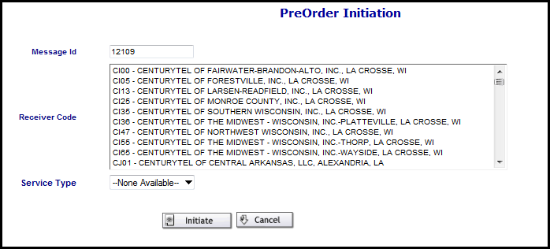

- Message Id – tracks the preorder—it can be the Purchase Order Number (PON) or any other alpha, numeric, or alphanumeric combination up to twenty-five characters in length.
- ICSC – drop-down that contains the CenturyLink ICSC for the region where the address or CFA is located.
- Service Type – contains three values—CFA_INQUIRY, CLLI_SCAN_INQUIRY and LOCATION_INQUIRY.
- Initiate – initiates the preorder.
- Cancel – discontinues the preorder

Type a tracking ID in the Message ID field. This can be up to twenty-five alpha, numeric, or alphanumeric characters, and needs to be entered in all CAPS.



Choose the region of the CenturyLink address from the Receiver Code box.

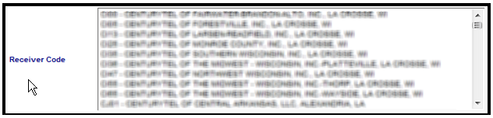

Select the Service Type field from the drop-down.

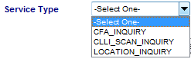

Click the Initiate button. The screen appears with the Inquiry tab as the default.



Use the following table to determine the next step.

If | Then
Doing a preorder on a CenturyLink address and user is on the LOCATION_INQUIRY screen | - Type the CCNA in the CCNA field.  - Type the state abbreviation in the State field.  - Type the address including city, state, and zip code in the Address Detail section.  - Click the Submit button.
Doing a preorder on a CFA that contains at least one CenturyLink location and user is on the CFA_INQUIRY screen | Type the CCNA in the CCNA field.  Type the state abbreviation in the State field.  Type the facility designation for the CFA—for example, C101 in the FACDESG field.  Type the type of facility—for example, T3 in the FACTYPE field.  Type the channel in the CHANNEL field.  Type the ACTL and MUX in the LOCA and LOCZ fields.  Click the Submit button.
If | Then
Doing a preorder using CLLI_SCAN_INQUIRY | Type the CCNA in the CCNA field  Type Location A CLLI in the LOCA field  Type Location Z CLLI in the LOCZ field  Click the Submit button

The query is initiated and the results display on the Results tab. The IRM fields shows whether or not the preorder was successful. See Appendix 3 for a list of the IRM Responses for PreOrder on a CenturyLink Address and for CFA that the user may receive.

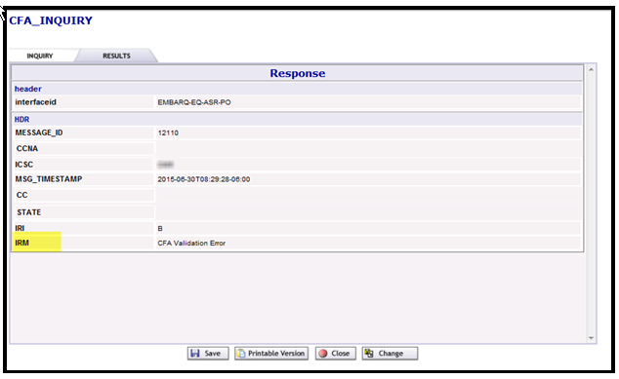

If the preorder is a success, the user can:

- Click the Save button to save the preorder.
- Click the Printable Version button to view and print the preorder.
- Click the Close button to exit.

Note: The preorder record is not saved if user closes without saving first.

If the preorder is not a success, the user can:

- Click the Change button to try the preorder again.
- Click the Save button to save the preorder.
- Click the Printable Version button to view and print the preorder.
- Click the Close button to exit

Once a CenturyLink address or CFA is validated via the Preorder tab and is determined to be valid, user can proceed to order initiation.

While entering an order, preorder validation of a CenturyLink address or CFA can be initiated by clicking the Validate button next to the CFA field or the Address Detail section. When this happens, the Inquiry tab of the LOCATION_INQUIRY or CFA_INQUIRY screen is bypassed and user is taken directly to the Results tab. The IRM field of the Results tab is where user can identify whether or not the CenturyLink address or CFA is valid.

Template Tab

A user can create a template in EASE VFO by selecting New from the Template tab drop-down menu. Information in templates should be basic so that additional orders of the same type can be created using the template.

Initiating a Template

Order Templates can be initiated in three ways:

- Choosing Save As Template from the Order tab menu on the Order List screen.

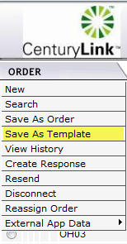

- Choosing Save As Template from the Action sub-tab menu while viewing an order

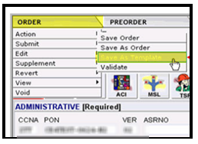

- Choosing New from the Template tab menu on the Order List screen

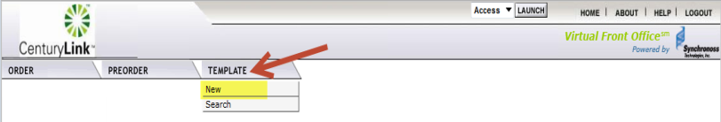

Creating a Template

Once the user has initiated a template, the Template Initiation page will appear.

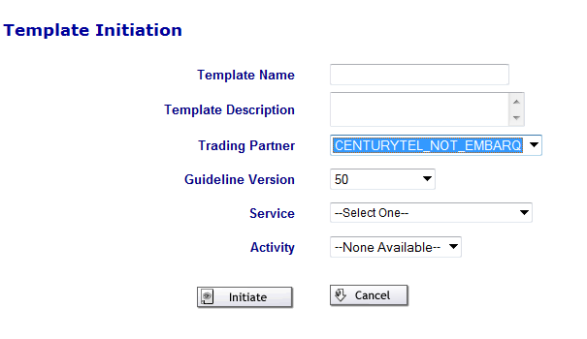

- Type the template name in the Template Name field.
- Type a description of the template in the Description field—for example, SA-2 Point New.
- Choose a value from the Trading Partner field drop-down menu. Result: The Guideline Version field pre-populates.
- Select the type of service for the template from the Service field drop-down menu.
- Select the type of order activity for the template from the Activity field drop-down menu.
- Click the Initiate button. Result: The order template is created and the template fields are ready to be populated.
- Populate the fields and forms to be included in the order template.
- Once the fields and forms for the template are populated, click the initiate button.



Modifying or Deleting a Template

With the Order List in view, the user will select Search from the Template Tab menu.

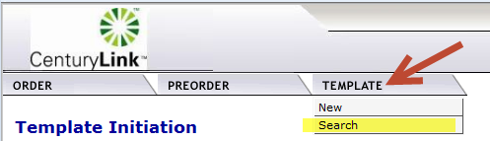

The Template List will appear.

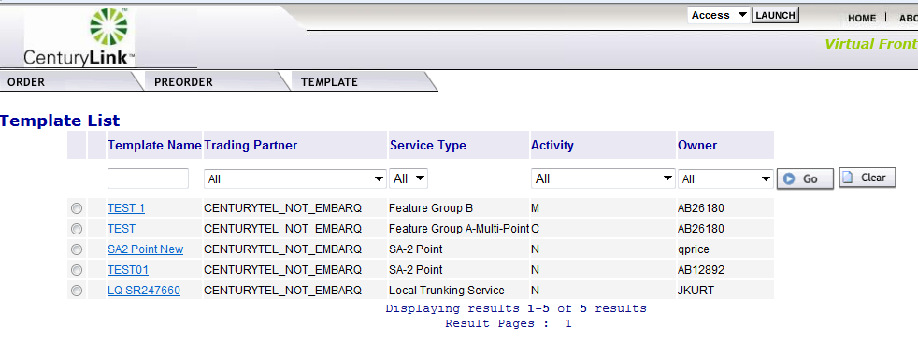

Use the following matrix to determine the next step:

If | And | Then
The template user wants to work with is in the Template List | User wants to delete the template | - Click the radio button to the left of the template name  - Click the Red X in the top right hand corner of the screen Result: A pop-up box displays asking if you are sure you want to delete the template.  - Click the OK button to delete the template and do not proceed Result: The template is deleted.
The template user wants to work with is in the Template List | User wants to change the template | Proceed
The template user wants to work with is not in the Template List | User wants to modify or delete the template | - Type the template name in the Template Name field and click the Go button. Result: The template displays in the Template List.  Note: If the template is not found, “No Records Found” is displayed.  - Proceed

Select the template name from the Template list; make changes as needed. The template changes will be saved after the user has clicked the Save icon.

EASE Help

Help text is available for each field once in an order in EASE VFO. The help text may assist the user with correcting errors or choosing valid field values. The help text for each field displays at the bottom of the screen after clicking into the field.

Additional Resources

- The ASR Order page URL: http://www.centurylink.com/wholesale/systems/ossconsolid.html

- EASE Training: http://training.centurylink.com/ease

- Address Validation Utility, Virtual Front Office, and Reference Table Maintenance: http://ease.centurylink.com/

- The ASOG document is available from the OBF Document Catalog at ATIS.org.

Contact Information

For additional assistance with ASR Inquiries:
- Via Phone: (913)353-7439

- Via Email: Helpdesk.ease@CenturyLink.com

Appendix 1 - Order List Status

The Order List status matrix below provides definition and user action for each status on the Order List.

Status | Definition | Send/Rcv or Receive | User Action
Accepted | The Access Provider (Trading Partner) has received the order and sent a positive acknowledgement for the order. Exchange Path has updated the status, stored the message in the Exchange Path database, and sent a notification message to VFO to update the status. The ASR has passed fatal validations. | Send/Rcv | Wait for FOC
Accepted | The Access Provider (Trading Partner) has received the order and it has passed fatal validations. | Receive | The response goes to Accept Submitted, so it can be transmitted to the order originator.
Accepted Submitted | The Accepted response is sitting in queue waiting to be transmitted to the ASR Originator. | Receive | Once the Accepted status has been transmitted, the status is changed to Accepted Sent.
Accepted System Errored | The Accepted response could not be transmitted to the ASR originator. | Receive | Once the system errors have been resolved, the Accept response can be Submitted again.
Accepted Sent | The Accepted response has  been transmitted to the ASR originator. | Receive | The user can create and submit.

Status | Definition | Send/Rcv or Receive | User Action
Cancel Accepted | The AP has returned a positive acknowledgement of canceling an ASR. Exchange Path has updated the  status, stored the message in the Exchange  Path Database, and sent a notification  message to VFO. | Send/Rcv | No Action
Cancel Received | The Cancel request has been received by the AP. | Send/Rcv | No Action
Cancel Rejected | The AP has returned a negative rejection acknowledgment for a cancellation. | Send/Rcv | View the reject reason and take the recommended action.
Cancel Resent | The Cancel request has been resent. | Send/Rcv | No Action
Cancel Sent | A Cancel request has been sent to the AP. | Send/Rcv | No Action
Cancel Submitted | The Cancel request has been sent to Exchange Path (behind the scenes EASE interface) for validation and subsequent processing. | Send/Rcv | No Action
Cancel Tracked | An order that is for tracking only has been cancelled. | Send/Rcv | No Action
Cancelled | The order has been supplemented with a cancel request. | Send/Rcv | No Action
Clarification | The AP has initiated a Clarification message. Exchange Path has updated the status, stored the message in the Exchange Path Database, and sent a message to VFO to update the status. | Send/Rcv | Review the Clarification and take the recommended action.
Clarification Invalidated | The AP has initiated a Clarification message for the order, but the clarification was not validated. | Send/Rcv | Review the Clarification and take the recommended action.

Status | Definition | Send/Send-Receive | User Action
Clarification Cleared | The Trading Partner has returned a  Clarification Cleared message for the  Access Order and Exchange Path has sent a notification message to VFO to update the status. | Send/Rcv | No Action
Clarification Cleared Invalidated | The AP has initiated a Clarification Cleared message for the order, but the Clarification was not validated. | Send/Rcv | No Action
Clarification Cleared Saved | The Clarification Cleared has been cancelled and a response notification has  been created and saved by the user in VFO. | Receive | A Clarification Cleared response is submitted by the user.
Clarification Cleared Submitted | The Clarification Cleared response is sitting in queue, waiting to be  Transmitted to the ASR originator. | Receive | Once the  Clarification Cleared  response has been  transmitted, the status  is changed to  Clarification Cleared  Sent.
Clarification Saved | There are issues/questions about an ASR and a Clarification response has been created and saved by the user in VFO. | Receive | The Clarification  response is submitted  by the user. Review the Clarification and take the recommended action.
Clarification Sent | The Clarification response has been transmitted to the ASR originator. | Receive | Review the Clarification and take the recommended action.
Clarification Cleared Sent | The Clarification Cleared response has been transmitted to the ASR originator. | Receive | The user can create and submit any of the  Subsequent statuses.
Clarification Cleared System Errored | The Clarification Cleared response could not be transmitted to the ASR originator. | Receive | Once the system errors have been resolved, the Clarification Cleared response can be submitted again.

Status | Definition | Send/Send-Receive | User Action
Clarification System Errored | The Clarification response could not be transmitted to the ASR originator. | Receive | Once the system errors have been resolved, the Clarification cleared response can be submitted again.
Clarification Submitted | The Clarification response is sitting in queue, waiting to be transmitted to the  ASR originator. | Receive | Once the Clarification  response has been  transmitted, the status  is changed to  Clarification Sent.
Clarification Validated | The Clarification has been initiated and validated, but not sent or submitted. (It is viewable online, but will not be sent back via e-mail, fax, or batch.) | Receive | Submit the Clarification.
Completed | The VFO user has manually updated the ASR status to Completed or the AP has initiated a Completed message. | Send/Rcv | Review Response
Completed Invalidated | The AP has initiated a completion message, but the completion was not validated by the internal EP system. | Receive | No Action
Completed Saved | The ASR has been Completed and a response has been created and  Saved by the user in VFO. | Receive | The Completed response is submitted by the user.
Completed System Errored | The Completed response could not be transmitted to the ASR originator. | Receive | Once the system errors have been resolved, the Completion response can be submitted again.
Completed Sent | The Completed response has been transmitted to the ASR originator. | Receive | No further updates are  allowed once the order is in a Completed Sent status.
Completed Submitted | The Completed response is sitting in queue, waiting to be transmitted to the ASR originator. | Receive | Once the Completed  response has been  transmitted, the status  is changed to Completed Sent.

Status | Definition | Send/Send-Receive | User Action
Confirmed | The AP has returned a Confirmation message for the order. Exchange Path has updated the status, stored the message in the EP database, and sent a notification message to VFO to update the status. | Send/Rcv | Review Response
Confirmed Sent | Indicates that the Confirmed response has been transmitted to the  ASR originator. | Receive | User can create and  submit any of the  subsequent statuses.
Confirmed Submitted | The Confirmed response is sitting in queue, waiting to be transmitted to the ASR originator. | Receive | Once the Confirmed  response has been  transmitted, the status  is changed to Confirmed Sent.
Confirmed Saved | The Confirmation response has been created and saved by the user in VFO. | Receive | The Confirmed response is submitted by the user.
Confirmed System Errored | The Confirmation response could not be transmitted to the ASR originator. | Receive | Once the system errors have been resolved, the Confirmed response can be submitted again.
DLR Saved | The DLR response has been created and saved by the user in VFO. | Receive | The DLR response is submitted by the user.
DLR Sent | The DLR response has been transmitted to the ASR originator. |  | The user can create and submit any of the  Subsequent statuses.
DLR System Errored | The DLR response could not be transmitted to the ASR originator. | Receive | Once the system errors have been resolved, the DLR response can be  submitted again.
DLR Submitted | The DLR response is sitting in queue, waiting to be transmitted to the ASR  Originator. | Receive | Review Response
Design Order Confirmed Saved | The DOC response has been created and saved by the user in VFO. | Receive | The DOC response is submitted by the user.

Status | Definition | Send/Send-Receive | User Action
Design Order Confirmed Submitted | The DOC response is sitting in queue waiting to be transmitted to the ASR originator. | Receive | Once the DOC response has been transmitted, the status is changed to Design Order Confirmed Sent.
Design Order Confirmed System Errored | The DOC response could not be transmitted to the ASR originator. | Receive | Once the system errors have been resolved, the DOC response can be submitted again.
Design Order Confirmed Sent | The DOC response has been transmitted to the ASR originator. | Receive | The user can create and submit any of the subsequent statuses.
Design Order Confirmed | The AP has returned a Design Order Confirmation message for the order. Exchange Path has sent a notification message to VFO to update the status. | Send/Rcv | Review Response
DLR/Design | The AP has returned a DLR for the order. Exchange Path has updated the status, stored the message in the EP database, and sent a notification message to VFO to update the status. | Send/Rcv | Review Response
Jeopardy with Errors Invalidated | The Jeopardy was initiated, not validated, and contains errors. | Send/Rcv | Validate and submit the Jeopardy response.
Jeopardy with Errors Submitted | The Jeopardy with Errors response is sitting in queue waiting to be  Transmitted to the ASR originator. | Receive | Once the Jeopardy with Errors response has been transmitted, the status is changed to Jeopardy with Errors Sent.
Jeopardy with Errors Saved | The FOC date is in Jeopardy due to errors on the ASR and a response has been created and saved by the user in VFO. | Receive | The Jeopardy with  Errors response is submitted by the user.

Status | Definition | Send/Send-Receive | User Action
Jeopardy with Errors System Errored | The Jeopardy with Errors  Response could not be transmitted to the ASR originator. | Receive | Once the system errors have been resolved, the Jeopardy with Errors response can be submitted again.
Jeopardy with Errors Sent | The Jeopardy with Errors response has been transmitted to the ASR originator. | Receive | The user can create and submit any of the  Subsequent statuses.
Jeopardy Invalidated | The Jeopardy was initiated and not validated. (It is viewable online, but will not be sent back via e-mail, fax, or batch. | Receive | Validate and submit the Jeopardy response.
Jeopardy Saved | The FOC date is in jeopardy and a response has been created and saved by the user in VFO. | Receive | The Jeopardy response is submitted by the user. Review the Jeopardy and take the recommended action.
Jeopardy Sent | The Jeopardy response has been transmitted to the ASR originator. | Receive | The user can create and submit any of the subsequent statuses.
Jeopardy Submitted | The Jeopardy response is sitting in queue waiting to be transmitted to the ASR originator. | Receive | Once the Jeopardy  response has been  transmitted, the status  is changed to Jeopardy Sent.
Jeopardy System Errored | The Jeopardy response could not be transmitted to the ASR originator. | Receive | Once the system errors have been resolved, the Jeopardy response can be submitted again.
Jeopardy Saved | The FOC date is in Jeopardy and a response has been created and saved by the user in VFO. | Receive | The Jeopardy response is submitted by the user.
Errored | The ASR has failed the validation process. Exchange Path has updated the Request Status, stored the ASR, and sent an Error Notification to VFO. | Receive | Correct the error and validate again.
Jeopardy | Jeopardy status indicates that there are situations that may jeopardize critical dates of the ASR. | Send/Rcv | Review the Jeopardy and take the recommended action.
Status | Definition | Send/Send-Receive | User Action
Jeopardy with Errors | Indicates there are situations that may jeopardize critical dates of the ASR and there are errors with the request. | Send/Rcv | Review the Jeopardy and take the recommended action.
Pending Completion | The Exchange Path Monitor process  determines that a Completion notice has  Not been received in the time allotted and issues a notification message to VFO to update the status. | Send/Rcv | Contact the AP to find out the cause of the delay in response.
Pending Design | The Exchange Path Monitor process determines the DLR or Design information has not been received in the time allotted and a notification message is sent to VFO to update the status. | Send/Rcv | Contact the AP to find out the cause of the delay in response.
Pending Confirmation | The Exchange Path Monitor process determines that the Firm Order Confirmation (FOC) has not been received in the time allotted and issues a notification message to VFO to update the status. | Send/Rcv | Contact the AP to find out the cause of the delay in response.
Pending Response | The Exchange Path Monitor process determines a Response has not been received in the time allotted and a notification message is sent to VFO to update the status. | Send/Rcv | Contact the AP to find out the cause of the delay in response.
Pending Validation | An initial request or a change to a request (other than Cancel) has been created, but the request has not been sent to Exchange Path for validation or submission to the AP. After selecting Submit or Validate, the resulting response from Exchange Path will be Validated or Errored. | Send/Rcv | Finish entering the order and submit.
Received | This status appears when service requests are sent to VFO for processing. This indicates the customer’s request has been received. | Send/Rcv | The Accept response is generated by the system if fatal validations are passed.

Status | Definition | Send/Send-Receive | User Action
Rejected | The AP has returned a negative (rejection) acknowledgment. Exchange Path has updated the status, stored the message in the Exchange Path  Database, and sent a notification message to VFO to update the status. | Send/Rcv | Review the response and take the recommended action.
Resent | Another copy of the last submitted version of the ASR is sent to the AP. | Send/Rcv | No Action
Sent | The order is sent to the AP, the status is updated, and a notification message is sent to VFO to update the status. | Send/Rcv | No Action
Sent Failed | An attempt to send the order to the AP fails. | Receive | Try to send the order again.
Submitted | This status indicates that an initial request or a change to a request has been sent to the AP for validation and subsequent processing—status does not apply to a cancel request. | Send/Rcv | No Action
Supplemented | The order has been supplemented. | Receive | No Action
Supplement Received | The customer has sent a supplement to the previously received service request. | Send/Rcv | The Accept response is generated by the system if fatal validations are passed.
System Errored | VFO has received a system error message from Exchange Path. | Send/Rcv | Read the error message, correct it, and submit the order again.
TP Cancelled | The Access Provider has cancelled the customer’s order due to no response to a Clarification/Notification Request. | Send/Rcv | Create a new order if one is still needed.
TP Cancelled Invalidated | The AP (also known as the Trading Partner (TP)) has cancelled the customer’s ASR due to no response to a Clarification/Notification Request (internal EP did not validate cancellation). | Receive | Create a new order if one is still needed.

Status | Definition | Send/Send-Receive | User Action
TP Cancelled Submitted | The TP Cancelled response is sitting in queue waiting to be transmitted to the ASR originator. | Receive | Once the TP Cancelled has been transmitted, the status is changed to TP Cancelled Sent.
TP Cancelled Saved | The ASR is being cancelled by the Access Provider because Clarifications have not been resolved and a response has been created  and saved by the user in  VFO. | Receive | The TP Cancelled response is submitted by the user.
TP Cancelled Submitted | The TP Cancelled response is sitting in queue waiting to be transmitted to the ASR originator. | Receive | Once the TP Cancelled  response has been  transmitted, the status  is changed to TP Cancelled _Sent.
TP  Cancelled System Errored | The TP Cancelled response could not be transmitted to the ASR originator. | Receive | Once the system errors have been resolved, the TP Cancelled response  can be submitted again.
TP Cancelled Sent | The TP Cancelled response has been transmitted to the ASR originator. | Receive | The user can create and submit any of the subsequent statuses.
TP Errored | The Trading Partner has returned one or  More error messages for the order.  Exchange Path has updated the status,  stored the message in the Exchange Path  Database, and sent a notification message to VFO to update the status. | Send/Rcv | Review the response and take the recommended action.
TP Errored Saved | The ASR has validation errors and a response has been created and saved by the user in VFO. | Receive | The TP Errored response is submitted by the user.
TP Errored Submitted | The TP Errored response is sitting in queue waiting to be transmitted to the ASR originator. | Receive | Once the TP Errored response has been transmitted, the status changes to TP Errored Sent.

Status | Definition | Send/Send-Receive | User Action
TP Errored System Errored | The TP Errored response could not be transmitted to the ASR originator. | Receive | Once the system errors have been resolved, the  TP Errored response  can be submitted again.
TP Errored Sent | The TP Errored response has been transmitted to the ASR Originator. | Receive | The user can create and submit any of the subsequent statuses.
Tracked | The order was initiated as a “Tracking Only” request and is not be transmitted to the AP. This is used when the order was sent manually outside of VFO and user wants to track the order progress manually in VFO. | Send/Rcv | No Action
Validated | This indicates that an order has been successfully validated and there are no errors. | Send/Rcv | No Action
Voided | An order that was never submitted can be voided to indicate that the order should not be transmitted to the AP. | Send/Rcv | No Action

Appendix 2 - Order Types

The Order Type matrix below provides the Service Type, CenturyLink product, Request/Order Type, EASE VFO Form, and Notes.

Service Type | CenturyLink Product | Request/Order Type | EASE VFO Forms | Notes
CCS Links | SS7 Links | LD/Switched | TQ  Trunking
EUSA-2 Point | - DS0  - DS1  - DS3  - Program Audio  - Program Video  - LC EVPL UNI | ED/Specials/PLT | EUSA  SES (EVPL) | End-user address to End-user address (only one address with EVPL)
EUSA-Multi-Point | - DS0  - DS1  - DS3 | ED/Specials/PLT | EUSA  MSL
End User EVC | UNI/EVC Combo | ED/LC EVPL | SES  EVC | LC EVPL Combo order with address
End User Switched Ethernet EVC | UNI/EVC Combo | ED/LQ MOE | SES  EVC | Combo order with address
End User Switched Ethernet | UNI | ED/LQ MOE | SES | UNI with one address
Feature Group A-Multi-Point | N/A | N/A | N/A | Per Tariff - CenturyLink offering is point-to-point only
Feature Group A | - Trunks  - Combos | AD/Switched | FGA

Service Type | CenturyLink Product | Request/Order Type | EASE VFO Forms | Notes
Feature Group B | - Trunks  - Combos | MD/Switched | Trunking  TQ  EOD
Feature Group C | - Trunks  - Combos | MD/Switched | Trunking  TQ  EOD | Not used by CenturyLink
Feature Group D | - Trunks  - Combos | MD/Switched | Trunking  TQ  EOD
Local Trunking Service | - Trunks  - Combos  - LIS and WIS Trunks  - LIS and WIS Combo  - LIS and WIS 911 Trunks  - LIS and WIS 911 Combo  - Paging  - Type 1 | MD/Switched | Trunking  TQ  EOD
Ring Service | - LC SONET  - LC SOCR | RD/LC Rings | Ring | Not offered as meet-point

Service Type | CenturyLink Product | Request/Order Type | EASE VFO Forms | Notes
SA-2 Point | - DS0  - DS1  - DS3  - LC MASC  - Collocation scenarios  - LC NetPoint  - Program Audio  - Program Video  - LC OptiPoint  - LQ OWS  - LQ GeoMax  - LQ SHNS  - Ethernet Transport  - LC EVPL UNI | SD/Specials/PLT | Transport  NAI (Daisy Chain) | - ACTL to end-user or ACTL to central office  - LC EVPL UNI has not SECLOC
SA-Multi-Point | - DS0  - DS1  - DS3 | SD/Specials | Transport  MSL
SACNXX | 500, 900 Service | MD/Switched | Trunking  TQ  EOD
Standalone EVC | EVC | SD/LC EVPL and LQ MOE | EVC
TQ | Translations Only | MD/Switched | TQ
Transport EVC | UNI/EVC Combo | SD/LC EVPL | Transport  EVC | ACTL and no SECLOC
Transport Switched Ethernet EVC | UNI/EVC Combo | SD/LQ MOE | SES  EVC | ACTL and no SECLOC
Transport Switched Ethernet | UNI | SD/LQ MOE | SES | ACTL and no SELOC

Service Type | CenturyLink Product | Request/Order Type | EASE VFO Forms | Notes
Virtual Connection EUSA | - Frame Relay  - ATM  - DSL over ATM  - Resale Frame Relay | XD/Broadband | EUSA  VC
Virtual Connection-SA | - Frame Relay  - ATM  - DSL over ATM | VD/Broadband | Transport  VC
WAL | WATS | WD/WATS | WAL

Appendix 3 – PreOrder IRM Responses

The IRM Field Response matrix below provides definition for each IRM Field Response.

The below matrix provides the definition for the IRM field response when doing a preorder on a CenturyLink address.

IRM Field Response | Definition
Exact match | The CenturyLink address is valid according to CenturyLink records.
Alternatives exist | The CenturyLink address is not an exact match of what CenturyLink records show. Alternative addresses are provided.
Zip code was not found. Request not executed : -2109 | The zip code entered is not in CenturyLink territory.
State Code is invalid for this Zip Code. Request not executed : -2110 | The state and zip code combination is invalid.
Facilities not found : -2131 | The address is valid in CenturyLink territory, but no facilities exist.
No CenturyLink addresses found for this address : -2130 | The address is not valid.

The below matrix provides the definition for the IRM field response for CFA when doing a preorder on a CenturyLink address.

IRM Field Response | Definition
Channel Vacant – Available for Assignment | The CFA is valid and the channel specified is available for assignment.
Channel Busy – Not Available for Assignment | The CFA is valid, but the channel specified is not available for assignment.
Requested Information Not Found | The CFA cannot be found in our records.

Appendix 4 – Address Fields and Definitions

The below matrix provides the address fields and definitions for the Address Details section of an order.

Address Field | Definition
AFT (Address Format Type) | Valid Entries:  A = Rural route and/or box number  B = Unnumbered  C = Provider Assigned house number  D = Descriptive  E = Provisioning Address
SAPR (Service Address Number Prefix) | Identifies the prefix for the address number of the service address
SASF (Service Address Number Suffix) | Identifies the suffix for the address number of the service address
SASD (Service Address Street Directional Prefix) | Identifies the street directional prefix for the service address—for example, N = North, S = South, E = East, W = West, etc
SATH (Service Address Street Type) | Identifies the thoroughfare portion of the street name of the service address—for example, LN = Lane, BLVD = Boulevard, ST = Street, etc
SASS (Service Address Street Directional Suffix) | Identifies the street directional suffix for the service address—for example, N = North, S = South, E = East, W = West, etc  Note: The SASS is different than the SASD. The SASS is when the directional comes after the street name—for example, Main St West.
LD1 (Location Designator 1) | Identifies additional specific information related to the address—for example, building, floor, unit, or room
LV1 (Location Value 1) | Identifies the value associated with the LD1 of the address

Address Field | Definition
LD2 (Location Designator 2) | Identifies additional specific information related to the address—for example, building, floor, unit, or room
LV2 (Location Value 2) | Identifies the value associated with the LD2 of the address
LD3 (Location Designator 3) | Identifies additional specific information related to the address—for example, building, floor, unit, or room
LV3 (Location Value 3) | Identifies the value associated with the LD3 of the address

Appendix 5 – Sample ASR

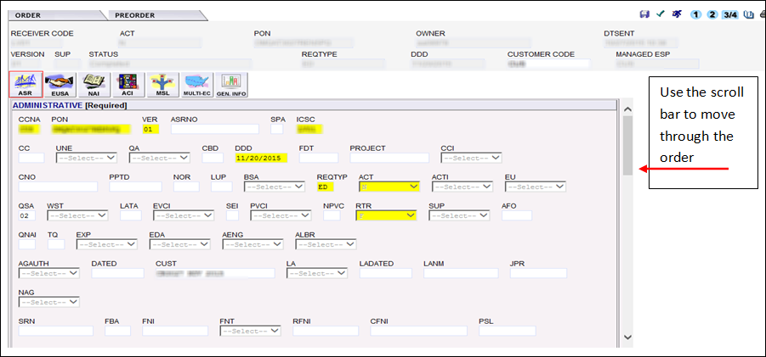
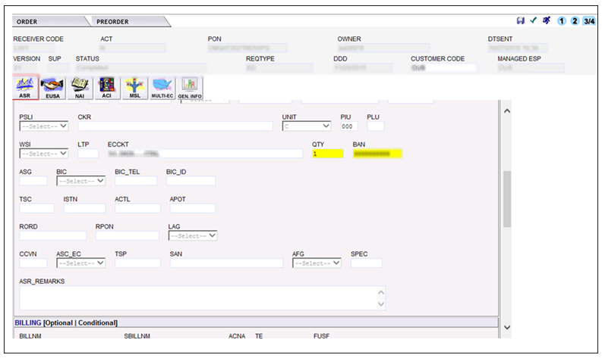

Appendix 5 – Sample ASR Continued

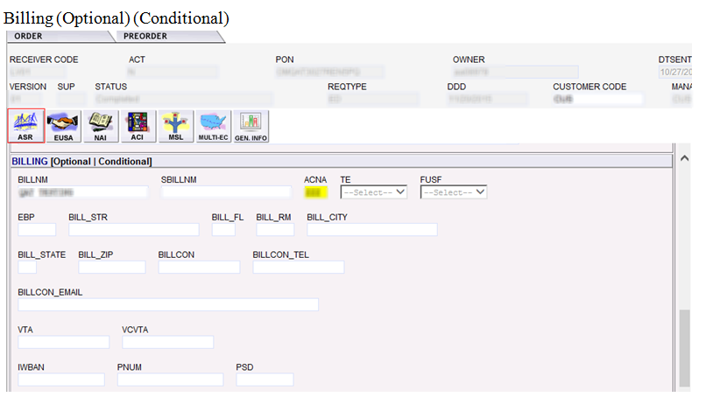
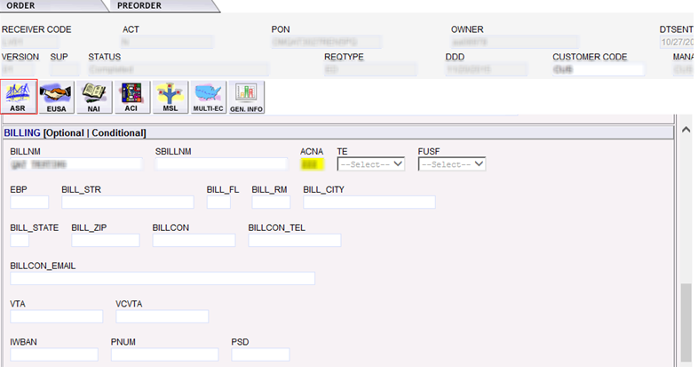

Contact (Optional) (Conditional)

