
CLEC PIC and LPIC Verification Job Aid

Version 11 – August 2011
Confidential
Copyright 2011 by CenturyLink. All rights reserved.

The information provided herein is for training purposes only. The information provided does not create or modify any legal obligations between CenturyLink and a Reseller. The parties’ relationship is governed by existing legal obligations.

CLEC PIC and LPIC Verification Job Aid
Table of Contents
Version History v
Documentation Conventions 1
Overview 1
Here’s how it works: 3
Getting Started 4
Filling Out the Form 4
Input and Output Options 4
Output Grouping 5
Internet Set Up 6
Input/Output Time Frames 8
File Request Limits 8
CARE Overview 9
Record Layout Overview 10
Record Layout – Input Codes 11
Record Layout – WTN Format 11
Record Layout – LSPID 11
Record Layout - Jurisdictional Indicator (JI) 12
Assumptions and Dependencies 13
New Accounts 14
Formatting Input Files 15
Input File Control Header Fields 15
Input File - Header Record Fields Examples 16
Header Record Fields (cont.) 17
Input File Detail Record Fields 18
CLEC to CenturyLink—Input Detail Record 20
CLEC to CenturyLink—Input Control Trailer Record 21
CLEC to CenturyLink – Input Trailer Record Example 22
Echo Back Acknowledgment File Information 24
“Echo Back” File 25
File Acceptance/Rejection Codes 26
Reading Output Files 27
CenturyLink to CLEC - Output Header Record 28
CenturyLink to CLEC—Output Detail Record 31
CenturyLink to CLEC Output Trailer Record 33
CenturyLink to CLEC – Output Trailer Record 34
CenturyLink to CLEC – Output Trailer Record (Cont.) 35
Output Acceptance Codes 36
Output Reject Codes 37
Output Reject TCSIs 37
Output Reject TCSIs, Cont. 38
Working With the Help Desk 39
Working with Your CenturyLink Service Manager’s Assistance 40
Processing During Release Weekends 41
Processing During System Sync Up 41
Output 41
Holiday Processing-Input and Output 42
Saturdays Before a Monday Holiday 42
Holidays 42
PIC/LPIC Manual Process 43
Input 43
Output 43

Version History
Revisions of this document are listed in chronological order.
Document Release | Date
Version 1 | 9-27-01
Version 2 | 6-3-02
Version 3 | 9-20-02
Version 4 | 12-22-02
Version 5 | 5-23-03
Version 6 | 6-1-03
Version 7 | 12-22-03
Version 8 | 6-13-05
Version 9 | 7-8-05
Version 10 | 12-5-05
Version 11 | 08-11-11

Documentation Conventions
As you read through this document there will be a variety of Notes added to the body of the text. These notes are of critical importance.
Be aware of the following conventions when you read the notes:
All Notes are important to successful file submission
- Italicized Notes are to be considered advisory and informational in nature
- Boxed Notes are to be considered as strongly worded cautions or user specific warnings

Overview
PIC/LPIC Verification allows you to verify the PIC/LPIC data on your accounts. It’s all very easy—you electronically send a file to CenturyLink, CenturyLink checks the PIC/LPIC information in the central office switch and then sends you back an output file with responses to your request.
The exchange of account information is at Working Telephone Number (WTN) level. Output (notification and confirmation) is produced at Working Telephone Number level detail.
Note: This process does not deal in RSIDs or ZCIDs. The Regional Subscription System (RSS) requires a four digit number that represents the CLEC. The Operating Company Number (OCN) also known as Local Service Provider Identification is used.

This Page Left
Intentionally Blank

Here’s how it works:
You will create an electronic file to send to CenturyLink for real-time PIC/LPIC switch verification. That file is to be formatted in the industry standard 1500 byte Customer Account Record Exchange (CARE) format.
Once your file is received, CenturyLink internal systems will verify the ownership of the telephone number to confirm that the requesting CLEC owns the telephone numbers in the batch file. Ownership will be determined by comparing the LSPID of the requesting CLEC to the LSPID at the WTN level. If the telephone number belongs to the requesting CLEC, the PIC/LPIC Verify process will proceed.
If the telephone number is not owned by the requesting CLEC, a reject message will be sent in the output file.
If the account passes through that first edit, the appropriate central office switch will be queried for the current PIC/LPIC information for each telephone number on the file.
Responses will be provided in an electronic 1500 byte CARE formatted output file.
Note: This file does not update any of your databases.
A separate file must be submitted for each LSPID. LSPIDs cannot be mixed in one input file.

Getting Started
Go to the CenturyLink website and pull a copy of the CLEC PIC/LPIC Verification Establish or Change Input and Output form.
The form is located at located at the following url:
http://www.centurylink.com/wholesale/clecs/electronicaccess.html

Filling Out the Form
To fill out the form you will need to determine how you would like your output grouped and what option you want to use for sending and receiving files.

Input and Output Options
There are two options available for submitting and receiving PIC/LPIC Verification files - Internet and Transmission (mainframe to mainframe).
The Internet option is the preferred option. It is easy to set up and easy to use.
The Transmission option is available only to customers who already are utilizing that option (for Subscription, etc.).

Output Grouping
There are two ways to receive the output files; by NPA for entire LEC or by CenturyLink Region.
If you select Grouping by NPA for Entire LEC:
- You will receive one output file, sorted by NPA, then by TCSI, and then by Telephone Number. The sort within each caregory is done by numeric descending order.
If you select Grouping by Region:
- You will receive three separate files, sorted by CenturyLink Regions (Central, Eastern, then Western), then by NPA, then by TCSI and then by Telephone Number. The sort within each category is done by numeric descending order.
Here are each of the regions and the states in that region:
Eastern Region
Iowa, Minnesota, Nebraska, North Dakota, South Dakota
Central Region
Arizona, Colorado, S Idaho, Montana, New Mexico, Utah, Wyoming
Western Region
Oregon, Washington, N Idaho
If you have questions about the form, please contact your CenturyLink Service Manager for assistance. After you have completed the form, email it to your CenturyLink Service Manager.
Note: If you have more than one LSPID, you will need to fill out one form for each.

Internet Set Up
Following is a list of the items you will need to set up to send and receive files over the Internet.
- A PC with an operating system such as:
- Macintosh
- Windows An internet browser for accessing the Qwest Protected Internet Delivery (QPID) Gateway; such as Microsoft Internet Explorer:

- A Zip utility such as:
- WIN ZIP
- Or one that supports up to 256 character file names.

Note: If an application is larger that 300K it will need to be in the format of a Zipped file. The CLEC needs to ensure that they have the ability to manipulate Zip files before downloading files to the CLEC user workstation. You must extract the file with a zip utility before you can view it.
- A copy of the Qwest Protected Internet Delivery (QPID) Gateway User Guide.
- Detailed instructions on how to set up and use the Internet for input and output, access the Qwest Protected Internet Delivery (QPID) Gateway User Guide, which can be found at the following url:
http://www.centurylink.com/wholesale/clecs/electronicaccess.html
Note: You may have to copy and paste this url to your browser to get to the website.
At this URL, go to the section marked Electronic OSS Access Forms, Web Access, and download the Qwest Protected Internet Delivery (QPID) Gateway User's Guide.
- Software Editor
- To locate free editing software that can be pulled for formatting 1500 byte files, access any search engine and search for Downloads:Development Tools:Editors.
- If you want to create a plain text file, use the NotePad software that comes with the Windows operating system.
- If you work in UNIX, use the vi editor in the UNIX operating system.

Input/Output Time Frames
PIC/LPIC Verify processing occurs only on Monday through Saturday, but your input files can be accepted Monday through Sunday.
Input files submitted Monday through Saturday are processed the same day received. Output files will be sent within 48 hours.
Transmission input files must be submitted and received by 10:00 p.m. daily, Monday - Friday, and 5:30 p.m. on Saturday (holidays excepted).
NOTE: Transmissions received after 10:00 p.m. (5:30 p.m. Saturday) will be processed the following business day.
Internet input files must be received by 7:00 p.m. daily, Monday-Friday and 5:30 p.m. on Saturdays to be processed that day (holidays excepted).
NOTE: All times listed are for the Mountain time zone (Mountain Standard Time, Mountain Daylight Time).

File Request Limits
Input files must not exceed 500 WTNs per file.
- Input files must be separated by LSPID so that all of the telephone numbers (TNs) submitted in one file have the same LSPID.

CARE Overview
A special coded "language" was developed within the Interexchange Carrier industry so communication of subscription (PIC related) activity between the carriers and Local Operating Companies could be standardized and universal. The overall language is referred to as CARE (Customer Account Record Exchange) and is broken down into numeric codes to send subscription (PIC related) transactions back and forth between the Customer (carrier) and the Provider (CenturyLink).
When a carrier sends a PIC related request they are sending an input transaction. When CenturyLink processes the PIC related request, they send notification to the carrier of what happened on the account in the form of an output transaction.
The portion of CARE that is used to convey exactly what to do with these transactions is the Customer Account Record Exchange/Industry Support Interface (CARE/ISI) and is comprised of the Transaction Code/Status Indicators.
CARE/Industry Support Interface (ISI) allows for the transmission of multiple types of transactions on the same file by the user of special identifiers called "Transaction Codes (TCs)" and "Status Indicators (SIs)". Together they convey the purpose of each transaction.
We are utilizing CARE for PIC/LPIC Verify so we have a standard language to communicate PIC/LPIC information to the CLECs.

Record Layout Overview
To send PIC/LPIC Verify files, you will need to format each transaction in a specific format. This is the 1500 byte record layout.
Each file sent and received will contain a header, the detail record, and a trailer. Each record submitted (for each telephone number) is 1500 bytes in length.
- The header signals that a file is incoming and supplies information about who is sending the file and the date the file is sent.
- The detail record will provide the actual telephone numbers and associated information.
- The input detail record shows what the CLEC wants done with the telephone numbers on the file.
- The output detail record shows the PIC/LPIC information on the telephone numbers. Input and output on each telephone number will be 1500 bytes in length.
- The trailer signals that this is the end of the file and supplies the total number of records on the file.
Just remember: input and output is like a train—the header is like the engine of the train and tells the world that it’s coming. The body is like 1500 train cars that carry information. The trailer is like the caboose or end of the train and let’s the world know that the train is finished.
No input or output file is complete unless it has a header, detail record, and trailer.

Record Layout – Input Codes
When formatting your Input Detail Record, always populate positions 1-2 with the Transaction Code of 07. The 07 tells RSS you are asking for PIC/LPIC Verify.
Always populate positions 3-4 with the Status Indicator of 70. The 70 tells RSS you are requesting the verification at the WTN level.
NOTE: This information is required.

Record Layout – WTN Format
When formatting your Input Detail Record, populate positions 21-30 with the WTN you want verified. The format is ten digits (NPA plus telephone number), no dashes.
NOTE: This information is required.

Record Layout – LSPID
When formatting your Input Detail Record, populate positions 42-45 with your LSPID.
NOTE: This information is required.
Remember: Only one LSPID per input file.

Record Layout - Jurisdictional Indicator (JI)
When formatting your file, you must designate whether you want the PIC, LPIC, or both verified. This is the Jurisdictional Indicator (JI).
Populate position 403 with the Jurisdictional Indicator.
- JI E = verify the PIC only (interLATA)
- JI A = verify the LPIC only (intraLATA)
- JI B = verify both the PIC and LPIC (inter and intraLATA)
When you format your file, you need to populate position 403 of the Detail Record with the JI so we will know at what level the account should be verified.
NOTE: This information is required.

Assumptions and Dependencies
Here are some basic requirements to keep in mind:
- PIC/LPIC Verification does not need to be scheduled in advance. The verification can be requested on an as-needed basis.
- The PIC/LPIC information provided in the output file is current and up-to-date as of the time the switch was verified. Changes to the PIC/LPIC information could be made after the verification occurred and before the CLEC receives the file.
- If the central office switch is down and the file cannot be run, RSS will provide the 2973 output TCSI for each WTN in the file.
- If the PIC/LPIC Verification file does not finish running before the CenturyLink systems come down for that day, RSS will finish running the file the next day.
- Once we have begun verifying the input file, we will not return any output on the file until every WTN has been verified.
- CenturyLink cannot provide information on PIC/LPIC changes that are pending at the time the input file is submitted.
- CenturyLink will query once for each file sent in by the CLEC. The query will not be re-run. If information is unavailable or errors occur the request will need to be resubmitted. RSS will send the 2973 output TCSI.
- The central office switches will search for the PIC/LPIC information on an account for an allotted time. If the switch cannot locate the WTN or the PIC/LPIC in that period of time, RSS will send the 2973 output TCSI.

New Accounts
If the CLEC is a new owner of an end user account, the CLEC will need to wait for 5-7 days before they request information on an account.
If the CLEC needs information sooner they can check in IMA or the CSR to verify if they are listed as the owner of the account. If CenturyLink records have been updated they can process requests on that specific WTN.

Formatting Input Files
Following is the Record Layout for input files. The Record Layout is provided in a table and then in screen shots so you can see how the layout looks.

Input File Control Header Fields
Notice that specific information in the Data Content column is required.
Position in Record | Field Structure | Element |  | Description | Data Content
1-2 | 9 (2) | Record Identification--Header |  | 00 | R
3-4 | 9 (2) | Record Identification--Direction |  | 01 = Customer to Provider | R
5-6 | X (2) | Not Available for Use |  | Blanks | R
7-12 | 9 (6) | Create Date |  | YYMMDD | R
13-16 | 9 (4) | Sequence Number |  | 0001-9999 | R
17-20 | X (4) | Provider Identification Code |  | See below | R
21-23 | X (3) | Reserved for Future CARE Assignment |  | Blanks | O
24-26 | 9 (3) | Provider RAO (Revenue Accounting Office) |  | Zeros | O
27-28 | X (2) | Sequence Group Identifier |  | Blanks | O
29-32 | X (4) | Version Number |  | 0004 | R
33-41 | X (9) | Not used in CenturyLink |  | Blanks | R
42-45 | X (4) | LSPID |  | Four numeric characters | R
46-1500 | X (1455) | Not Available for Use |  | Blanks | R
Field Structure Legend
9 = Numeric, right justified, zero filled
X = Alphanumeric, left justified, blank filled
Data Content Legend  R = Required  O = Optional |  |  | Provider Identification Code  Combined CenturyLink file 9636  Eastern region 9631  Western region 9638  Central region 9636

Input File - Header Record Fields Examples
The following provides on-line screen shots of the header record format.
- 00 indicates that this is a file header, 01 indicates this is a Customer to Provider file.
- 010718 is the Create Date. In this example it indicates this file was created by the CLEC July 18, 2001.
- 0001 is the Sequence number for this transaction. You will need to increment this number prior to submitting your next file to CenturyLink.
- This field indicates how you choose your output file sort. Combined CenturyLink file = 9636, Eastern region = 9631, Western region = 9638, Central region = 9636
Note: You will need to track your sequence numbers to ensure you increment them correctly and to validate that you have received your output files.

2.
3.
4.
1.
0004

Header Record Fields (cont.)
- This field shows the Provider RAO (Revenue Accounting Office) which is zero filled.
- This field shows the version number which is always 0004
7. In this example, 7810 is the CLEC’s LSPID.
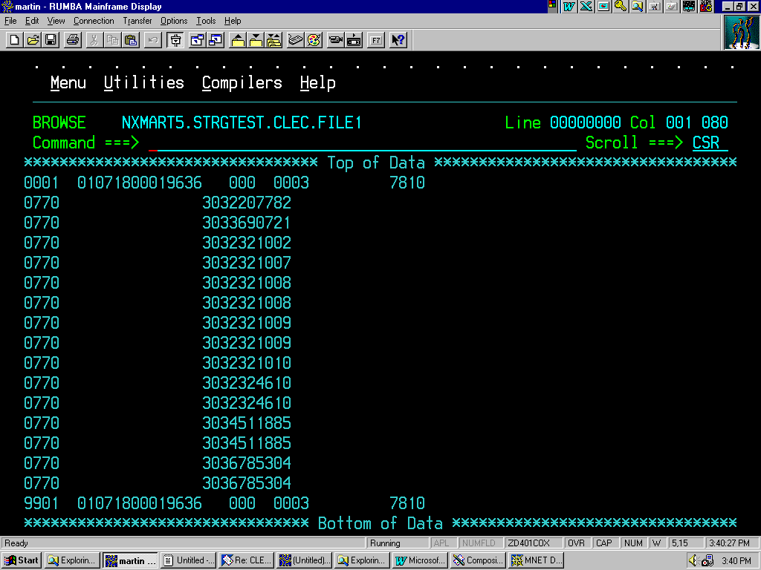
6.
7.
5.
0004

Input File Detail Record Fields
This chart shows the specific input for each field on the Detail Record (i.e. the body of the PIC/LPIC request).
Position in Record | Field Structure | Element | Description | Data Content
1-2 | 9 (2) | TC (Transaction Code) | 07 | R
3-4 | 9 (2) | SI (Status Indicator) | 70 | R
5-20 | X (16) | Not Available for Use | Blanks | O
21-30 | 9 (10) | WTN (Working Telephone Number) --Current/New  This is where the telephone number of the line to be verified is placed | NPA, NXX, line number | R
31-44 | X (14) | Not Available for Use | Blanks | O
45 | X (1) | CTI (Customer Type Indicator) | One alpha character | O
46-342 | X (297) | Not Available for Use | Blanks | O
343-352 | X (10) | Customer Reference Number | Customer Provided | O
353-368 | X (16) | Customer Order Number | Customer Provided | O
369-402 | X (34) | Not Available for Use | Blanks | O
403 | X (1) | Jurisdictional Indicator (JI)  A = LPIC (IntraLATA information only)  E = PIC (InterLATA information only)  B = PIC and LPIC (Inter and intraLATA information) | Customer Provided  A, B, or E | R
404-771 | X (368) | Not Available for Use | Blanks | O
772 – 775 | X (4) | LSPID | Four numeric characters | R
776-1500 | X (725) | Not Available for Use | Blanks | O

Field Structure Legend
9 = Numeric, right justified, zero filled
X = Alphanumeric, left justified, blank filled

Data Content Legend
R = Required
O = Optional
CLEC to CenturyLink – Input Detail Record Data Example
The following provides on-line screen shots of the detail record format.
- Positions 1-4; positions 1-2 list the TC code, and 3-4 list the SI code.
- Positions 21-30; this field lists the Working TNs that the CLEC is requesting PIC/LPIC information on.
1.
2.

- This field (#403) in the body of the report is where the Jurisdictional Indicator (JI) is shown for a given TN (see page 11 for JI descriptions).
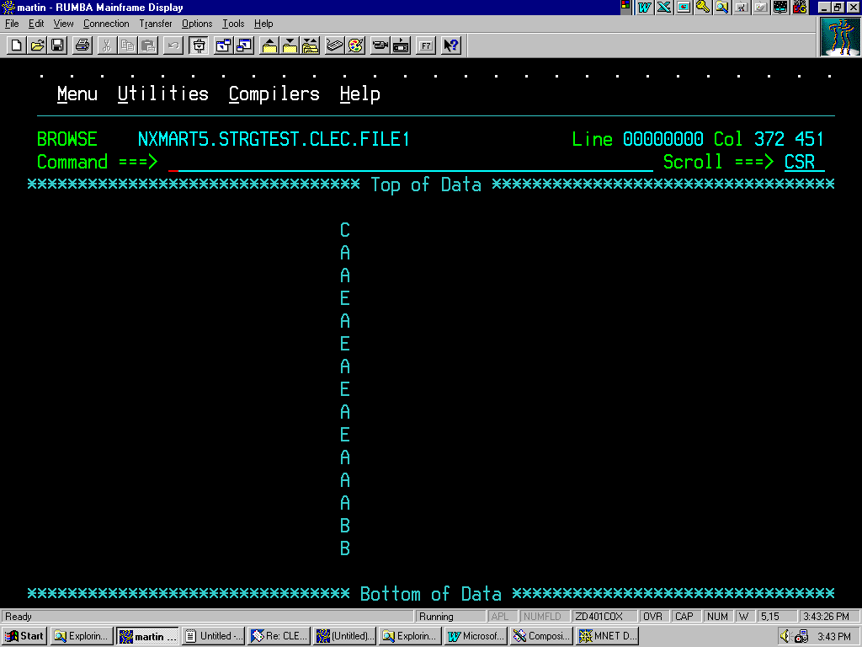
3.

CLEC to CenturyLink—Input Detail Record
- This field contains the LSPID.
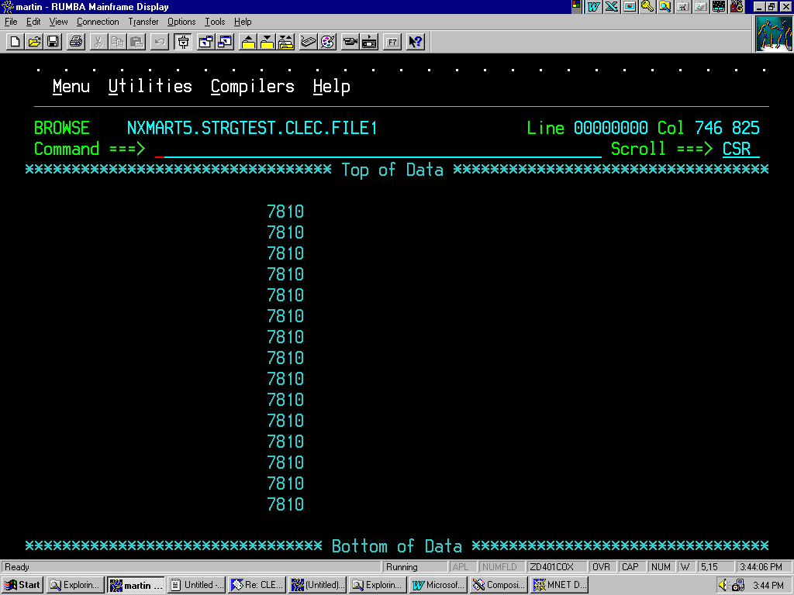
4.

CLEC to CenturyLink—Input Control Trailer Record
The chart shown on this page lists the specific input for each field on the Trailer Record.
Most of the information shown in the trailer is in the same format as the header, it is important to note that the sequence numbers should match.
Position in Record | Field Structure | Element | Description | Data Content
1-2 | 9 (2) | Record Identification -- Trailer | 99 | R
3-4 | 9 (2) | Record Identification – Direction | 01 = Customer to Provider | R
5-6 | X (2) | Not Available for Use | Blanks | O
7-12 | 9 (6) | Create Date | YYMMDD | R
13-16 | 9 (4) | Sequence Number | 0001-9999 | R
17-20 | X (4) | Provider Identification Code | See below | R
21-23 | X (3) | Not Available for Use | Blanks | O
24-26 | 9 (3) | Provider RAO (Revenue Accounting Office) | Zeros | O
27-28 | X (2) | Sequence Group Identifier | Blanks | O
29-32 | X (4) | Version Number | 0004 | R
33-41 | X (9) | Not used in CenturyLink | Blanks | R
42-45 | X (4) | LSPID | Four numeric characters | R
46-114 | X (69) | Not Available for Use | Blanks | O
115-121 | 9 (7) | Grand Total Record Count | Includes header and trailer | R
122-1500 | X (1379) | Not Available for Use | Blanks | R
Field Structure Legend

Provider Identification Code
Combined Qwest file 9636
Eastern region 9631
Western region 9638
Central region 9636
9 = Numeric, right justified, zero filled
X = Alphanumeric, left justified, blank filled

Data Content Legend
R = Required
O = Optional

CLEC to CenturyLink – Input Trailer Record Example
The following provides on-line screen shots of the trailer format.
1. Positions 1-4 in the Trailer Record; positions 1-2= 99, this indicates that this is the Trailer line for this file, positions 3-4= 01, this indicates that this file is a CLEC to CenturyLink file.
2. All other input on this line should be the same as the Header line; Date, Sequence Number, Output File (Combined, Eastern, Western, & Central), RAO (not used by CLEC in this application), Version Number (not used by CLEC in this application) and 7810 is the CLEC LSPID.
Please see the chart on the previous page for a full listing of field inputs.
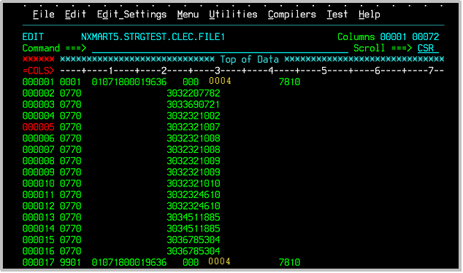

1.
2.

- 3. Position 115-121 shows the Record Number field, which shows the grand total record count for this CLEC to CenturyLink input file, in this case 18 records.
NOTE: The Header and Trailer are included in the grand total count.
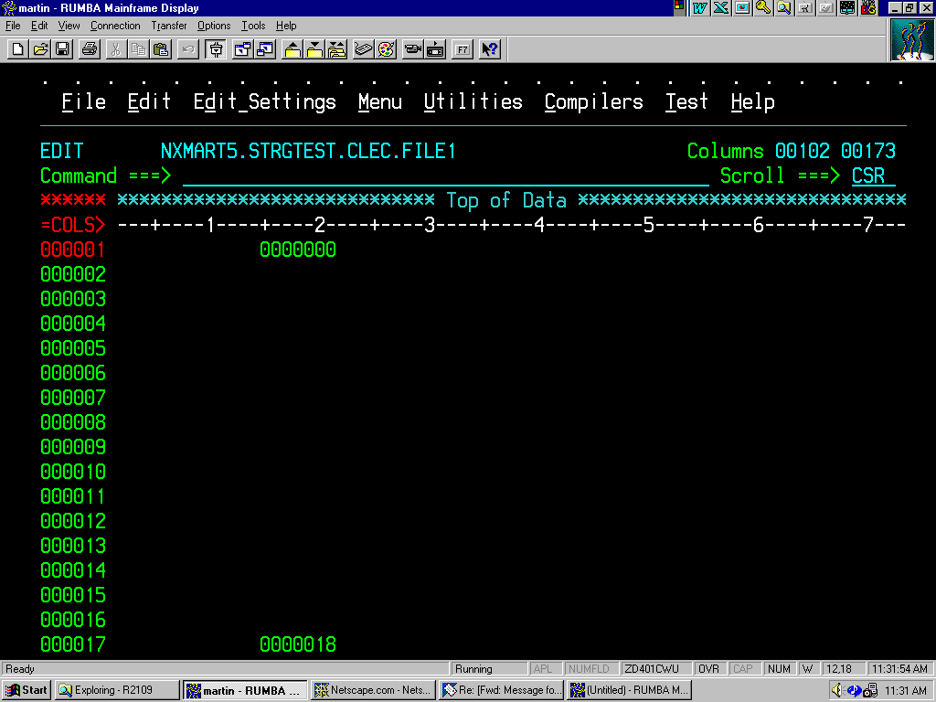
3.

Echo Back Acknowledgment File Information
Once you have transmitted your input file, CenturyLink will provide an echo back of the header record and a trailer record and the standard acknowledgment detail record.
- You will receive the echo back the next day
The following provides a list of the acceptance/rejection codes that will populate positions 13-14 and 15-99 of the “Echo Back” screen, as well as the field formats of the “Echo Back” screen.
The Acknowledgment (Echo Back) from your input file will be formatted as follows:
Position in Acknowledgment File | Description of Information
1-5 | These positions will populate with the CenturyLink Company ID--the echo back of what is sent in the header record
6 | This position will populate with A if the file is accepted. This field will be blank if the file is errored back.
7-12 | These positions will populate with the date CenturyLink accepted the file (YYMMDD format)
13-14 | These positions will populate with the File Acceptance/Rejection code
15-103 | These positions will populate with the English description of the File Acceptance/Rejection code
104-110 | This field will contain the count of the number of CARE transactions on the file. This number excludes the header and trailer information
111-1500 | These positions will be blank

“Echo Back” File
After submitting the batch file to CenturyLink, the CLEC will receive what is called an “Echo Back” file that will advise the user of the status of their request. In the example shown the file had no errors and was processed properly.
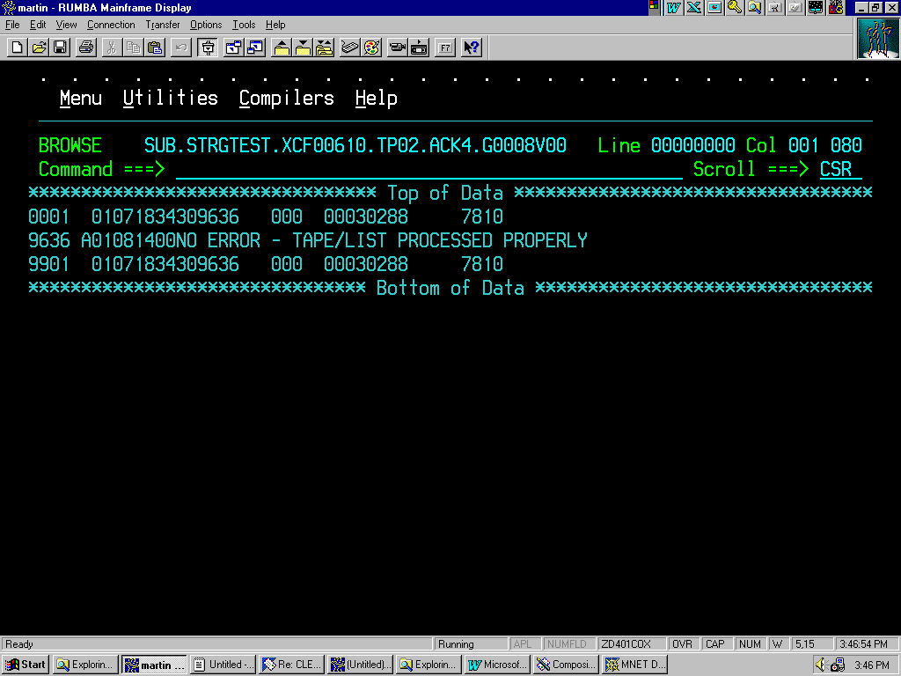

In the following example, the response is that the LSPID in the trailer does not match the one in the header.
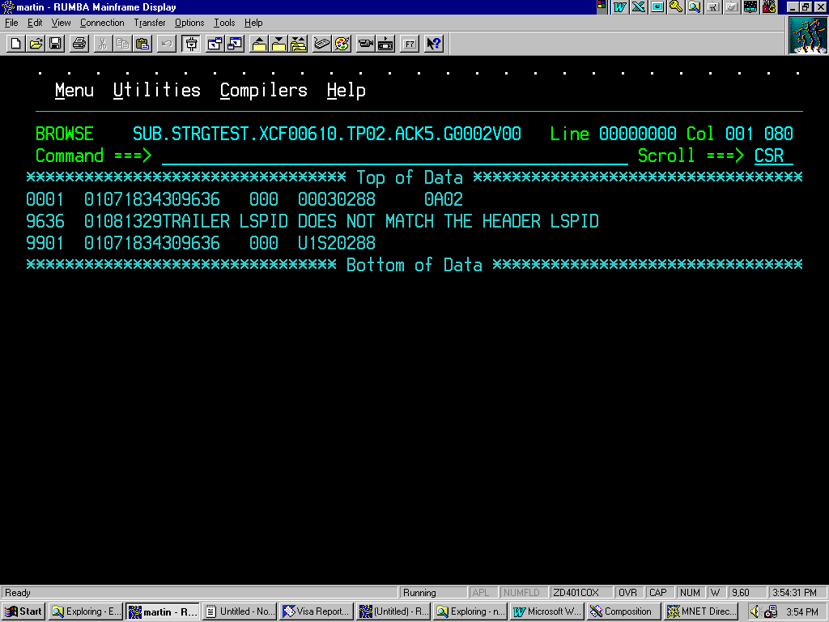

Problems
If you are is unable to process output files or have not received an echo back file from CenturyLink, contact the Help Desk at 1-888-796-9102.

File Acceptance/Rejection Codes
You will also receive Acceptance and Rejection notification information. The following is a list of acceptance/rejection codes that will populate positions 13-14 and 15-99.
Positions 13-14 Numeric Code | Positions 15-99 Code Definition
00 | No error--List processed properly
01 | First record of file is not header
02 | Second header exists on file
03 | Last record of file is not trailer
04 | No detail records on file
05 | Trailer record count does not equal accumulated record count
06 | File cannot be read
07 | Record type invalid
08 | Record type missing
09 | Create date invalid
10 | Create date missing
11 | Sequence number invalid
12 | Sequence number missing
13 | Provider identification code invalid
14 | Provider identification code missing
15 | ACNA (Access Carrier Name Abbreviation) invalid
16 | ACNA missing
17 | Send to RAO invalid
18 | Send to RAO missing
19 | Trailer record type does not match header record type
20 | Trailer create date does not match header create date
21 | Trailer sequence number does not match header sequence number
22 | Trailer Provider identification code does not match header Provider identification code
23 | Trailer ACNA does not match header ACNA
24 | Trailer sent to RAO does not match header sent to RAO
25 | No records on file
26 | Invalid data set name
27 | Invalid LSPID
28 | Both LSPID and ACNA missing*
29 | Trailer LSPID does not match the Header LSPID*
30-42 | Not utilized by CenturyLink
43 | File not processed – Invalid or unsupported record length
44-69 | Reserved for future CARE assignment
70-99 | Reserved for local use
* Local use

This Page Left
Intentionally Blank

Reading Output Files
Following is the Record Layout for output files. The Record Layout is provided in a table and then in screen shots so you can see how the layout looks.
Output File Control Header Fields
Notice that specific information in the Data Content column is required.
Position in Record | Field Structure | Element | Description | Data Content
1-2 | 9 (2) | Record Identification—Header | 00 | P
3-4 | 9 (2) | Record Identification--Direction | 02 = Provider to Customer | P
5-6 | X (2) | Not Available for Use | Blanks | P
7-8 | 9 (2) | File Create Date Year | YY | P
9-10 | 9 (2) | File Create Date Month | MM | P
11-12 | 9 (2) | File Create Date Day | DD | P
13-16 | 9 (4) | Sequence Number | 0001-9999 | P
17-20 | X (4) | Provider Identification Code | See below | P
21-23 | X (3) | Not Available for Use | Blanks | P
24-26 | 9 (3) | From RAO | Four numeric characters | P
27-28 | X (2) | Sequence Group Identifier | Blanks | P
29-32 | X (4) | Version Number | 0004 | P
33-41 | X (9) | Not Available for Use | Blanks | P
42-45 | X (4) | LSPID | Four numeric characters | P
46-1500 | X (1455) | Not Available for Use | Blanks | P

Legend  9 = Numeric, right justified, zero filled  X = Alphanumeric, left justified, blank filled  P = Populated  * = Populated if applicable to Transaction Code | Provider Identification Code  Combined CenturyLink file 9636  Eastern region 9631  Western region 9638  Central region 9636

CenturyLink to CLEC - Output Header Record
The Control Header Record shows:
- 00, which indicates that this is a header file, and 02 indicating that this is a Provider (CenturyLink) to Customer (CLEC) file.
- 010828 is the Create Date and indicates that this file was created by CenturyLink and sent to the CLEC on August 28, 2001.
- 0004 is the Sequence number for this transaction from CenturyLink to the CLEC.
- This field indicates the output file sort for this file, in this case Combined CenturyLink file = 9636.
- This field shows the Provider (Revenue Accounting Office) RAO and is populated by CenturyLink.
- This field lists the version number that will always be 0004.
- This field is the LSPID and in this example it is 7810.
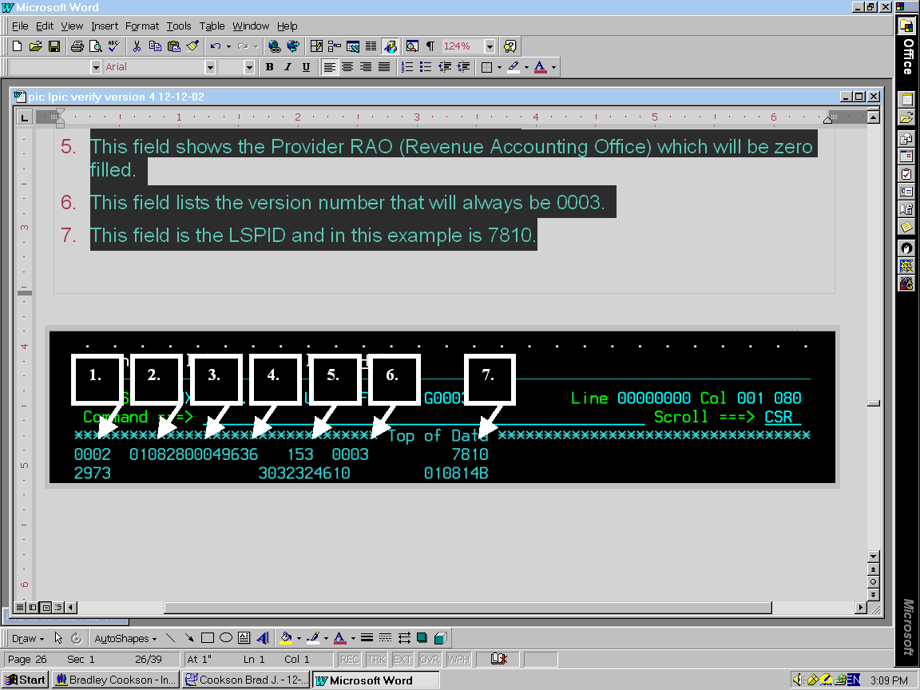

0004

CenturyLink to CLEC Output Detail Record
This chart identifies the input for various fields in the CenturyLink to CLEC Detail Record.
Position in Record | Field Structure | Element | Description | Data Content
1-2 | 9 (2) | TC (Transaction Code) | 29 | P
3-4 | 9 (2) | SI (Status Indicator) | Two numeric characters | P
5-20 | X (16) | Not Available for Use | Blanks | P
21-30 | 9 (10) | WTN (Working Telephone Number) – Current/New | NPA, NXX, line number | P
31-34 | X (4) | Not Available for Use | Blanks | P
35-38 | X (4) | Terminal Number -- Current/New | Four numeric characters | P*
39-44 | 9 (6) | Date | YYMMDD | P
45 | X (1) | CTI (Customer Type Indicator) – Current/New | One alpha character | P
46-342 | X (297) | Not Available for Use | Blanks | P
343-352 | X (10) | Customer Reference Number | Customer Provided | *
353-368 | X (16) | Customer Order Number | Customer Provided | *
369-402 | X (34) | Not Available for Use | Blanks | P
403 | X (1) | JI (Jurisdictional Indicator) | Customer Provided  A, B, or E | P
404-432 | X (29) | Not Available for Use | Blanks | P
433-436 | X (4) | CIC (Carrier Identification Code) | Four numeric characters | P
437-756 | X (320) | Not Available for Use | Blanks | P
757 | X (1) | Special Services Indicator | W | *
758-771 | X (14) | Not Available for Use | Blanks | P
772-775 | X (4) | LSPID | Four numeric characters | P
776-790 | X (15) | Not Available for Use | Blanks | P
791 | X (1) | Date Use Indicator | Single alpha character | P
792-1500 | X (709) | Not Available for Use | Blanks | P

LEGEND 9 =Numeric, right justified, zero filled X =Alphanumeric, left justified, blank filled
P= Populated * = Populated if applicable to Transaction Code and information is available

CenturyLink to CLEC—Output Detail Record
8. The output TCSIs are in this field. This information will tell you if your request was rejected or accepted.
9. Position 21-30 lists the WTN requested by the CLEC
10. Position 39-44 lists the Date. Position 45 (following the date) lists the Customer Type Indicator (CTI), either current or new. This field is filled by CenturyLink.
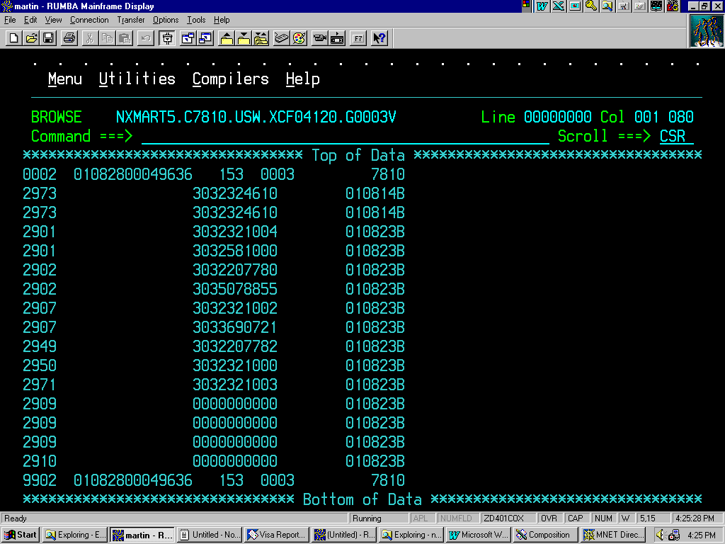
9.
10.
8.

11. Position 403 shows the Jurisdiction Indicator (see page 12 for definitions).
12. Position 433-436 shows the Carrier Identification Code (CIC) associated with the WTN.
403 700
11.
12.
CSR
0333
0222
0444
0111
0666
7077

A
A
E
A
E
E

CenturyLink to CLEC Output Trailer Record
This chart identifies the input for various fields in the CenturyLink to CLEC Trailer Record.
Position in Record | Field Structure | Element | Description | Data Content
1-2 | 9 (2) | Record Identification -- Trailer | 99 | P
3-4 | 9 (2) | Record Identification -- Direction | 02 = Provider to Customer | P
5-6 | X (2) | Not Available for Use | Blanks | P
7-8 | 9 (2) | Create Date Year | YY | P
9-10 | 9 (2) | Create Date Month | MM | P
11-12 | 9 (2) | Create Date Day | DD | P
13-16 | 9 (4) | Sequence Number | 0001-9999 | P
17-20 | X (4) | Provider Identification Code | # See below | P
21-23 | X (3) | Not Available for Use | Blanks | P
24-26 | 9 (3) | Provider RAO | 153 | P
27-28 | X (2) | Sequence Group Identifier | Blanks | P
29-32 | X (4) | Version Number | 0004 | P
33-41 | X (9) | Reserved | Blanks | P
42-45 | X (4) | LSPID | Four numeric characters | P
46-114 | X (69) | Not Available for Use | Blanks | P
115-121 | 9 (7) | Grand Total Record Count | Including header and trailer | P
122-1500 | X (1379) | Not Available for Use | Blanks | P

Legend  9 = Numeric, right justified, zero filled  X = Alphanumeric, left justified, blank filled  P = Populated  * = Populated if applicable to Transaction Code | Provider Identification Code  Combined CenturyLink file 9636  Eastern region 9631  Western region 9638  Central region 9636

CenturyLink to CLEC – Output Trailer Record
- Position 1-4 in trailer record shows 9902, which indicates this is the trailer record for a CenturyLink to CLEC output file.
- All other data on this line should be the same as the Header line; Date, Sequence Number, Output File (Combined, Eastern, Western, & Central), RAO, Version Number and 7810 is the CLEC LSPID.
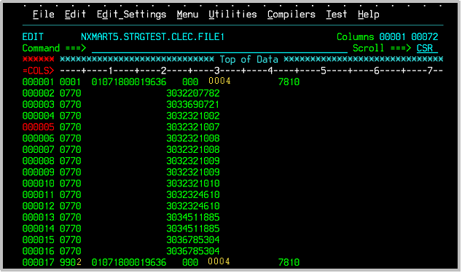

153 0004

13.
14.
153 0004

CenturyLink to CLEC – Output Trailer Record (Cont.)
- Position 115-121 depicts the Record Number field, which shows the grand total record count for this CLEC to CenturyLink input file, in this case 18 records.
The Header and Trailer are included in the grand total count

15.

NOTE: Remember that the Header and Trailer are included in the grand total count.
NOTE: If the CLEC chooses to convert and download the output file in an ASCII file format, a extra carriage return will be added to the file.

Output Acceptance Codes
The following is the output code you will receive if the PIC/LPIC Verification was successful.
- 2970 - Primary Interexchange Carrier (PIC) For Working Telephone Number (WTN) As Requested By LSP
Positions 433-436 of the Output Detail Record will show the PIC or LPIC that was found in the CenturyLink switch for that WTN.
If you requested PIC and LPIC information (JI B) and the PIC is different from the LPIC, remember that you will receive two records for that WTN.
One record will show the PIC and the other will show the LPIC.

Output Reject Codes
In your output file, you will receive acceptance or rejection notification via TCSIs. Following is the list of reject codes you codes you may receive.

Output Reject TCSIs
The following is a list of the output TCSIs used for PIC/LPIC Verify:
- 2901 – Invalid TC (Transaction Code) - TC is not recognized by the Provider.
This reject TCSI means something other than the input TC of 07 was used.
• 2902 – Invalid SI (Status Indicator) - SI is not
recognized by the Provider.
This reject TCSI means that something other than the input SI of 70 was used.
- 2907 – Working telephone number not found - WTN does not exist in the Provider file.
This reject TCSI means that the WTN you submitted cannot be found in CenturyLink systems.
- 2909 – Working telephone number not numeric - Non-numeric characters are present in the WTN element.
This reject TCSI means that the WTN you submitted contains some alpha characters.

Output Reject TCSIs, Cont.
- 2910 – Working telephone number is all zeros - WTN is all zeros.
This reject TCSI means you submitted all zeros in the WTN field.
- 2912 – Working Telephone Number (WTN) Numbering Plan Area (NPA - NXX) Is Invalid For Provider.
This reject TCSI means you submitted a WTN that is either not valid for CenturyLink or you have mistyped the NPA/NXX.
- 2949 - Jurisdictional Indicator (JI) Invalid, JI is not valid for Provider.
- 2950 - Jurisdictional Indicator (JI) Missing, JI is not present on AC Record.
- 2962 - Working telephone number is not subscribed, WTN is not subscribed to any AC.
- 2971 – WTN is not resold to requesting LSP.
- 2973 – Request rejected – switch unable to process. CenturyLink is unable to process this request due to switch failure. Please resubmit your request or contact your CenturyLink Service Bureau for assistance with the WTN.
Confirmation TCSI
The following is a Confirmation TCSI code:
- 2970 - Primary InterExchange Carrier (PIC) For Working Telephone Number (WTN) As Requested By LSP.

Working With the Help Desk
The Help Desk will be the first tier of response for user questions. Their number is 1-888-796-9102.
The Help Desk will answer questions about connectivity access for batch processing of requests including any messages that the report connectivity is down, or unreachable.
The Help Desk will answer questions about system access for PIC/LPIC Verification files including information about RSS being down.
The types of questions they answer are:
- I can’t send in my CARE file.
- I am sending a file but get no response.
- The system isn’t responding.
These and other systems oriented issues such as the following can be addressed by the Help Desk:
- Initial Set-up and Test File Transfers
- File Resends
- Partial File Received
- Records Missing
or
- Internet User Problems

Working with Your CenturyLink Service Manager’s Assistance
Call your CenturyLink Service Manager for assistance with the following:
- If you have general questions on how the batch process works
- If you need assistance with your file setup
- If you do not understand the output you received (TCSI codes)
- Interpreting CenturyLink to CLEC file contents such as understanding the TCSI codes
- Questions regarding specific PIC/LPIC information
Note: Your Service Manager will provide you with information regarding RSS System Releases and Sync Ups.

Processing During Release Weekends
When software changes or system enhancements are made, the RSS On-lines will be brought down at 8:00 p.m. Friday night (Mountain Time). The new release (programming) will be loaded into RSS that night.
During Release Weekends, PIC/LPIC Verification files submitted on Friday will run on Saturday. Files submitted Saturday will be run Monday. Output for both files will be sent on Tuesday.

Processing During System Sync Up
Several times a year, CenturyLink does a sync up between the systems databases. The purpose of the sync up is to uncover and correct any discrepancies between the databases.
During these times the batch processing function will not be available. Sync ups are normally scheduled to occur after a subscription release.
The Friday cycle will run as usual Friday night. After that cycle completes, the sync up will be run. During sync up weekend, the normal Saturday cycle will not run.

Output
All Saturday input will be held and processed with the following Monday’s input. The transmission and internet output will be available on Tuesday.

Holiday Processing-Input and Output

Saturdays Before a Monday Holiday
- Saturday is considered a normal business day.
- Batch input will be accepted.
- Transmission and internet output will be sent on Sunday.

Holidays
- This is not a normal business day.
- No cycle will be run.
- No processing will be done.
NOTE: Your CenturyLink Service Manager will keep you informed as to any changes in the normal cycle times.

PIC/LPIC Manual Process

Requests from CLECs who have an alpha-numeric LSPID need to be handled manually. CLECs in this situation should contact their Service Manager for assistance.

Input
CLECs will send their real-time PIC/LPIC switch verification requests via an Excel spreadsheet. The spreadsheet should contain the WTN, JI, and LSPID for each telephone number they wish to have verified. The CLECs must submit a separate spreadsheet for each LSPID. LSPIDs cannot be mixed on the same request spreadsheet.
The spreadsheet must not exceed 50 WTNs per day.
Requests will be accepted Monday through Friday. CenturyLink will process and send responses within 2 business days of receipt (Monday through Friday).

Output
CenturyLink will verify ownership of the telephone number to confirm that the requesting CLEC owns the telephone number. Ownership will be determined by comparing the LSPID on the spreadsheet to the LSPID at the WTN level.
CenturyLink will return the completed spreadsheet with the verification information within 2 business days from the time it has been received (Monday through Friday).

