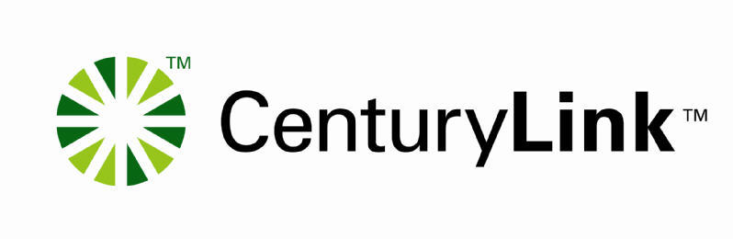

Directory Listing Inquiry System (DLIS)
User Guide

Version 2.7.8
April 30, 2018

Document information

Version notice

The versions of this guide are listed below. Changes are identified with a bleed bar.

Version | Document date | Description
2.0 | January 4, 2005 | DLIS Re-write includes parsing account and listing level fields to align with OBF. This document replaces V1.02.
2.1 | February 18, 2005 | Page 7 Add clarification for password requirements.  Page 9 & 12-25 Updated screen shots  Page 10 Update link for IMA FBDL Guide.  Page 17 & 21 Add paragraph – erred caption/SLU listings display  Page 26 Add new error description
2.2 | March 15, 2005 | Chapter 1 Getting Started – Add information about unsupported browsers
2.3 | August 21, 2005 | Chapter 1 Getting Started – Update DLIS Hours
2.4 | October 3, 2005 | Chapter 1 Getting Started – Update LOC Hours of Operation
2.5 | March 20, 2006 | Chapter 1 Getting Started – Update LOC
2.6 | May 18, 2006 | Add CCNA Field to the following DLIS Screens:  - Directory Listing Detail Response Display Screen  - Listing History Display Screen  - AN Display Search Response Screen  - Account History Display Response Screen  Change Provider ID field name to CC (Company Code)
2.7 | April 2, 2007 | Remove contact information and add reference to use Wholesale Customer Contacts PCAT  Update password requirements  Update login screen shot (Page 7)  Replacement. AN Display Search Response screen shot (Page 15)
2.7.1 | April 10, 2007 | Correct URL to Customer Contact PCAT on page 5  Add correct URL to Customer Contact PCAT on page 6
2.7.2 | June 30, 2007 | - Changes Service Delivery Gateway (SDG) to CenturyLink™ Protected Internet Delivery (CPID) in name of DLIS Digital Certificate Requests form on page 5.  - Telephone numbers for Qwest Wholesale Systems Help Desk were removed on pages 27 and 28 and replaced by a link to Qwest Wholesale Customer Contacts PCAT.
2.7.3 | February 28, 2008 | Page 7 Change URL from: https://kai03.qwest.com/Qsearch/DLIS/Login.aspx to: http://dlis.qwest.com
2.7.4 | October 19, 2009 | - Page 6 – Corrected the link and link name for “View information about access to Qwest Systems” related to Digital Certificates  - Page 7 – Updated DLIS Hours to link to Customer Contact PCAT  - Page 8 – Corrected the DLIS URL to  - Page 10  - Corrected the link for the IMA FBDL User Guide to  - Updated 3rd paragraph to include: These should be corrected as soon as possible to avoid possible published errors.  - Added a new paragraph: When you enter a City name for a search, a city with a single mark in the name must be entered with two marks. For example, Coeur D’Alene should be entered as Coeur D’’Alene.  - Added Enhanced Service Providers to last paragraph  - Page 11 – Updated to include without dashes: Enter the LTN without dashes and click the search tab.  - Page 12 – Removed the link for the IMA FBDL User Guide. The link is available on Page 9.  - Page 15 – Added: Enter the AN without dashes and click the search tab.  - Page 17 – Removed unnecessary Note.  - Page 20 – Added a Note: The number in parenthesis after each Caption Header indicates the number of indents associated with the Caption set.  - Page 21 – Updated info for SLU Search. Enter the SLU Header telephone number without dashes.  - Page 24 – Updated info for NSTN Search. Alpha characters must be entered in upper case. Using lower case may result in a ‘Not Found’ error.  - Page 26 – Updated info for SAC search. Enter the SAC telephone number without dashes or spaces and click the Search button.
2.7.5 |  | - Page 7 – Updated DLIS Hours section – added link for OSS Hours of Availability
2.76 |  | - Change or removed all occurrences of Qwest to CenturyLink
2.77 |  | - Page 8 - Correct URL on Page  - Page 10 – Correct default password: from 1029ctl to 1029-ctl.  - Add: These listings are referred to as Guideline listings. They are a type of placeholder listing and will not appear in Directory Assistance or a published directory. If CenturyLink sends you a query for a correction regarding a listing in red text  - Update Copyright Date  - Remove obsolete link in Footer
2.78 | April 30, 2018 | - Remove reference to CPID in digital certificate requirements

You may obtain the latest version of this guide at
http://www.centurylink.com/wholesale/systems/dirlist.html

Copyright
© 2018 CenturyLink, Inc. All Rights Reserved.

Table of Contents
Document information 2
Version notice 2
Copyright 4
Trademarks 4
Chapter 1 – Getting Started 6
DLIS hours 7
Logging on to DLIS 8
Chapter 2 – Overview 10
Chapter 3- Listed Telephone Number Search 11
Chapter 4 – Account Number Search 16
Chapter 5 – Caption Search 19
Chapter 6 – Straight Line Under (SLU) Set Search 22
Chapter 7 – Non Standard Telephone Number Search 25
Chapter 8 - Service Access Type (SAC) Search 27
Chapter 9 – Error Codes 29
Chapter 10 – Use Case Scenarios 31

Chapter 1 – Getting Started
Before you can use DLIS, you must have a CenturyLink Digital Certificate and the Internet Explorer (http://www.microsoft.com) browser available on your desktop.

If you do not have a Digital Certificate, please visit the following URL for ordering information: http://www.centurylink.com/wholesale/systems/generalinfo.html
Click on “View information about access to CenturyLink’s Systems.”

Follow the instructions contained in the External User Access to CenturyLink’s Systems Via Digital Certificate document. Facility Based CLECs should complete the DLIS Digital Certificate Requests form and submit it to your CenturyLink Wholesale Service Manager. Independent Local Exchange Carriers should submit their completed forms to their CenturyLink Listing Account Manager.

The Security Group will coordinate with the appropriate groups to have security and system access established. This process requires a minimum of 48 hours to complete.

You will receive your CenturyLink Digital Certificate number and PIN via email. The Digital Certificate must be downloaded using Internet Explorer 6.0. The instructions for downloading certificates can be found at: http://ecom.centurylink.com/ecomhelp/. After successfully downloading your Digital Certificate, you will be able to access DLIS.

If you attempt to access DLIS via an unsupported browser, you will receive an error message and instructions to download Internet Explorer. You may also be required to install your existing digital certificate using the same instructions.

You may contact the Wholesale Systems Help Desk (Wholesale Customer Contacts) for help or if you have questions regarding this process.

DLIS hours

DLIS hours of operation may be found on the OSS Hours of Availability web page at http://www.centurylink.com/wholesale/cmp/ossHours.html.

Contact information for the CenturyLink Wholesale Systems Help Desk and the Listing Operations Center may be found in the Wholesale Customer Contacts PCAT.

Logging on to DLIS

The following URL should be used to access DLIS and saved to your Favorites:

http://www.centurylink.com/dlis
When you log into DLIS for the first time, you will be prompted for your DLIS Login and Password.
- DLIS Login = Customer Carrier Name Abbreviation (CCNA) and your digital certificate number (example: ABC123456789)
- Default password is 1029-ctl.

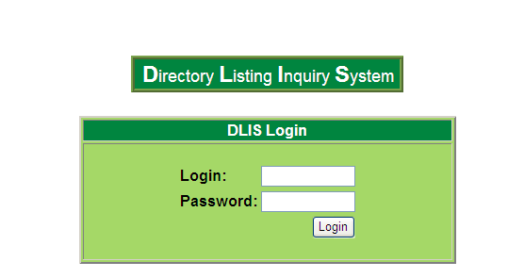

For Assistance, you may contact the CenturyLink Wholesale Systems Help Desk.

Logging On To DLIS (continued)

The following DLIS Change Password Screen will be returned. You must change your default password.

Password requirements:
- Minimum of 8 characters
- Maximum of 12 characters
- Passwords must contain at least 2 or more of the following:
- A-Z or a-z (upper or lower case)
- Number (0-9)
- Special Character (!,@,#,$,%, etc)
- No character constraints

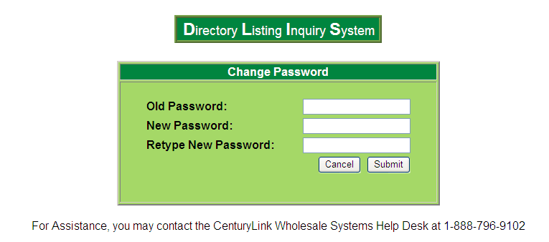

Chapter 2 – Overview
DLIS enables users to view directory listing information prior to and subsequent to submitting directory listing orders to CenturyLink for processing. Listing information may be accessed by:

- Account Telephone Number
- Listed Telephone Number
- Non Standard Telephone Number
- Service Access Code
- Straight Line Under (SLU) name
- Caption name

When multiple matches are found, DLIS allows you to select one or more listings to be displayed. Using the Company Code will help you determine if you own the account/listing.

Erred prior level information will be displayed in red text on DLIS to assist you in identifying error conditions. These listings are referred to as Guideline listings. They are a type of placeholder listing and will not appear in Directory Assistance or a published directory. If CenturyLink sends you a query for a correction regarding a listing in red text, they should be corrected as soon as possible to avoid possible published errors.

When you enter a City name for a search, a city with a single mark in the name must be entered with two marks. For example, Coeur D’Alene should be entered as Coeur D’’Alene.

For additional information regarding directory listings, please refer to the CenturyLink Interconnect Mediated Access (IMA) Facility Based Directory Listing (FBDL) User Document at the following URL:
http://www.centurylink.com/wholesale/ima/gui /
DLIS uses the Qwest listing database to obtain directory listing information. The listing database retains directory listing data for CenturyLink, Independent Exchange Carriers, Competitive Local Exchange Carriers, and Enhanced Service Providers.

Note: Stylization symbols do not appear on DLIS however data does appear in upper and lower case.

Chapter 3- Listed Telephone Number Search
After logging in, the following screen appears.
The Listed Telephone Number (LTN) Search Screen will be the first screen displayed. All other search options may be initiated from this screen.

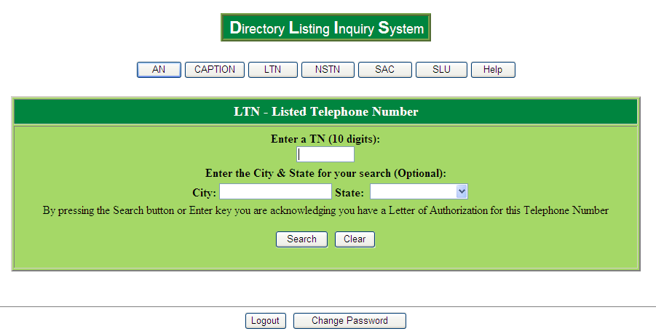

Enter the LTN without dashes and click the search tab.

If you wish to refine your search, you may enter the City and State information.

For a list of valid cities, please visit the following URL: www.centurylink.com/wholesale/clecs/lsog.html and select the document titled Foreign Directory Name Table.

Listed Telephone Number Search (continued)

The Directory Listing Detail Response screen is returned.

You may refer to the IMA FBDL User Document for field descriptions.
Top of Form
Top of Form
Directory Listing Detail Response
Jun 28 2011 10:53:02

Display Listing Records 1 Of 1
Account Information
AN: | TOS:

Service Address
SAPR: | SANO: | SASF: | SASD:
SASN: |  |  |  | SATH:
SASS:
LD 1: | LV 1: | LD 2: | LV 2: | LD 3: | LV 3:
City: |  |  |  | State:

Directory Listing Information
LTN/NSTN: |  |  |  |  |  | OMTN: | CCNA: | Company Code:
ALI: |  |  |  | RTY: | LTY: | STYC: | TOA: | DOI:
DML: | NOSL: |  | TMKT: |  | BRO:
DIRNAME:
LNPL: |  | LNLN:
LNFN:
DES: |  |  | TL: |  | TITLE1: |  | NICK:
PLA:
ADI:
LAPR: |  | LANO: |  | LASF: | LASD: | LASN: e
LATH: |  |  |  | LASS: |  | Location Text:
LALOC: |  |  |  |  |  | LAST:
HTN: |  |  |  | HNSTN: |  |  |  | SO:
LTXTY:
LTEXT:

Prior Level Information
LVL: | PLINFO:
PLTN: |  | PLNSTN: | SO:

Delivery Address
DIRQTYA: |  | DIRQTYNC:
DDAPR: | DDANO: |  | DDASF: | DDASD:
DDASN:
DDATH: |  | DDASS:
LD 1: | LV 1: | LD 2: | LV 2: | LD 3: | LV 3:
City: |  |  |  | State: | Zip:

Bottom of Form

Listed Telephone Number Search (continued)

You may also view history for the listing by clicking on the History tab from the Directory Listing Detail Response screen. A pop-up screen will be displayed.

The Listing History Display screen provides information regarding the last two activities applied to the listing. This includes the following data:
- Account Number
- Listed Telephone Number
- Company Code
- Order Number (same as Purchase Order Number – PON)
- Activity Type (Listing Activity Type – LACT)
- Completion Date

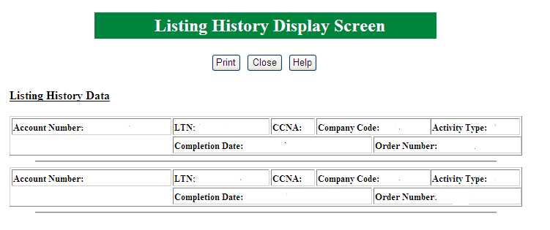

Listed Telephone Number Search (continued)

When multiple listings exist for an LTN, the LTN Display Search Response screen will be returned. You may select which listing(s) you would like to view by checking the box in the SEL column and clicking the Display Listing Information tab.

The Directory Listing Detail Response screen will be returned (refer to page 10).

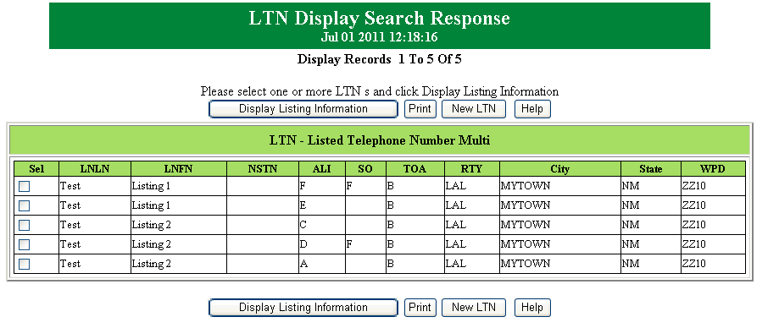

Chapter 4 – Account Number Search
The following screen is displayed when you click the AN tab.

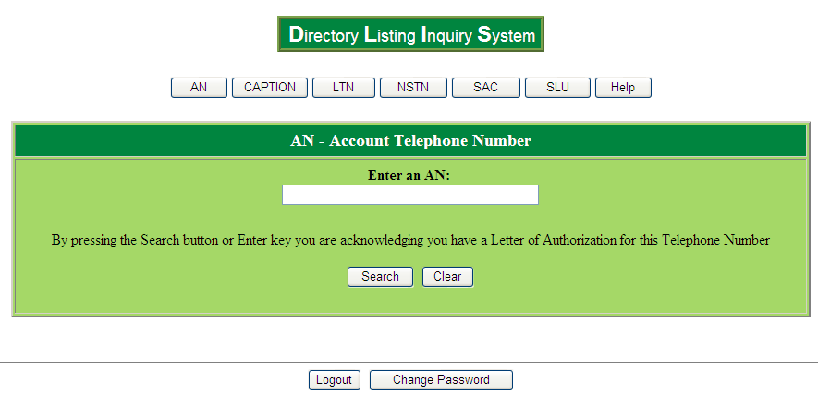

Enter the AN without dashes and click the search tab.

Account Number Search (continued)

The AN Display Search Response screen is returned. You may select one or more LTNs to view by checking the box in the SEL column and clicking the Display Listing Information tab.

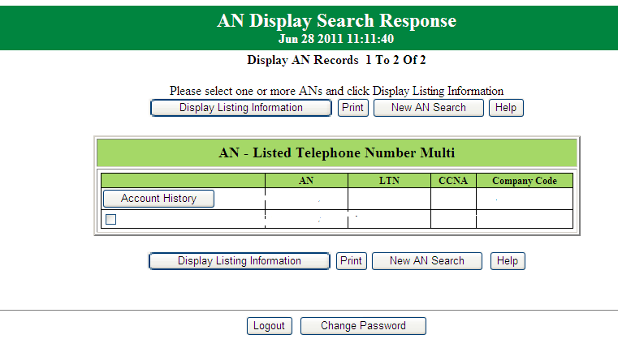
Account Number Search (continued)

You may also click on the Account History tab to view account level history. A pop-up screen appears.

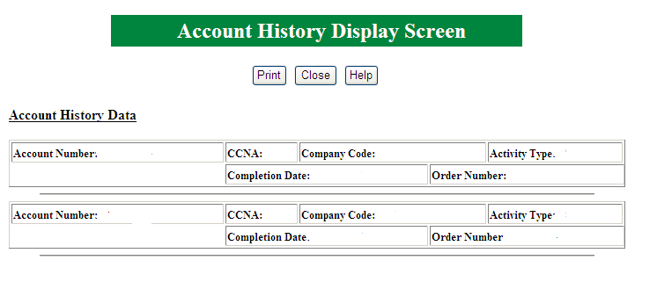

The Account History Display screen provides information regarding the last two activities applied to the Account. This includes the following data:
- Account Number
- Company Code
- Order Number (same as Purchase Order Number PON)
- Activity Type (same as the Local Service Request Activity LSR.ACT)
- Completion Date

When multiple ANs exist, the AN Display Search Response screen will be returned. You may select which account and listing(s) you would like to view by checking the box next to the AN/LTN/Provider ID and clicking the Display Listing Information tab.

The Directory Listing Detail Response screen will be returned (refer to page 10)

Chapter 5 – Caption Search
The following screen appears when you click the Caption tab.

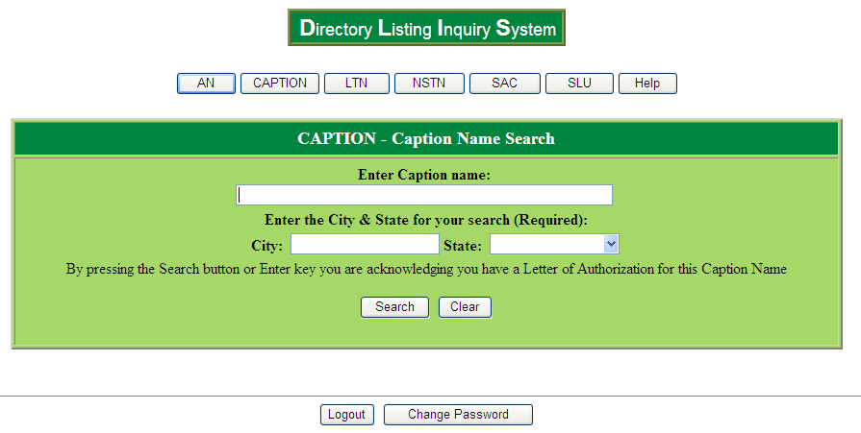

Enter all or part of the caption header name and the City and State information and click the search tab. Providing a complete caption header name will ensure an accurate response.

For a list of valid cities, please visit the following URL: www.centurylink.com/wholesale/clecs/lsog.html and select the document titled Foreign Directory Name Table.

Caption Search (continued)

The Caption Display Search Response Screen appears.

You may view the specific details for any listing(s) contained within the caption set by checking the box in the SEL column and clicking the Display Listing Information tab.

The Directory Listing Detail Response screen will be returned (refer to page 10).

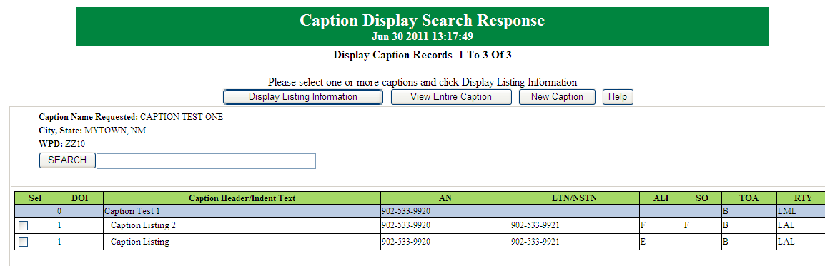

NOTE: Erred caption indent listings will be displayed in red font.

Caption Search (continued)

When multiple caption header matches are found, the Caption Selection screen will be returned. You may select which caption header you would like to view by highlighting the name and clicking the Display Caption Information tab.
Note: The number in parenthesis following the Caption Header name indicates the number of indents associated with the Caption set.

The Caption Display Search Response Screen will be displayed (refer to page 17).
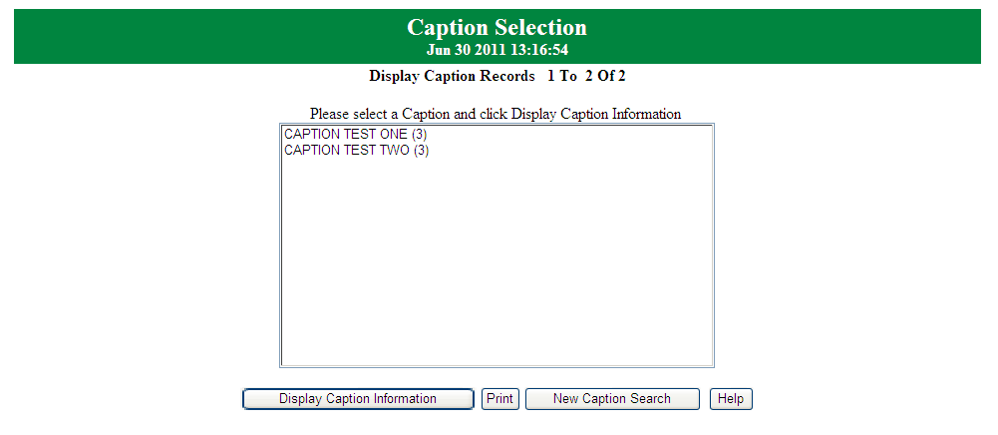

Chapter 6 – Straight Line Under (SLU) Set Search
The SLU – Straight Line Indent screen appears when you click on the SLU tab.

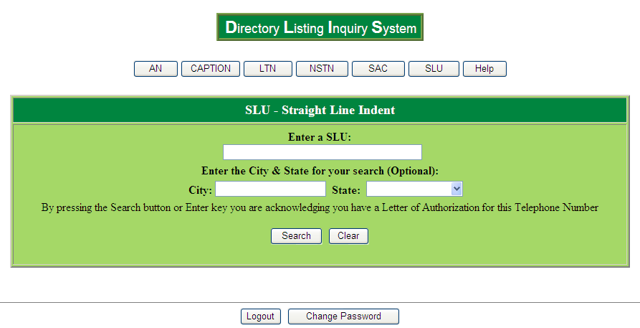

Enter the SLU Header telephone number without dashes and click the search tab.

You may refine your search by entering the City and State information.

For a list of valid cities, please visit the following URL: www.centurylink.com/wholesale/clecs/lsog.html and select the document titled Foreign Directory Name Table.

Straight Line Under (SLU) Set Search (continued)

The SLU Display Search Response Screen appears.

You may view the specific details for any of the Telephone Numbers contained within the SLU set by checking the box in the SEL column and clicking the Display Listing Information tab.

The Directory Listing Detail Response screen will be returned (refer to page 10).

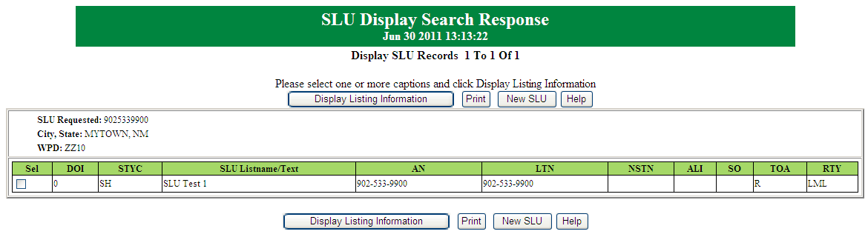

Straight Line Under (SLU) Set Search (continued)

When multiple SLU matches are found, the SLU Display Search screen will be returned. You may select which SLU header you would like to view by clicking the Select tab.

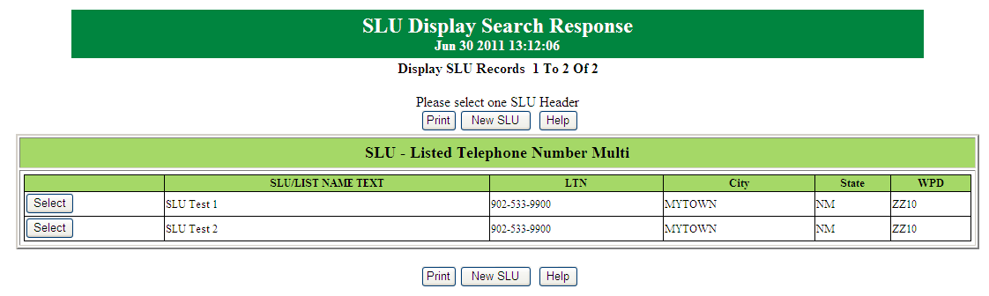

NOTE: Erred SLU indent listings will be displayed in red font.

Chapter 7 – Non Standard Telephone Number Search
The NSTN – Non Standard Telephone Number screen appears when you click the NSTN tab.

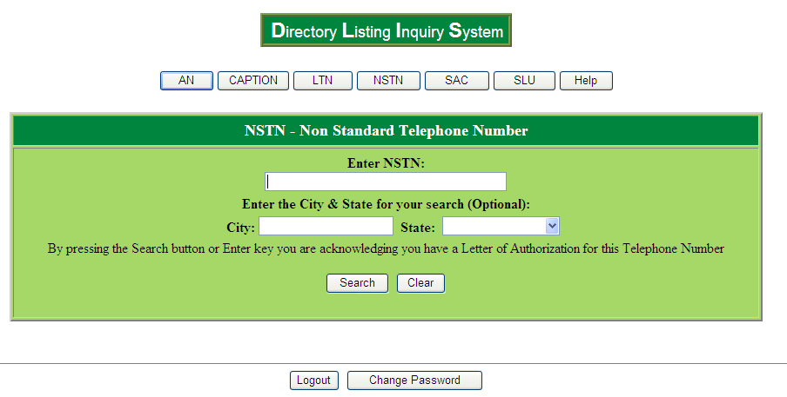

Enter the NSTN (must be an exact match) and click the search tab.

Please note that NSTN entry must be entered exactly as the NSTN appears, including apostrophes, asterisks, hyphens and spaces. Alpha characters must be entered in upper case. Using lower case may result in a ‘Not Found’ error.

You may refine your search by entering the City and State information.

The Directory Listing Detail Response screen will be returned (refer to page 10).

For a list of valid cities, please visit the following URL: www.centurylink.com/wholesale/clecs/lsog.html and select the document titled Foreign Directory Name Table.

Non Standard Telephone Number Search (continued)

When multiple listings exist for an NSTN, the NSTN Display Search Response screen will be returned. You may select which listing(s) you would like to view by checking the box in the SEL column and clicking the Display Listing Information tab.

The Directory Listing Detail Response screen will be returned (refer to page 10).

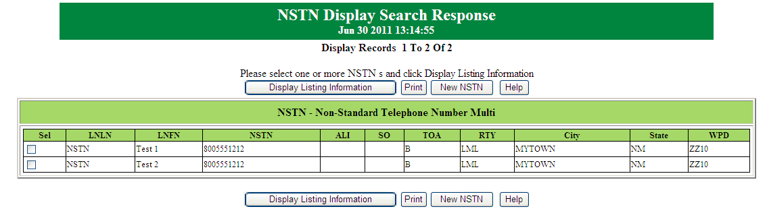

Chapter 8 - Service Access Type (SAC) Search
The SAC – Service Access Type screen appears when you click the SAC tab.

Note: SACs are 800 type numbers, i.e., 800, 866, 877, etc.

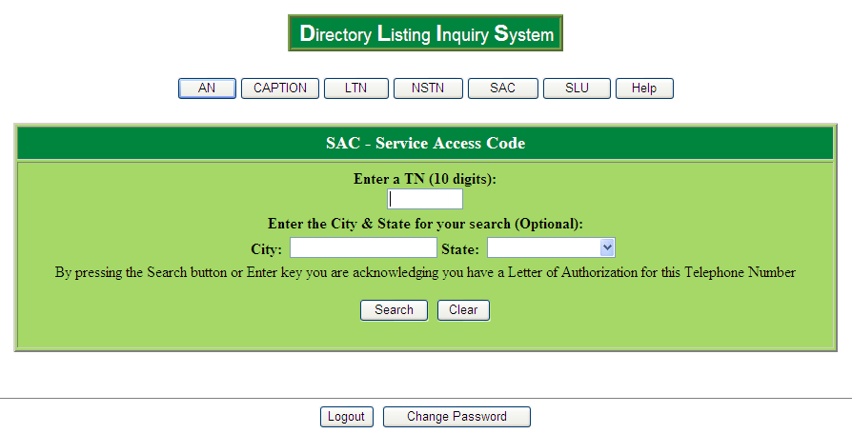

Enter the SAC telephone number without dashes or spaces and click the Search button. The City and State information is optional, however; this information should be provided when available to help minimize delays with the search as well as segregate the listing you are searching for.

The Directory Listing Detail Response screen will be returned (refer to page 10).

For a list of valid cities, please visit the following URL: www.centurylink.com/wholesale/clecs/lsog.html and select the document titled Foreign Directory Name Table.

Service Access Type (SAC) Search (continued)

When multiple listings exist for a SAC, the SAC Display Search Response screen will be returned. You may select which listing(s) you would like to view by checking the box in the SEL column and clicking on the Display Listing Information tab.

The Directory Listing Detail Response screen will be returned (refer to page 10).

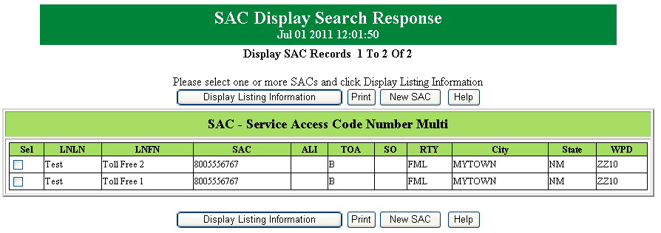

Chapter 9 – Error Codes
An error message may be returned when invalid data is entered and /or when DLIS data cannot be translated. The following matrix provides error code descriptions and corrective procedures.

DLIS Login Errors

Error Description | Corrective Procedures
ERROR MESSAGE | CORRECTIVE PROCEDURES
Invalid Telephone Number, try again | Verify TN and reenter.
No matching data found | Verify TN is correct. If TN is correct, listing does not exist in the database
City and State are required, please enter | Enter City and State for search
Unable to process, please try again later | Possible connectivity problem. Try again later and if problem persists, contact the CenturyLink Wholesale Systems Help Desk (Wholesale Customer Contacts)
SAC number invalid, try again | Verify SAC TN and enter the correct number.
Non-Standard Telephone Number invalid, try again | Verify NSTN and reenter
No match found on Directory Name File | Verify City and State and reenter
City is required when State is Entered | Verify City and reenter
State is required when City is Entered | Verify State and reenter
TN is not a SAC, try LTN Search | Verify SAC and renter or try LTN Search
No matching data found on Directory Name file. Verify City and State combination and try again. | Verify the City and State and reenter
Account Number invalid, please try again | Verify AN and reenter
SAC TN, use SAC screen for SAC type search | Verify TN and reenter in LTN or if valid SAC, reenter in SAC screen
Password expired | Your password has expired and must be changed.
Technical or system problems logging in | Technical or system problems may be preventing you from logging in. Contact the CenturyLink Wholesale System Help Desk (Wholesale Customer Contacts).
Login failed. Please try again | You have entered an invalid login or password. Validate this information and reenter.
User account disabled | You may receive this error message if you type your password incorrectly three or more times.  Technical or system problems may be preventing you from logging in. Contact the CenturyLink Wholesale System Help Desk (Wholesale Customer Contacts).

Chapter 10 – Use Case Scenarios
The following matrix identifies various Use Case Scenarios to help you understand when DLIS should be accessed and the expected results.
Local Service Request (LSR) Activity Type (ACT) or Directory Listing (DL) Listing Activity Type (LACT) | DLIS expected results | Recommended procedures when DLIS does not return expected results
LSR.ACT = N (New Account) | Telephone Account Number (AN) – DLIS should return Error Code: 2.0 indicating no matching data was found.  If the Account has Additional Listings at different LTNs, each LTN should be checked.  Once DLIS confirms that listings do not exist for the AN or LTN(s), you may issue your New Account listing order request. | If DLIS returns listing information for the AN or LTN(s), verify who owns the listing(s) by checking the Company Code. If the listing belongs to you, verify your customer service records and determine your listing ordering needs.  If the listing(s) does not belong to you and is related to a CenturyLink Number Port order, confirm the completion date of the Number Port order with the CSIE and check DLIS upon completion of the order.  If the listing(s) does not belong to you and is not related to a CenturyLink Number Port order, re-check your customer service records and determine your listing ordering needs.
LSR.ACT = C (Change to an existing account)  DL.LACT = O DL.LACT = I DL.LACT = N DL.LACT = D (Change to an existing listing) | The DLIS LML (RTY = LML) should always be confirmed and should match your customer service records exactly. Once the LML and other pertinent information (i.e., SA, LA, TOS, etc.) has been confirmed, you may issue your Change listing order request for the LML.  If the change is for an additional type listing, the LML should be confirmed first and then the respective additional listing(s) LTN. The additional listing(s) should match your customer service records exactly. If the change is to add a new additional listing; the LTN and other pertinent data (i.e., LA, ALI, TOA, etc.) should be been confirmed and then you may issue your Change listing order request for the additional listing(s). | If DLIS returns listing information that does not match your customer service records, verify who owns the listing(s) by checking the Company Code. If the listing belongs to you, verify your customer service records and determine your listing ordering needs.  If the listing(s) does not belong to you and is related to a CenturyLink Number Port order, confirm the completion date of the Number Port order with the CSIE and check DLIS upon completion of the order.  If the listing(s) does not belong to you and is not related to a CenturyLink Number Port order, re-check your customer service records and determine your listing ordering needs.
LSR.ACT = D (Disconnect Account) | The DLIS LML (RTY=LML) should always be confirmed and should match your customer service records exactly. Once the LML and other pertinent data (i.e., SA, LA, TOS, etc.) have been confirmed, you may issue your Disconnect listing order request for the account.  Additional type listings at the same LTN as the LML as well as additional type listings at different LTN(s) should be confirmed prior to issuing a Disconnect listing order. The additional listing(s) should match your customer service records exactly. Once this and other pertinent data (i.e., LA, ALI, TOA, etc.) has been confirmed, you may issue your Disconnect listing order request for the account.  Additional type listings must always be included on a ‘D’ order. | If DLIS returns listing information that does not match your customer service records, verify who owns the listing(s) by checking the Company Code. If the listing belongs to you, verify your customer service records and determine your listing ordering needs.  If the listing(s) does not belong to you, re-check your customer service records and determine your listing ordering needs.
LSR.ACT = T (Physical Move) | The DLIS LML (RTY=LML) should always be confirmed as well as the account SA. This data should match your customer service records exactly. Once the LML has been confirmed, you may issue your ‘T’ listing order request for the LML.  If the account includes additional type listing(s), the LML should be confirmed first and then the respective additional listing(s) LTN. Additional type listings must always be included on a ‘T’ order.  The additional listing(s) should match your customer service records exactly. Once this and other pertinent data (i.e., LA, ALI, TOA, etc.) has been confirmed, you may issue your ‘T’ listing order request for the account. It is imperative that you verify the LA for each listing to ensure your end-user needs for printing or not printing the LA are met. | If DLIS returns listing information that does not match your customer service records, verify who owns the listing(s) by checking the Company Code. If the listing belongs to you, verify your customer service records and determine your listing ordering needs.  If the listing(s) does not belong to you and is related to a CenturyLink Number Port order, confirm the completion date of the Number Port order with the CSIE and check DLIS upon completion of the order.  If the listing(s) does not belong to you and is not related to a CenturyLink Number Port order, re-check your customer service records and determine your listing ordering needs.
LSR.ACT = W (Conversion As Is) | The Company Code should be confirmed first and should match the CLEC Company Code the listing is being converted from.  The DLIS LML (RTY=LML) should always be confirmed and should match your customer service records exactly. Once the LML has been confirmed, you may issue your Conversion listing order.  Additional type listings must always be included on a ‘W’ order. | If DLIS returns listing information that does not match your customer service records, verify who owns the listing(s) by checking the Company Code. If the listing belongs to you already or there is a discrepancy regarding the Provider, verify your customer service records and determine your listing ordering needs.

